  Date: |  |  |  | Theme: Seaside STF2 Week:- 06.6.2020  Year group: Group 2
Literacy      This Photo by Unknown Author is licensed under CC BY-NC-ND   | Numeracy     | Creative     | Thinking     |  | Healthy me    
Task 1 (For pupils who go to an RWI group)  RWI  Practice your daily sound book, click on the link below.  https://www.oxfordowl.co.uk/api/interactives/29317.html  Task 1 (Comprehension group)  Read the text and answer the questions. Attached to the webpage.  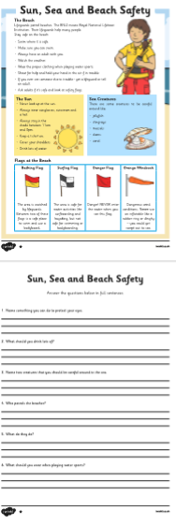  Task 2  Spellings – complete your weekly spellings. Sheets are attached on the website.  Group 1  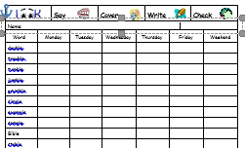  Group 2  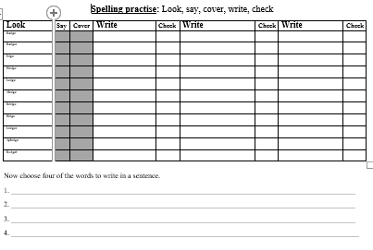  Read the story Tiddler again.  https://www.youtube.com/watch?v=qcTQADUywZY  Read the story with your child and discuss who is in the story and what are they doing. Look at the pictures. Recall the sea creatures.  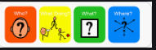  Retell the story in the correct order. What happens at the beginning of the story? What happens in the middle? What happens at the end?  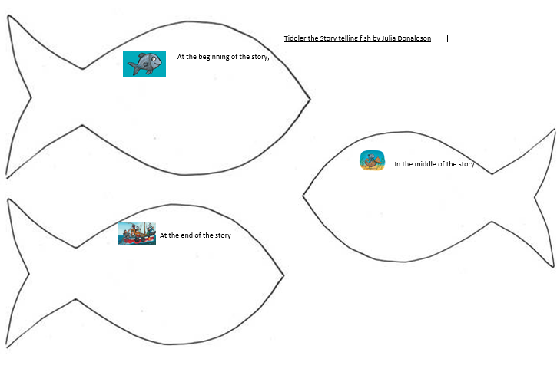  Welsh  Beth sy ar lan y mor (What is on the beach?)  Look at the picture and repeat the words.  Write sentences of what you see at the beach.  Beth welaist ti? What did you see?  Gwelais i ...  I saw ... | Mathematics  Continue to work on your times tables. You can log into Hwb and practice on J2blast. Log into Hwb with your account details which I sent home in their file. Go to and then click on the J2blast. You can practice your tables and spellings using this program.    Multiplication  Data  List and tables. We will be using the online platform ‘My Maths’. I have set the children homework online. They will need to log into ‘My Maths’ using their code.  Task 2  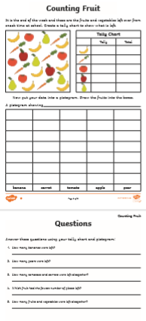 | Creative skills.  Creative skills.  Design your own ice-cream. What flavour would you have?  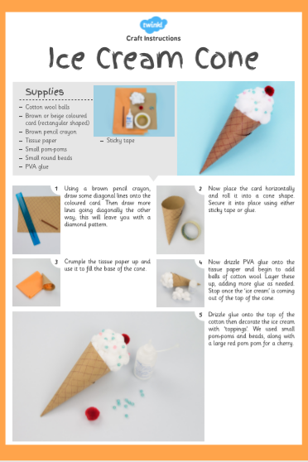 | Seaside past, present and both.  Watch the PowerPoint which is attached to the website. Look at the pictures and draw and write objects in the correct section.  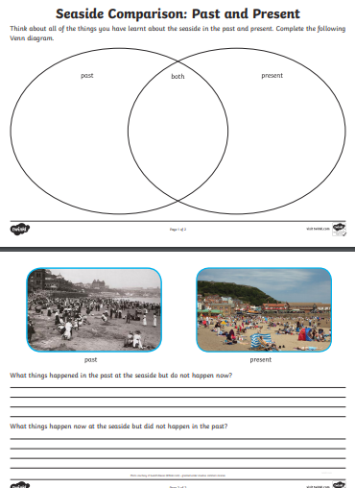 |  | Health and Well being challenge  Join in with Joe Wicks PE 30 min a day via YouTube live every morning at 9am (Mon-Fri). Alternatively, go on a 30 min walk everyday but stay safe.  Cosmic Kids Yoga –Under the Sea  Watch and carry out the cosmic kid’s yoga.  https://www.youtube.com/watch?v=YR1OxBk8BF4&list=PL8snGkhBF7nj7RIos7wF90k4wwUacnSow  Dangers in the sea.  Look at the picture and discuss the dangers in the sea. Why are they dangerous? Circle all the dangers.  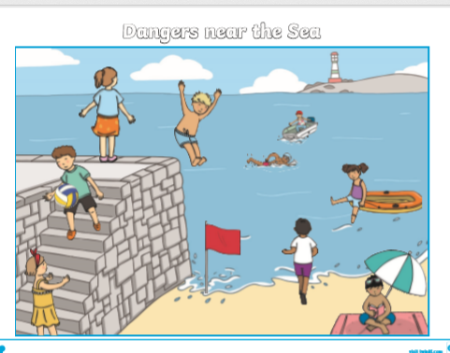  Watch the PowerPoint and design a safety poster for the beach.  

