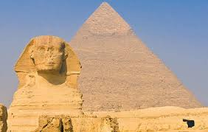
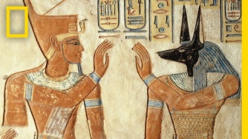
Pharaohs Homework
Over the next half term year 4 & 5 will be learning about the pharaohs and ancient Egypt. In the grid below you will find many interesting activities for you to complete at home. Choose one activity each week to complete in your homework book. Your book will need to be returned to school every Friday for the class reflection time where homework will be displayed and shared with class peers.
ICT/Art/DT  Create top trump cards using Ancient Egyptian Gods and Goddesses. | Geography  Mark Egypt and its major landmarks on a world map. Include cities, rivers and oceans. | DT  Make a 3D model of a typical home during Ancient Egyptian times. | Numeracy  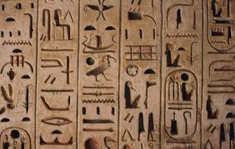  Write some maths questions or word problems to solve using Egyptian number symbols.
Art/DT *  Research and make an Ancient Egyptian game e.g. Senet. | Literacy/Geography  Research the importance of the River Nile and how it was used.  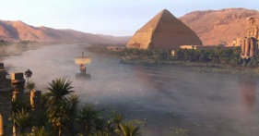 | Literacy/ICT  Research the 7 wonders of the Ancient World. You could create a brochure or leaflet to present your information. | Literacy  Find out some interesting facts about Ancient Egypt and create a multiple choice quiz. You could challenge your family and friends to answer them.
Literacy  Write an acrostic poem using the letters of a key ‘topic’ word e.g. Egypt | Art  Create your own Egyptian style portrait with your name in hieroglyphs | PSHCE/History/Literacy  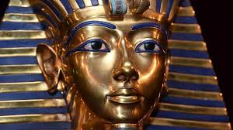  Write 10 questions that you would ask Tutankhamun. | Design your own homework task relating to the topic and present in your own method.

