  Date: |  |  |  | Theme: STF2 Week:- 29.6.2020  Year group: Group 2
Literacy      This Photo by Unknown Author is licensed under CC BY-NC-ND   | Numeracy     | Creative     | Thinking     |  | Healthy me    
Task 1 (For pupils who go to an RWI group)  RWI  Practice your daily sound book, click on the link below.  https://www.oxfordowl.co.uk/api/interactives/29317.html  Task 1 (Comprehension group)  Read the text and answer the questions. Attached to the webpage.  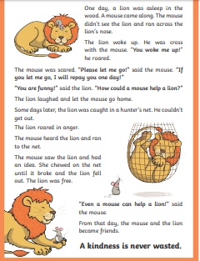  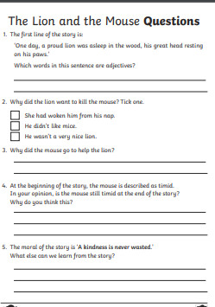  Task 2  Spellings – complete your weekly spellings. Sheets are attached on the website.  Group 1  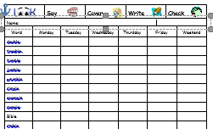  Group 2  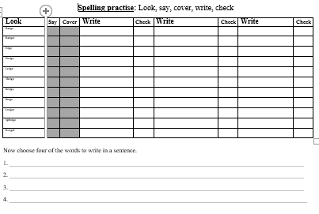  Welsh  Write a list of things you would take to the beach in Welsh in your home learning books. Use the flashcards to help you. | Mathematics  Continue to work on your times tables. You can log into Hwb and practice on J2blast. Log into Hwb with your account details which I sent home in their file. Go to and then click on the J2blast. You can practice your tables and spellings using this program.    Multiplication  Data  Watch the data presentation and talk about the graphs. (on website) What do they tell you? What information can you gather from the graphs?  Task 1  Look at the graph below and answer the questions.  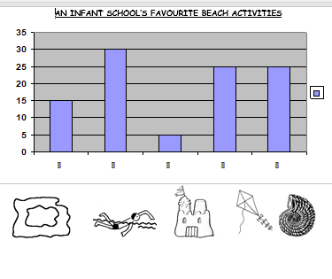  Task 2  Use the data and create your own graph.  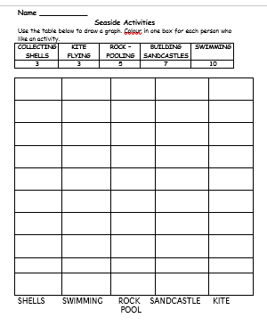 | Creative skills.  Create your own underwater scene for Tiddler. Send me pictures of your scene for our display.  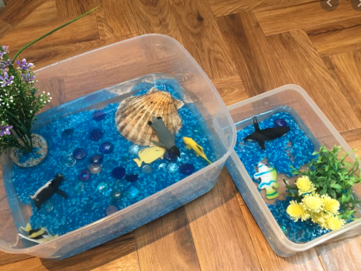  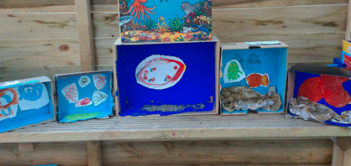 | Today we are going to listen to the story called ‘Tiddler’.  https://www.youtube.com/watch?v=qcTQADUywZY  Read the story with your child and discuss who is in the story and what are they doing. Look at the pictures. Recall the sea creatures.  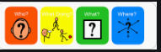  Think of creatures that live in the ocean and animals that live on land. Draw and write as many animals as you can think of. Create a table in your home learning books. See if you can find some unusual creatures.  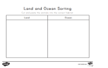 |  | Health and Well being challenge  Join in with Joe Wicks PE 30 min a day via YouTube live every morning at 9am (Mon-Fri). Alternatively, go on a 30 min walk everyday but stay safe.  Cosmic Kids Yoga –Under the Sea  Watch and carry out the cosmic kid’s yoga.  https://www.youtube.com/watch?v=YR1OxBk8BF4&list=PL8snGkhBF7nj7RIos7wF90k4wwUacnSow  All about me.  Draw your own rainbow in your home learning books and use adjectives to describe yourself. Colour in the rainbow. Write some sentences in your books to describe yourself using adjectives.  

