  15/03/2022 |  |  |  | Theme: Pharaohs  Year group: Year 4/5
Literacy     | Numeracy  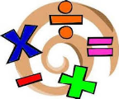   | Creative     | Thinking     |  | Healthy me    
The Egyptian pyramids  Watch the following short animation  The Egyptian Pyramids  Imagine you were the explorer. Create a diary entry explaining the happenings and events of that day.  Consider your emotions, feelings and surroundings.  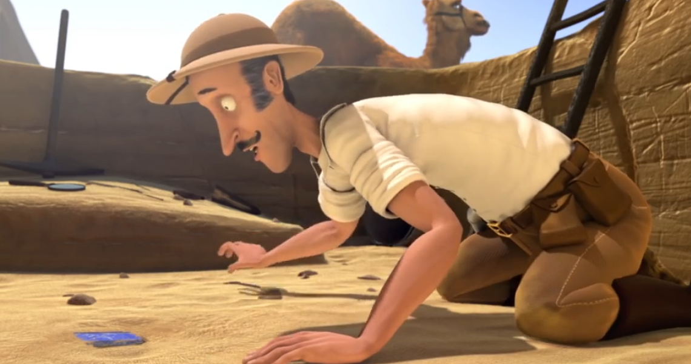  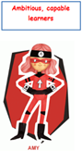 | Area and perimeter  Use your prior knowledge that you have gained during lockdown to calculate the area and perimeter of different Egyptian tombs.  Use the following resources to help, if you are stuck with the concepts.  Perimeter - What is the perimeter?  Area - Calculating Area | Egyptian Flat Bread  Most ancient Egyptian food was cooked out in the open in a courtyard or on the rooftop.  Ordinary people rarely ate meat as it was expensive to raise animals for meat. Ordinary people ate mostly grains and vegetables as well as fish and fowl that they caught.  A staple food was Flat Bread.  Follow the method to create traditional ancient Egyptian Flat Breads.  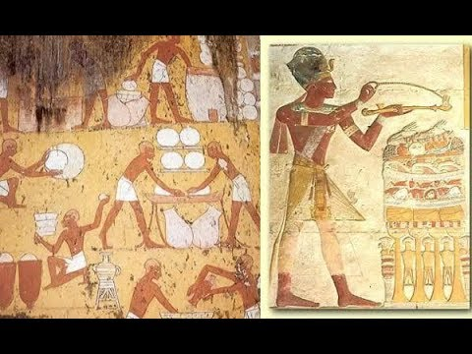  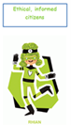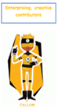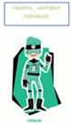 | Ancient Egyptian Timeline  Arrange key events from ancient Egypt in chronological order.  Remember higher the BC dates, the longer ago the event happened, because we are saying it was x amount of years Before Christ.  Also AD means Anno Domini and refers to times after Christ was born  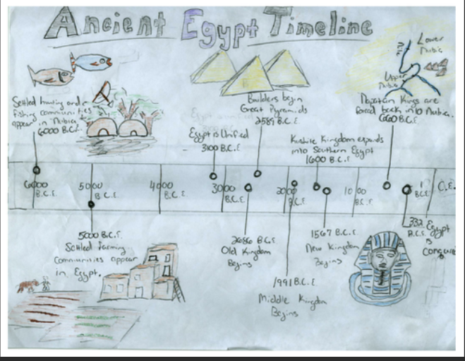 |  | Respect  This month’s value is Respect.  Watch the following video based on respect.  Mutual respect  Write a short paragraph why you believe it is important to be respectful in and outside of school.  Once you are happy with your paragraph, use the following Flipgrid join code to record your response.  https://flipgrid.com/a6c68806  

