
Week 1
Literacy:- Write a set of instructions on how to build a beanstalk.
RWI – Daily word building. Give your child a word and ask them to build the word.
Maths:- Look at TIME. Try both analogue time and digital time. Look at half past the hour, quarter to the hour and quarter past the hour. Practise the 2, 5 and 10 x tables. If your child is ready move them onto the 3 X tables.
Number work – Addition and subtraction sums. 20+ 42 =
Lots of maths games on this website - https://www.topmarks.co.uk/maths-games/5-7-years/counting
Ideas:- Use an Analogue clock and ask the pupil to move the hands to the correct position of half past, quarter past and quarter to. Show them a digital clock. Practise writing the times.
Analogue time Digital Time
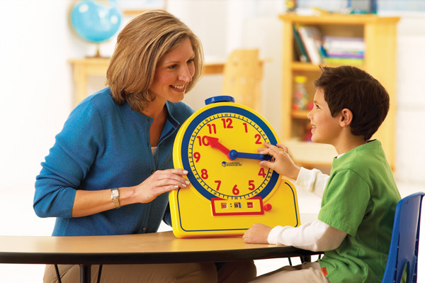
Example of Instructional writing
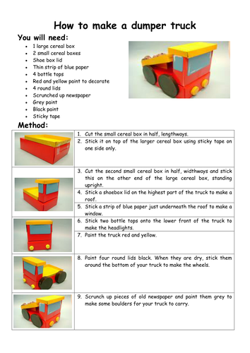

Challenges
Week 1

Build a beanstalk using a range of junk material. Once finished measure the beanstalk using standard units (CM, M) but if not possible use non-standard units.
Ideas to measure


