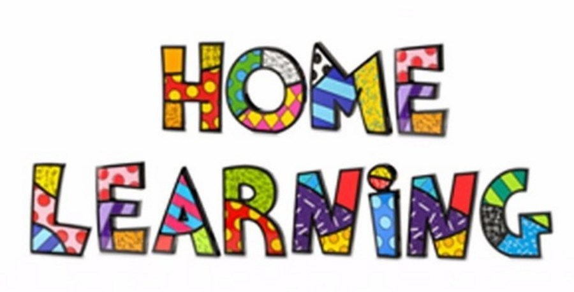
Week 9 – 01.6.2020
Literacy: - Reading
Listen to the story ‘Owl Babies’’. You can find the story on the link below
https://vimeo.com/55971653
https://youtu.be/9U9y35kWBvM
Using the colourful semantic cards, discuss who is in the story, what they are doing and where. Show pupils 5 pictures in the story and get them to write sentences to match the pictures.

Task 2 – Sequence the story
Sequence the story in the correct order. Use the pictures to help you. Write sentences under each of the pictures.

Task 3 (For pupils who go to an RWI group)
RWI
Practice your daily sound book, click on the link below.
https://www.oxfordowl.co.uk/api/interactives/29317.html
Task 4 (Comprehension group)
Read the text and answer the questions. Attached to the webpage.
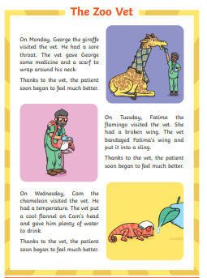

Mathematics
Continue to work on your times tables. You can log into Hwb and practice on J2blast. Log into Hwb with your account details which I sent home in their file. Go to and then click on the J2blast. You can practice your tables and spellings using this program.

Division (Sharing)
Introduce the symbol for division

Watch the video on YouTube and answer the questions.
https://www.youtube.com/watch?time_continue=182&v=fXf4KdfNhF0&feature=emb_logo
.
Task 1
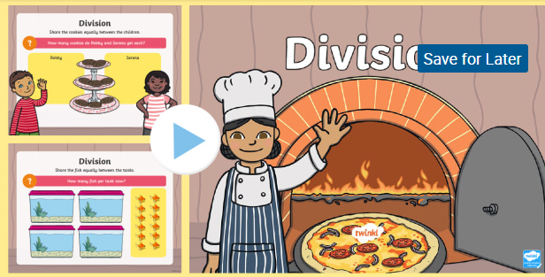
Watch the PowerPoint and share the items equally. Practise writing the number sentence for each pictures.
Task 2
Complete the worksheet. You can write number sentences.
12 2 =
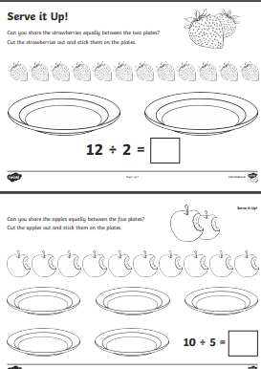

Task 3
Play Hit the Button. Choose the Division Facts and select an appropriate level.
https://www.topmarks.co.uk/maths-games/hit-the-button
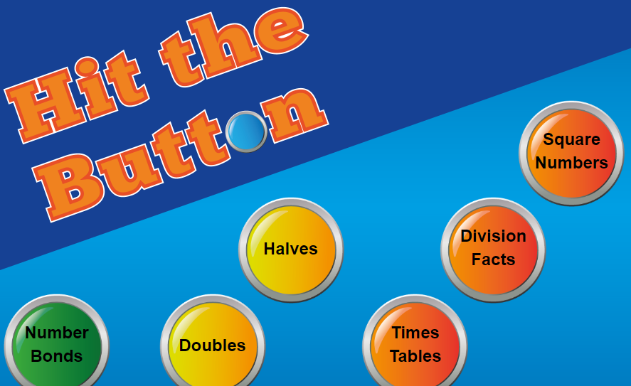

Weekly Maths:- (IEP) Look at missing numbers in a sum ( see below). Please continue to work on this weekly.
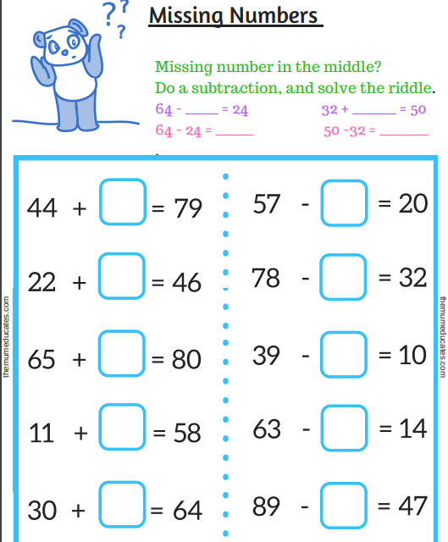

Continue with the addition and subtraction booklets for the pupils on the webpage.
Challenges
Week 9
Challenge 1
Environmental art. Go outside and use materials in the garden to make your own owls. Send me pictures on Dojo.
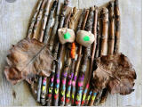

Challenge 2 – Owl toast
Have fun making owl toast. Listen to your parents and follow the instructions.
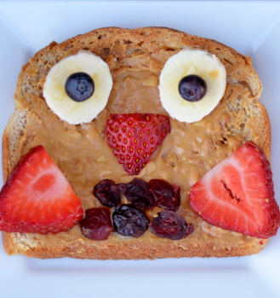

Challenge 3
Day and night animals
Watch the PowerPoint and sort the animals into day and night. Answer the questions on Nocturnal and Diurnal animals. You can use the term day and night time animals.
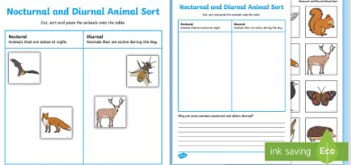
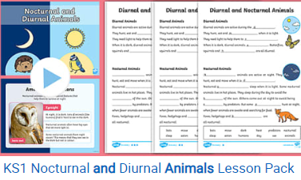
Challenge 4
Memory games
- Play ‘Kim’s game’. Put a few items on a tray (for example, a crayon, an apple, a building brick, a toy car). Then look, cover, remember and check!
- Talk about, photograph or write out some ‘events’ from something you have done together – can your child remember the correct order?
- Go shopping – try to remember the list together!

P.E. Challenge:
Join in with Joe Wicks PE 30 min a day via YouTube live every morning at 9am (Mon-Fri). On the other hand, go on a 30 min walk everyday but stay safe.

Challenge 6
Numeracy Challenge
Play games on the following websites, particularly working in number skills such as place value, addition and subtraction
www.topmarks.co.uk ,
www.snappymaths.com
https://www.bbc.co.uk/bitesize/subjects/z826n39

