  1 |  |  |  | Theme: Pharaohs  Year group: Year 4/5 PPA Mrs Watts
Literacy     | Numeracy  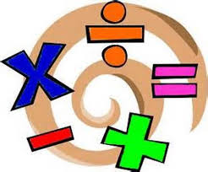   | Creative     | Thinking     |  | Healthy me    
PSE: Red Nose Day 2021
I know how toovercome challenges.
Watch Ethan’s story:
https://youtu.be/hAKvelOllts
Discuss:
1). The challenges that Ethan has had to overcome in his life. 2). The difficulties he has experienced with walking and
communicating.
3). What challenges does he
face on a daily basis?
4). What qualities have
helped him to overcome these?
Look at the resource, The Note’.
Then, complete the resource, ‘Barriers’.
Create a poster of your goals and how to achieve them.
Include:
- A heading.
- Your goal – it can be anything.
- How you will achieve it?
- Qualities you need to overcome barriers and achieve your goal, e.g. perseverance.

P.E: Gymnastic skills
This term, you have been learning to move in different ways and improving your gymnastic skills. This week, you will learn some more movements.
Click on the link:
Gymnastics - Day 1 - KS2 on Vimeo
And follow the lesson.
Record your 4 movements (at the end of the lesson) using Flipgrid:

https://flipgrid.com/4c2cddf7

If you have any questions/problems, email me:
Wattss11@hwbmail.net
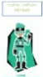
Or, message me on Class Dojo, or Teams.

