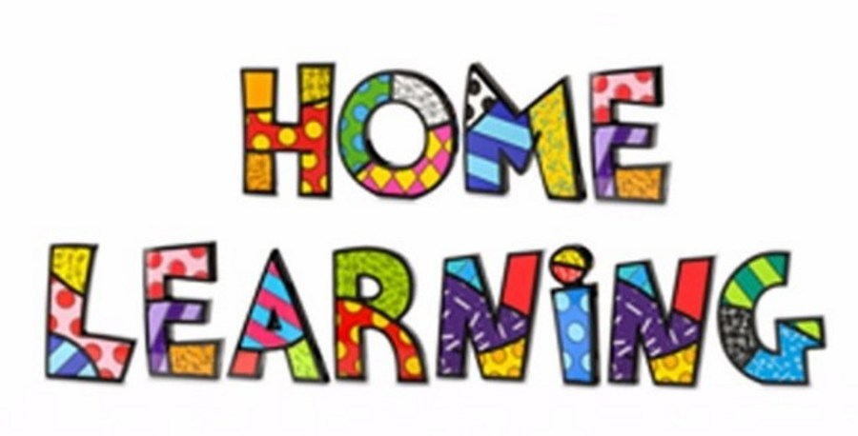
Week 10 – 08.6.2020

Task 1 (For pupils who go to an RWI group)
RWI
Practice your daily sound book, click on the link below.
https://www.oxfordowl.co.uk/api/interactives/29317.html
Task 1 (Comprehension group)
Read the text and answer the questions. Attached to the webpage.
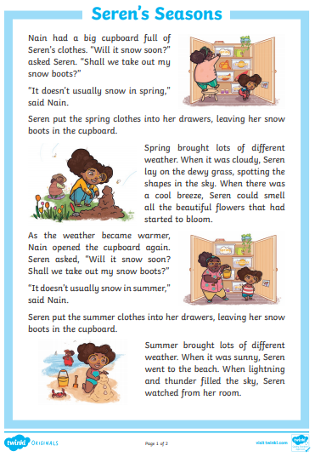
Task 2
Spellings – complete your weekly spellings. Sheets are attached on the website.
Level 1
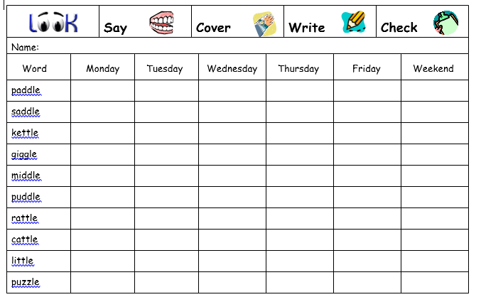

Level 2
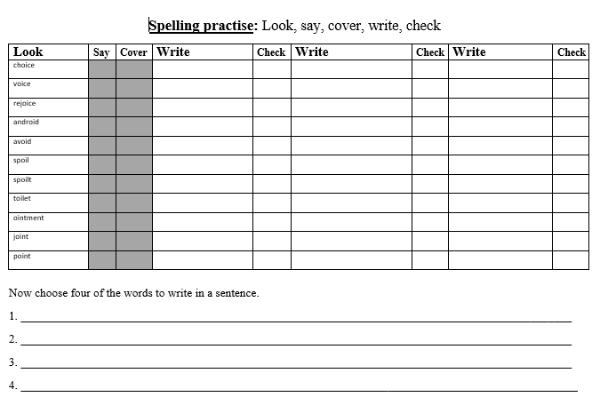
Mathematics
Continue to work on your times tables. You can log into Hwb and practice on J2blast. Log into Hwb with your account details which I sent home in their file. Go to and then click on the J2blast. You can practice your tables and spellings using this program.

Division (Sharing)
Continue learning about division this week.

Watch the video on YouTube and answer the questions.
https://www.youtube.com/watch?time_continue=182&v=fXf4KdfNhF0&feature=emb_logo
.
Task 1
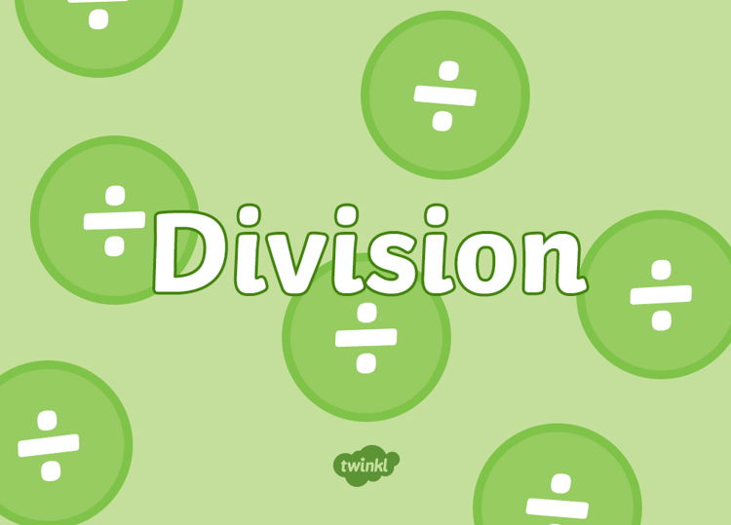
Watch the PowerPoint and share the items equally. Practise writing the number sentence for each pictures.
Task 2
Complete the worksheet.
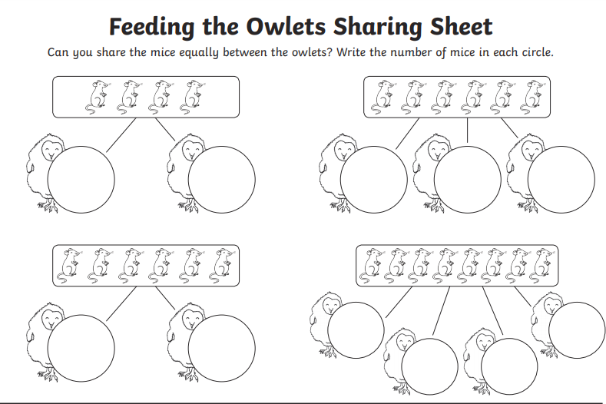

Write your own number sentences for the children:-
24 4 =

Task 3
Play Hit the Button. Choose the Division Facts and select an appropriate level.
https://www.topmarks.co.uk/maths-games/hit-the-button
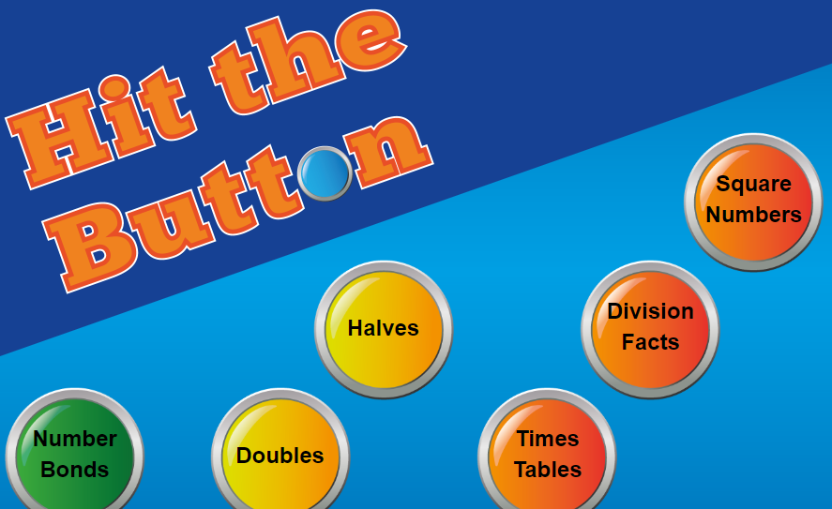

Weekly Maths:- (IEP) Look at missing numbers in a sum ( see below). Please continue to work on this weekly.
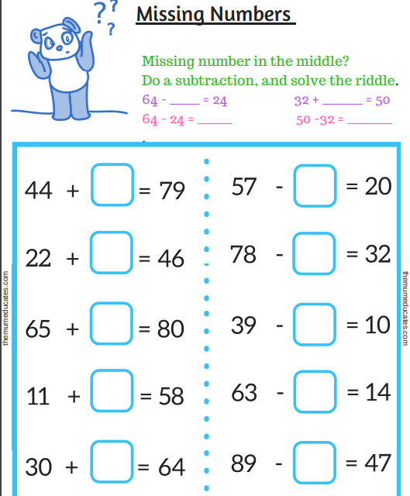

Continue with the addition and subtraction booklets for the pupils on the webpage.
Challenges
Thinking Challenges
Our new topic for this half term is the Seaside. What do you know about the seaside? Draw pictures and write words around the image of the seaside of everything you can name and think of.

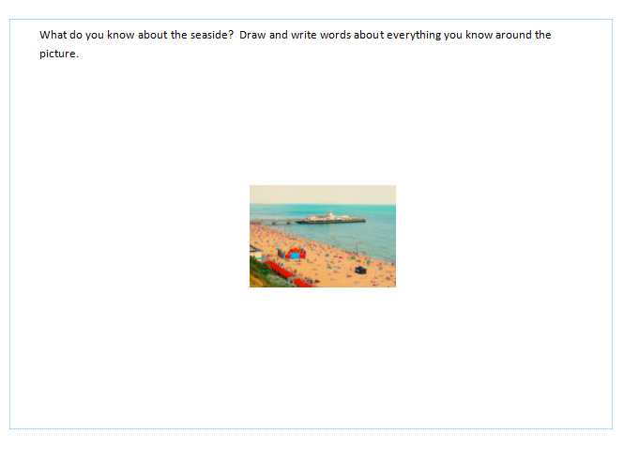

Creative Challenge
Create a seaside scene using different mediums. You can use a range of materials including sand, shiny paper.
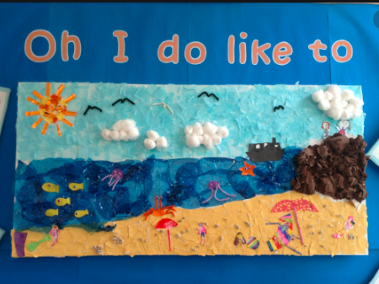

Thinking challenges
Memory games
- Play ‘Kim’s game’. Put a few items on a tray (for example, a crayon, an apple, a building brick, a toy car). Then look, cover, remember and check!
- Talk about, photograph or write out some ‘events’ from something you have done together – can your child remember the correct order?
- Go shopping – try to remember the list together!

P.E. Challenges:
Join in with Joe Wicks PE 30 min a day via YouTube live every morning at 9am (Mon-Fri). On the other hand, go on a 30 min walk everyday but stay safe.

Numeracy Challenges
Play games on the following websites, particularly working in number skills such as place value, addition and subtraction
www.topmarks.co.uk ,
www.snappymaths.com
https://www.bbc.co.uk/bitesize/subjects/z826n39

Division Challenge cards. On website.


