  Date: |  |  |  | Theme: Seaside STF2 Week:- 13.7.2020  Year group: Group 2
Literacy      This Photo by Unknown Author is licensed under CC BY-NC-ND   | Numeracy     | Creative     | Thinking     |  | Healthy me    
Task 1 (For pupils who go to an RWI group)  RWI  Practice your daily sound book, click on the link below.  https://www.oxfordowl.co.uk/api/interactives/29317.html  Task 1 (Comprehension group)  Read the text and answer the questions. Attached to the webpage.  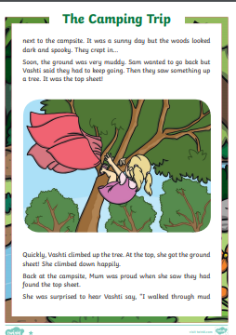  Task 2  Spellings – complete your weekly spellings. Sheets are attached on the website.  Group 1  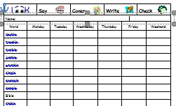  Group 2  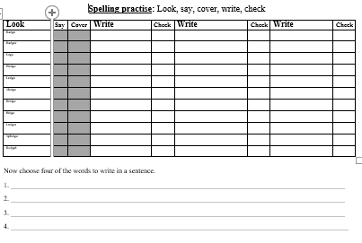  Task 3  Watch/read the PowerPoint on sharks. Write a fact file on sharks. You can carry out your own research.  Task 4  Write about your favourite sea creatures. Tell me what you like about it and draw me a picture. I would like to learn many interesting facts about your sea creature.    Rising stars  Don’t forget to read your book and answer the quiz | Mathematics  Continue to work on your times tables. You can log into Hwb and practice on J2blast. Log into Hwb with your account details which I sent home in their file. Go to and then click on the J2blast. You can practice your tables and spellings using this program.    Multiplication  Fractions  Fractions. We will be using the online platform ‘My Maths’. I have set the children homework online. They will need to log into ‘My Maths’ using their code. Pupils will be learning to find half and quarters of shapes and numbers. Shaded in shapes by reading the fraction.  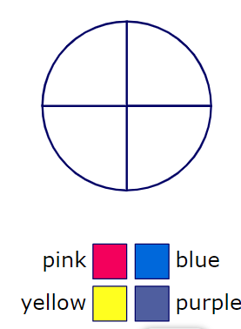  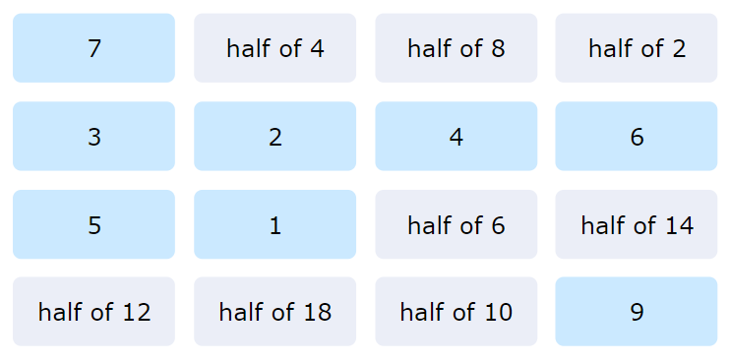  I have also attached some relevant worksheets link to fractions.  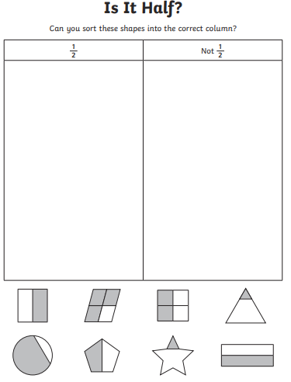 | Creative skills.  Using junk material, make a sea creature. It can be a real creature or one you have made up. Have fun!  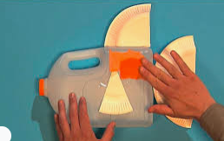  Design and make your own lolly.  Use a plastic cup. Send me a picture of your lolly.   | Floating and sinking  Find objects around the house and make a prediction, do you think they will float or sink?  Test your objects and record your results.  Draw a table in your home learning books and record your results. |  | Health and Well being challenge  Join in with Joe Wicks PE 30 min a day via YouTube live every morning at 9am (Mon-Fri). Alternatively, go on a 30 min walk everyday but stay safe.  Cosmic Kids Yoga –Under the Sea  Watch and carry out the cosmic kid’s yoga.  https://www.youtube.com/watch?v=YR1OxBk8BF4&list=PL8snGkhBF7nj7RIos7wF90k4wwUacnSow

