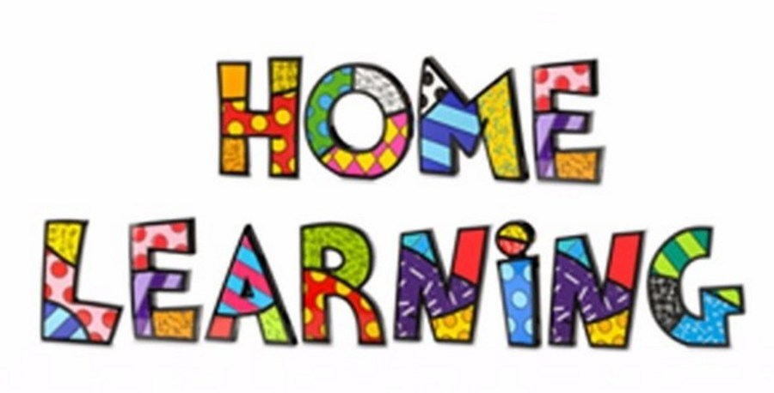
Week 6 – 4.5.2020
Literacy:- Continue to read ‘Peace at last’. You can find the story on YouTube.
https://youtu.be/9U9y35kWBvM
Using the colourful semantic cards, discuss who is in the story. Can the pupils name the characters in the story? Ask the pupils questions about the story? What is making the noise? Who is snoring? Referring back to the colourful semantic strip.

Task 2
Comprehension.
Read the questions to the pupils and get the pupils to tick the correct box. Pupils can write a sentence to each of the question. Remember your capital letters and full stops.
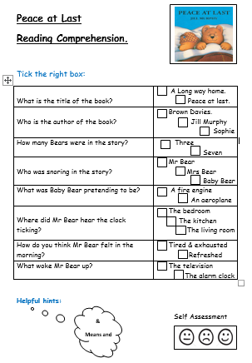

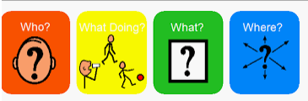
Task 3 – Dreaming
Write about the dream that Mrs Bear might have while she is sleeping.
Talk about dreams. What do they dream of at night-time? Think about what Mrs Bear might have been dreaming about.
Draw a picture of Mrs Bear dreaming and write about her dream.

Mathematics
Continue to work on your times tables. You can log into Hwb and practice on J2blast. Log into Hwb with your account details which I sent home in their file. Go to and then click on the J2blast. You can practice your tables and spellings using this program.
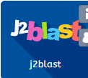
Time
Use the interactive clock to tell the time. Remind the children that the long hand is the minute hand and the short hand is the hour hand.
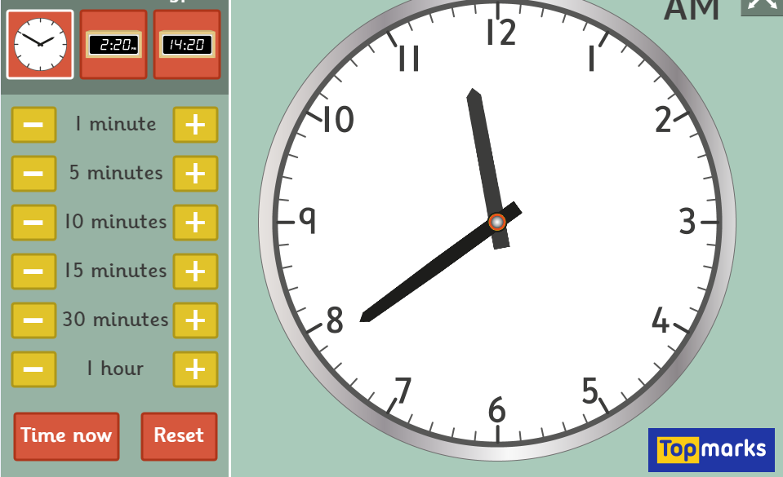
https://www.topmarks.co.uk/time/teaching-clock
Task 1
Make your own clock. Ask the children to make the time 10 o’clock, half past 2 etc. The template is on the webpage.
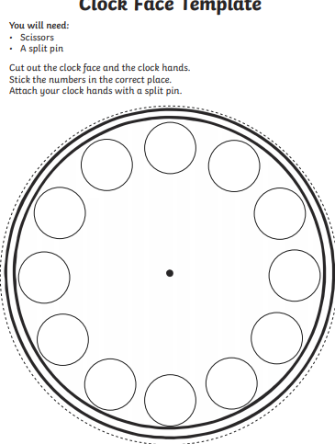
Task 2
Complete the time worksheets. They are on the webpage.
Task 3
Play the interactive game. You can set it at different levels; this will help the children practice telling the time.
https://mathsframe.co.uk/en/resources/resource/116/telling-the-time
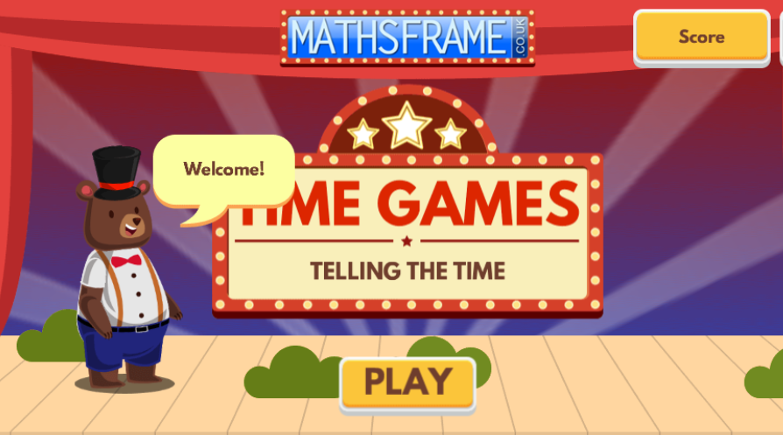
Weekly Maths:- Look at missing numbers in a sum ( see below). Please continue to work on this weekly.
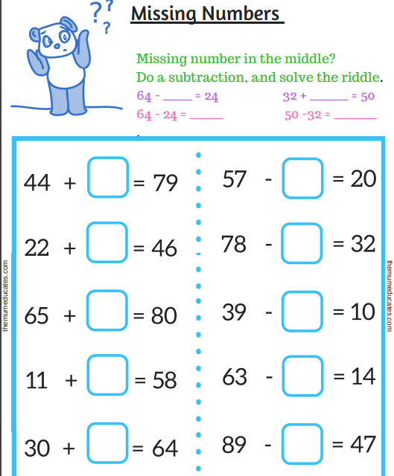

I have attached addition and subtraction booklets for the pupils on the webpage.

VE Day on Friday 8th May
Look at the PowerPoints and discuss key points.
Design and make a medal for a war hero. You can draw it or make it out of playdough. It can be any shape or size.
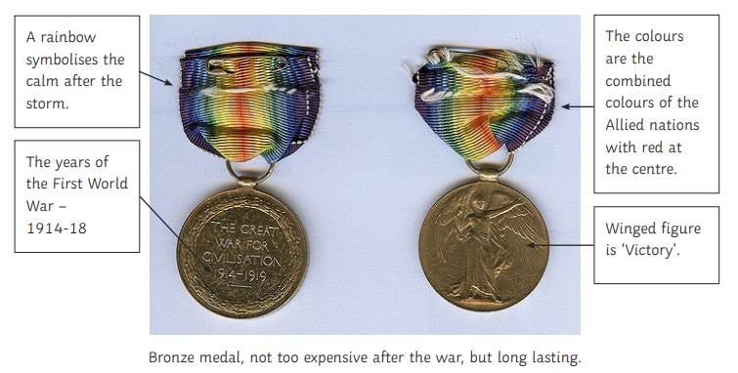

Colour in and make your flag of the United Kingdom to wave around on VE Day.


Challenges
Week 6
Challenge 1 – Light sources


Go around your home and find different sources of light. Draw pictures of the light sources and write what they are.

Challenge 2
Look out the window during the night and talk about what you can see. Create a night-time picture using different materials.

Challenge 2
Make a moveable bear. You can draw your own or use the template on the page.
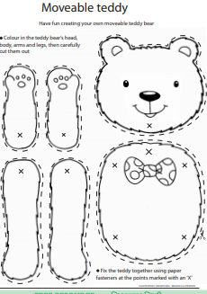

Challenge 4
P.E. Challenge:
Join in with Joe Wicks PE 30 min a day via YouTube live every morning at 9am (Mon-Fri). On the other hand, go on a 30 min walk everyday but stay safe.

Challenge 5
Numeracy Challenge
Play games on the following websites, particularly working in number skills such as place value, addition and subtraction
www.topmarks.co.uk ,
www.snappymaths.com
https://www.bbc.co.uk/bitesize/subjects/z826n39

