  Date: 22.6.2020 |  |  |  | Theme: STF2  Year group: Group 2
Literacy      This Photo by Unknown Author is licensed under CC BY-NC-ND   | Numeracy     | Creative     | Thinking     |  | Healthy me    
Task 1 (For pupils who go to an RWI group)  RWI  Practice your daily sound book, click on the link below.  https://www.oxfordowl.co.uk/api/interactives/29317.html  Task 1 (Comprehension group)  Read the text and answer the questions. Attached to the webpage.  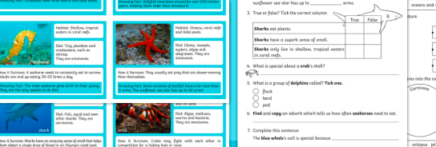  Task 2  Spellings – complete your weekly spellings. Sheets are attached on the website.  Group 1  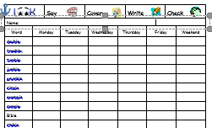  Group 2  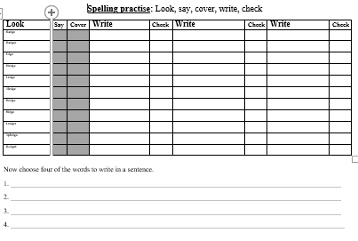 | Mathematics  Continue to work on your times tables. You can log into Hwb and practice on J2blast. Log into Hwb with your account details which I sent home in their file. Go to and then click on the J2blast. You can practice your tables and spellings using this program.    Multiplication  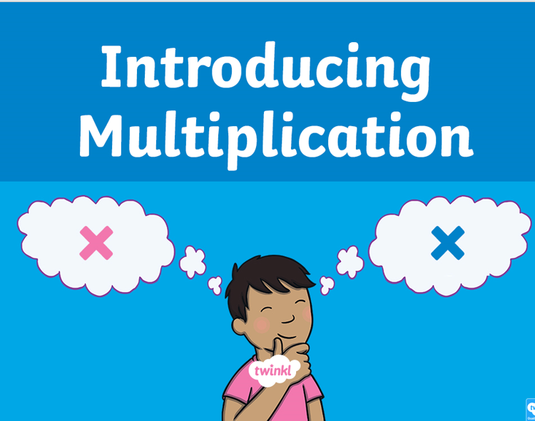  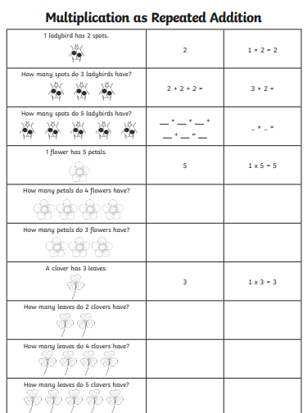  Higher level  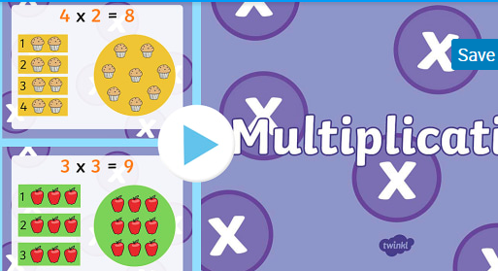  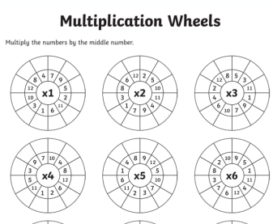  Numeracy Challenges  Play games on the following websites, particularly working in number skills such as place value, addition and subtraction  www.topmarks.co.uk ,  www.snappymaths.com  https://www.bbc.co.uk/bitesize/subjects/z826n39 | Creative skills.  Create your own crab.  Create your own Crab using your creative skills. Below are just a few ideas! You can think of your own. I look forward to seeing your pictures.  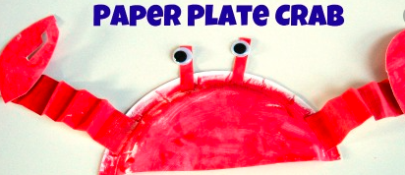  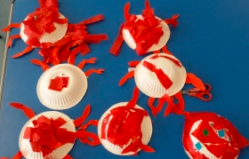 | Sea Creature Fact files.  Today we are going to find out about crabs.  Listen to the story the clumsy crab.  https://www.youtube.com/watch?v=Uy6uf1XXJaE  Read the story with your child and discuss who is in the story and what are they doing, what is in the story and where are they.  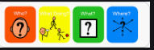  Choose 3 pages in the story and write interesting sentences using the colourful semantic strip. Remember your punctuation.  Learn how to sign crab.  https://www.youtube.com/watch?v=kW9OZwgQpWA  Information text  Draw an image of a crab and label it parts of the body. There are many different pictures on the internet. Use books and the internet to find facts about a crab.. Find out where it lives, what does it eat? You could even find out about its lifecycle. I have attached a template as an example. This work can go into our class book. You can even do your work using your ICT skills. |  | Health and Well being challenge  Join in with Joe Wicks PE 30 min a day via YouTube live every morning at 9am (Mon-Fri). Alternatively, go on a 30 min walk everyday but stay safe.  Cosmic Kids Yoga –Under the Sea  Watch and carry out the cosmic kid’s yoga.  https://www.youtube.com/watch?v=qC83oFEeVZA

