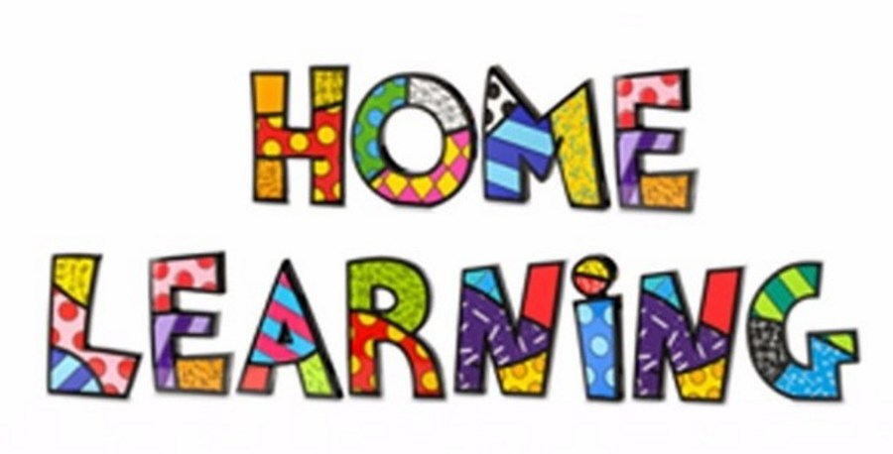
Week 7 – 11.5.2020
Literacy: - Continue to read ‘Peace at last’. You can find the story on YouTube.
https://youtu.be/9U9y35kWBvM
Using the colourful semantic cards, discuss who is in the story. Can the pupils name the characters in the story? Ask the pupils questions about the story? What is making the noise? Who is snoring? Referring back to the colourful semantic strip. Pupils to answer questions verbally in full sentences. For example, Mrs Bear is snoring in bed in the bedroom.

Task 2
Activity booklet
Complete the activities in the booklet. There are a range of activities, for example, matching the words, adjectives, describing the characters and colouring in the nouns.

Task 3 – Instructions
Mr Bear eats a sandwich in the middle of the night. Write a set of instructions to teach someone how to make their own delicious sandwich. Make your own sandwich.

Task 4 (For pupils who go to a RWI group)
RWI
Practice your daily sound book, click on the link below.
https://www.oxfordowl.co.uk/api/interactives/29317.html
Task 4 (Comprehension group)
Read the text and answer the questions. Attached to the webpage.
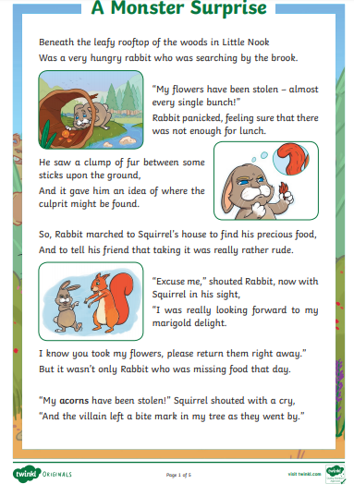
Mathematics
Continue to work on your times tables. You can log into Hwb and practice on J2blast. Log into Hwb with your account details which I sent home in their file. Go to and then click on the J2blast. You can practice your tables and spellings using this program.

Measurement
Use the PowerPoint to introduce how to use a ruler. The children have used rulers before.
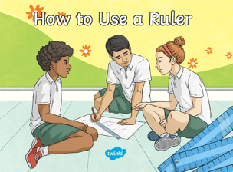
Use the second PowerPoint (Measuring in cm) to get the children to practice measuring. PowerPoints are on the webpage.
Task 1
Find objects around the house and measure them using a ruler. Draw a picture and write the measurement.
Task 2
Estimation – Find objects and estimate (guess the length). Once you have estimated, measure to see if you were correct.
Task 3
Play the interactive game. You can set it at different levels; this will help the children practice their measuring skills.
https://www.topmarks.co.uk/maths-games/measuring-in-cm
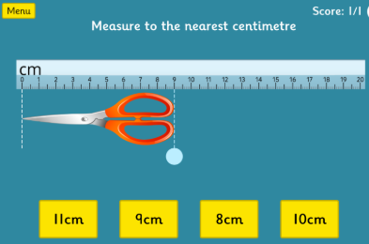

Weekly Maths:- (IEP) Look at missing numbers in a sum ( see below). Please continue to work on this weekly.
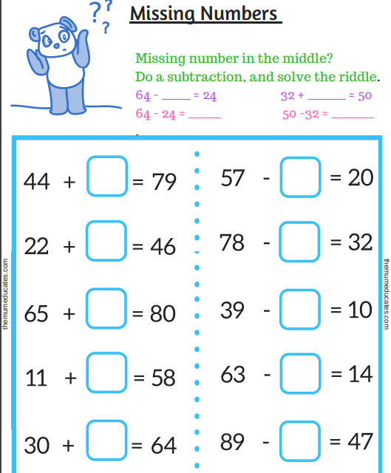

Continue with the addition and subtraction booklets for the pupils on the webpage.

Challenges
Week 7
Challenge 1
Watch the PowerPoint attached to the webpage. Think about when we wear our pyjamas, or when we eat breakfast. Sort the pictures into the night and day.

Challenge 2 – Light sources


Look at the PowerPoint, sources of light.
Using the pictures, sort the pictures into sources of light and not sources of light.

Challenge 3
Make teddy bear toast using fruit.
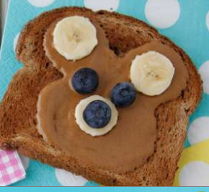
Write the instructions to make the toast.

Challenge 4
The moon is shown in a number of the illustrations. Use a book about space or the internet to find out about the moon and create your own image of the moon

Challenge 5
P.E. Challenge:
Join in with Joe Wicks PE 30 min a day via YouTube live every morning at 9am (Mon-Fri). On the other hand, go on a 30 min walk everyday but stay safe.

Challenge 6
Numeracy Challenge
Play games on the following websites, particularly working in number skills such as place value, addition and subtraction
www.topmarks.co.uk ,
www.snappymaths.com
https://www.bbc.co.uk/bitesize/subjects/z826n39

