
Easter Holidays - Week 3/4
Literacy:- We have been reading Jim and the Beanstalk. I want you to read Jack and the Beanstalk. There are many versions online or if you have the book home, that is great!
Think about how the two stories are the same and how different.
Different Same Different
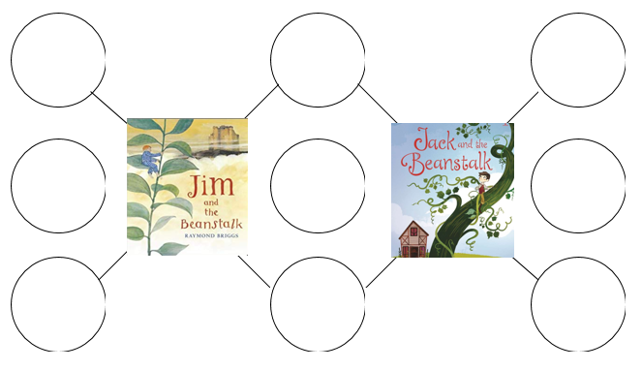
I have attached the sheet to the webpage. Alternatively, if you want to complete it on paper that is fine too.
Task 2
Use the colourful Semantic strip to write sentences about the story Jack and the Beanstalk.

Task 3 – Rhyming words
You can print out the words or write them down. Pupils need to read each word and match the words that rhyme. Put each word into a sentence.
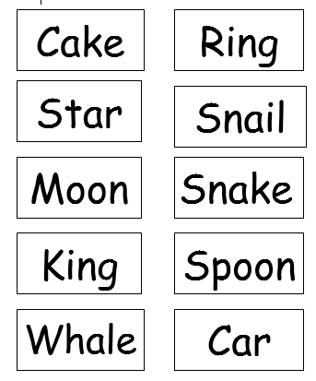

Mathematics
Continue to work on your times tables. You can log into Hwb and practice on J2blast. Log into Hwb with your account details which I sent home in their file. Go to and then click on the J2blast. You can practice your tables and spellings using this program.

Doubling numbers
Practising doubling numbers up to 10 and 20.
This is a good game for practising doubling - https://www.topmarks.co.uk/maths-games/hit-the-button
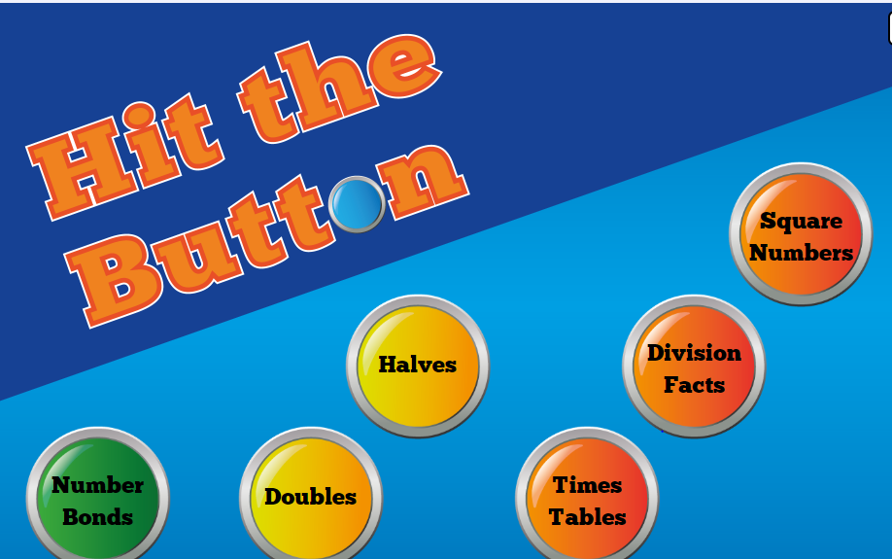
Maths:- Look at missing numbers in a sum ( see below). Please continue to work on this weekly.
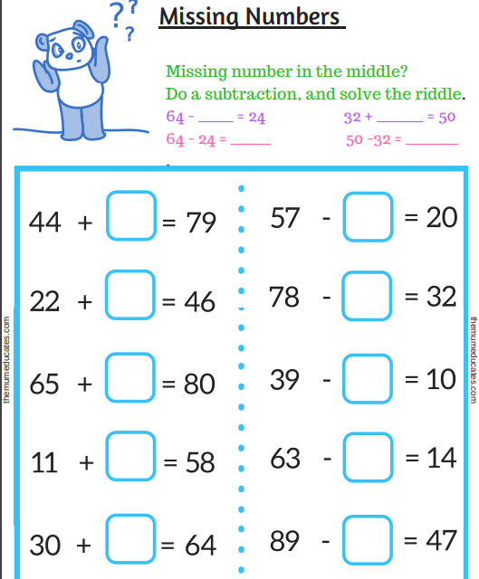

Problem solving
Dotty Toadstool – worksheet attached.
Try to find as many different ways to put the dots back on the toadstool.
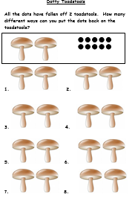
Measuring using standard units
Click on this link for measuring game - https://www.topmarks.co.uk/maths-games/7-11-years/measures
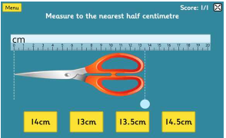
Measuring around your foot
Draw around your foot and use standard/non-standard units to measure.

Go into the garden and look around the house to find things that are longer and shorter than your foot. Measure the objects, you could use buttons/beads/pencils/cubes (non-standard) or standard units (CM) Record the answers, sort the objects into longer and shorter, and take a photograph.
Mathematical language to be use – longer than and shorter than, centimetres.

2D shapes
How many shapes do you know? Can you name them all? Go around your home and garden and find 2D shapes. Describe the shapes and write down their properties.
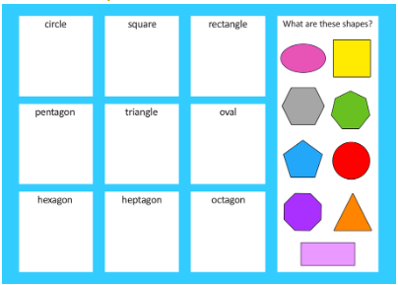

Easter Holiday Challenges
Design an Easter Egg – ICT
It would normally be the Easter holidays. I would like you to design your own Easter egg using either JIT/Paint.
Login to your HWB account (user name and password was sent home in file) and draw an egg. Think of the shape, colour and patterns.

First log in to Hwb and then select
Next choose

Finally choose the
this is where you can draw your egg.
Please remember to save your work and name it.

Or
First log in to Hwb and then select

Next choose


Finally choose the correct tools and create your picture.

Creative work
Get creative and make your own Easter bunny or chick. Below are just a few examples but you can create your own.


