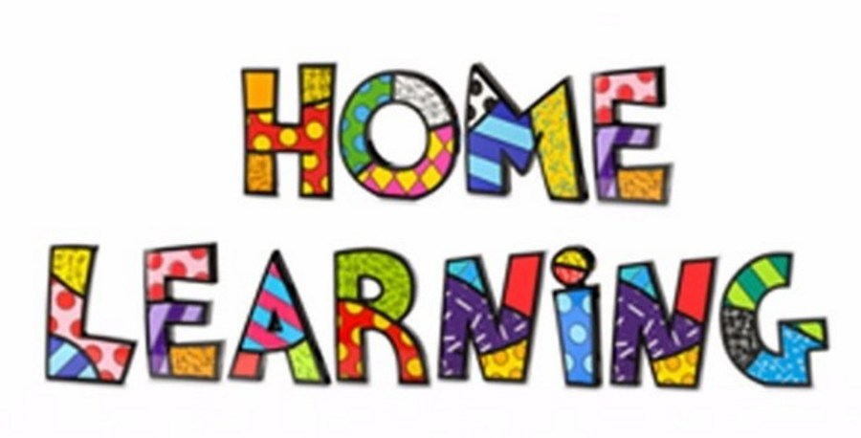
Week 5
Literacy:- Read ‘Peace at last’. You can find the story on YouTube.
https://www.youtube.com/watch?v=9U9y35kWBvM
Using the colourful semantic cards, discuss who is in the story. Can the pupils name the characters in the story? Pupils to point to the characters on request and repeat their names. Pupils to write a list of the characters that are in the story. Discuss what they are doing and where they are?

Task 2
Choose 3 pages in the story and write interesting sentences using the colourful semantic strip. Remember your punctuation.

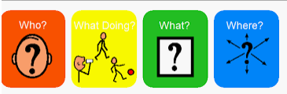
Task 3 – Rhyming words
We are going to continue with rhyming words this week. Click on the link below and learn more about words that rhyme.
https://www.bbc.co.uk/bitesize/topics/zjhhvcw/articles/zqjgrdm

Sort the words into the correct column.
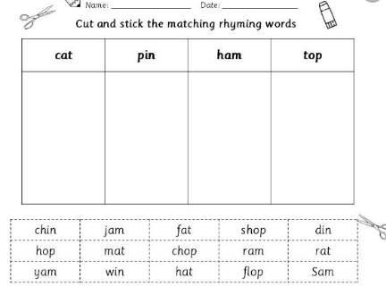

Mathematics
Continue to work on your times tables. You can log into Hwb and practice on J2blast. Log into Hwb with your account details which I sent home in their file. Go to and then click on the J2blast. You can practice your tables and spellings using this program.

Hundreds, tens and units
This game has different levels that you can play. Test your knowledge of hundreds, tens and units.
https://www.topmarks.co.uk/maths-games/5-7-years/place-value-odd-and-even
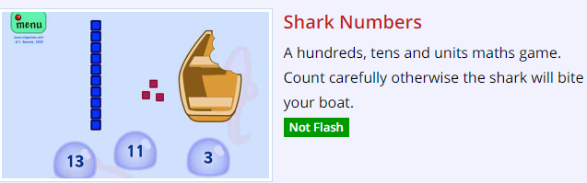

Write the value of the digit, which is underlined.
Set 1
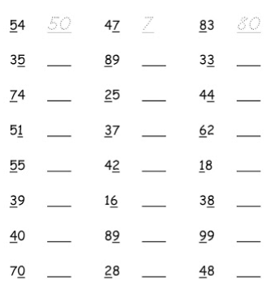

Set 2
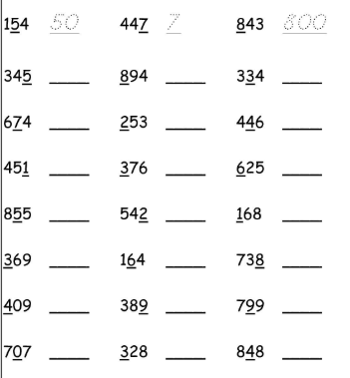
Weekly Maths:- Look at missing numbers in a sum ( see below). Please continue to work on this weekly.
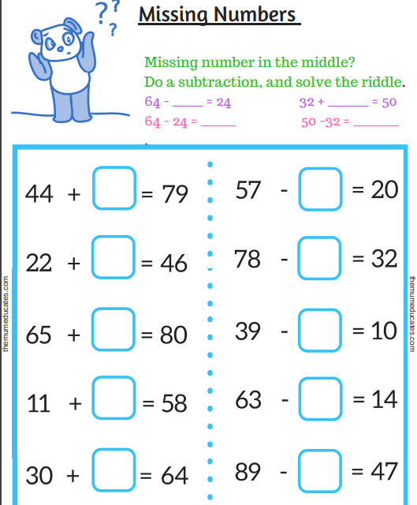

Problem solving
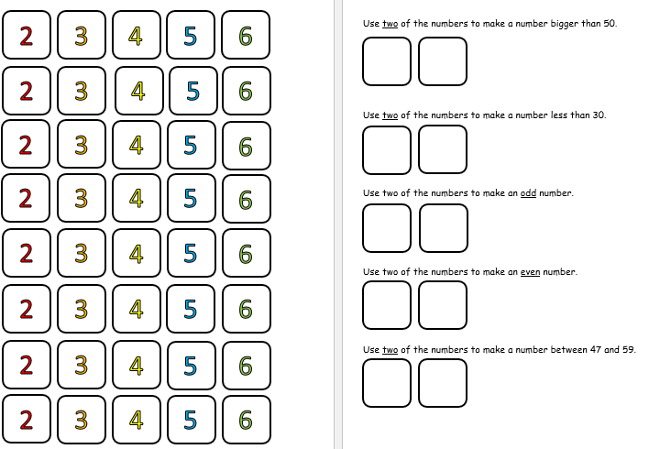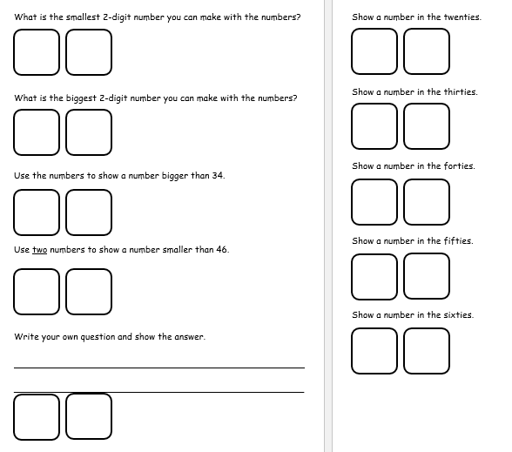

Challenges
Week 5
Our new topic is the Light bulb.
What do you think of when you see the light bulb? Draw a light bulb and write down all your ideas in a brainstorm. What does a light bulb make you think of?


Challenge 2
Look out the window during the day and what can you see. Create a daytime picture using different materials. Think about what you can see during the daytime.

Challenge 3
Make a bear puppet to retell the story Peace at Last.
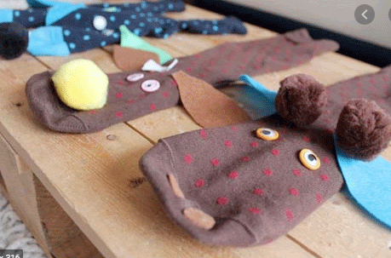

Challenge 4
P.E. Challenge:
Join in with Joe Wicks PE 30 min a day via YouTube live every morning at 9am (Mon-Fri). On the other hand, go on a 30 min walk everyday but stay safe.

Challenge 5
Numeracy Challenge

Play games on the following websites, particularly working in number skills such as place value, addition and subtraction
www.topmarks.co.uk ,
www.snappymaths.com
https://www.bbc.co.uk/bitesize/subjects/z826n39

