  08/03/2022 |  |  |  | Theme: Pharaohs  Year group: Year 4/5
Literacy     | Numeracy  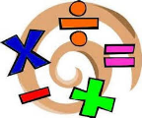   | Creative     | Thinking     |  | Healthy me    
The story of Tadeo Jones  Watch the following animation  Tadeo Jones video  Use the following story starter to create your own adventure story based on the animation.  ‘’Standing at the mysterious opening, I felt nervous of what might be ahead. Nevertheless, I knew I had to be brave and go inside. I slowly stepped forward and entered the tomb ….  Before creating your story. Use the story mountain planner (included in the resources) to plan your story.  J2E Spell Blast  Log into Hwb and access J2E Spell Blast. Continue to practice your spelling patterns. / Mrs Lovering has also shared spelling with your parents and guardians via Class Dojo.  Reading  Access your My Rising Stars accounts and catch up on your current allocations. If you require new texts/titles please get in contact with me and I will allocate you new texts/titles.  Ms Davies’ Welsh Missions  Mission 1  Look back at the things that you have learnt over the last few weeks. Can you remember all the Welsh work that you have completed?  Tick the ones that you most enjoyed in the list and tell me why you enjoyed them. You can write in English or you can try to use your Welsh language patterns instead.  Mission 2  Our next Welsh writing genre is Recount. Find out what a recount is and write a short sentence about it. Write a recount (in English) about something that you have been doing or did on the weekend. Use the editable word document to help you.  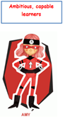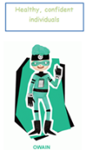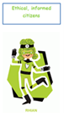 | Reasoning with patterns and sequences  Use the following Oak Academy lessons based on patterns and sequences for each day: Watch the videos, complete the worksheets and quizzes for each day.  Monday : To Investigate the Place Value of Different Number Systems  Tuesday: To investigate Roman Numerals up to one hundred  Wednesday: Number sequences  Thursday: Number sequences (Part 2)  Friday: Identifying patterns  Share your daily evidence with me via an email BannisterM@hwbcymru.net  MyMaths  Log into MyMaths platform via  https://www.mymaths.co.uk/  You’ve all received new allocations linked to place value. Remember to read the lesson materials before completing the quizzes  J2E TT Blast  Log into Hwb and access J2E TT Blast. Continue to practice your times tables.  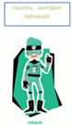 | Ms Davies’ Music Mission  Listen to ‘Mary Mary – Shackles (Praise Be)’ using the link below.  Mary Mary – Shackles  Answer the questions about the song using the editable word document.  Hieroglyphics  Use the following link and PDF within the resources to learn more about how ancient Egyptians used to write and communicate  What were Egyptian hieroglyphs?  Practise writing in hieroglyphics.  Explore the role of amulets and how they were worn by ancient Egyptians for good luck. Create designs of your own amulets.  Share your daily evidence with me via an email BannisterM@hwbcymru.net  Or Class Dojo  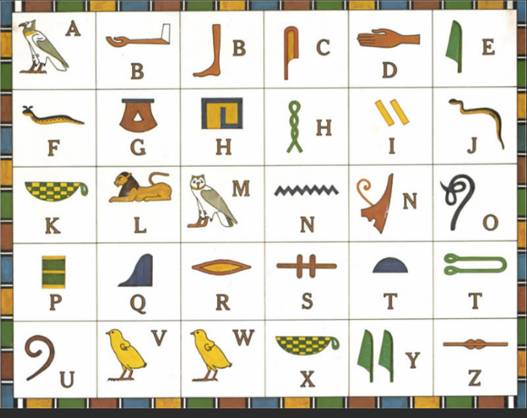  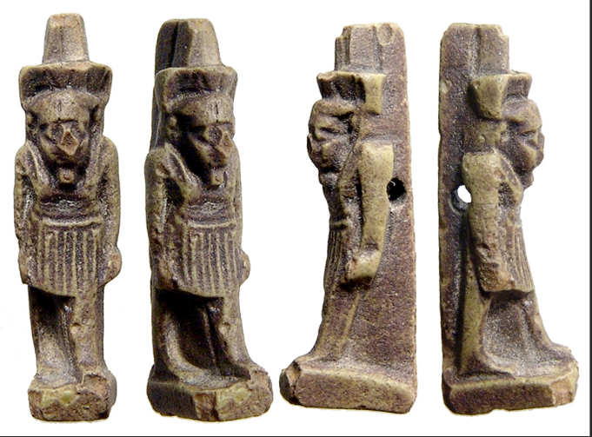  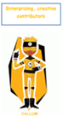 | Science Week  British Science week falls between Friday 5th March – Friday 14th March.  The theme for the British Science Week 2021 activity is ‘Innovating for the future’  Within this week’s resources, I have included a number of experiments/ investigation you can conduct in Hub/at home. These require limited resources. Try an experiment each day.  Share your daily evidence with me via an email BannisterM@hwbcymru.net  Or Class Dojo  Map of ancient Egypt  The cities of ancient Egypt were built close to the Nile River so citizens could take advantage of the goods delivered by boat. Cities and towns were divided into “Upper” and “Lower” regions.  Conduct some research into how Ancient Egypt was divided and create a map of this region.  Include the following:  Town & Cities  Rivers  Seas  Deserts  Regions e.g upper/lower  Share your daily evidence with me via an email BannisterM@hwbcymru.net  Or Class Dojo  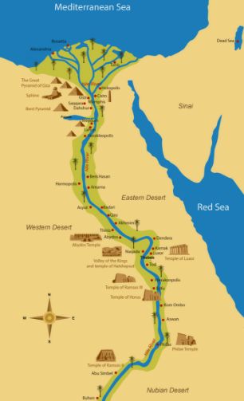  Mrs Watts’ RE Mission  Look at ‘The Bible PowerPoint’. Use the information to complete the activity (in resources). |  | Life during Ancient Egypt vs present day.  Use your knowledge of life during Ancient Egypt to create an informative poster comparing and contrasting current day life and to life during Ancient Egypt.  The way you present your work is up to you. However, it must be bright and colourful, contain pictures and be factual.  Mrs Watts’ PE Mission  Complete the activity, ‘Sequence Champions’  Record your movements using Flipgrid:  https://flipgrid.com/4d312acb  If you have any questions/problems, email me:  Wattss11@hwbmail.net  Or, message me on Class Dojo, or Teams.  

