STF 2
Welsh Blended Learning

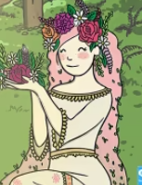
Blodeuwedd (which means Flower Face) was a beautiful princess who was created by magic out of flowers and lived in Wales many years ago.
She had a crown made of wild flowers, pink hair that fell to her knees and a long green dress made out of moss and wild flowers. She was very beautiful and everyone loved her.
Blodeuwedd loved to be outdoors with nature and all the animals loved her too.

Challenge 1:
Blodeuwedd loved spending time in the outdoors. Can you go out for a walk or take a look out of the window to see what you can find? Try and find the on the scavenger hunt and learn the names in Welsh. Listen to the recording of how to pronounce the names by clicking on the OR code.

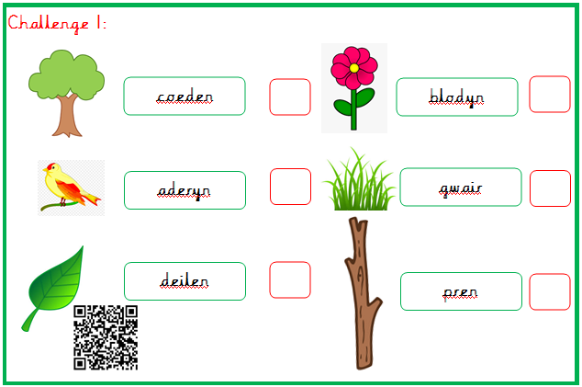

Challenge 2:
Create a crown similar to Blodeuwedd’s crown.
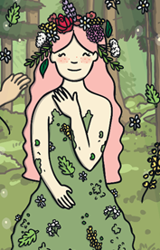
You will need:
- 1 long strip of paper or card and ask an adult to measure your head but don’t glue both ends together until the flowers have dried.
- Create your own flowers using card/paper and colouring pencils, felt pens or paint. You could also find some pictures of flowers in magazines. You can also print the flowers on the attached PDF and cut them out.
- Once cut glue them on to the crown.
- Wait for the glue to dry and then stick both ends of the band together.
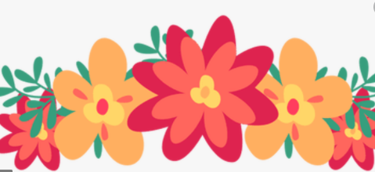
Challenge 3:
Draw a picture of Blodeuwedd.
Remember to draw a beautiful crown of flowers on her head. Once you have drawn your picture try to label the parts of her body in Welsh. Look at the word mat to help you.

