STF2
Welsh Blended Learning – Week 3

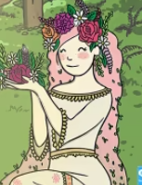
Blodeuwedd (which means Flower Face) was a beautiful princess who was created by magic out of flowers and lived in Wales many years ago.
She had a crown made of wild flowers, pink hair that fell to her knees and a long green dress made out of moss and wild flowers. She was very beautiful and everyone loved her.
Blodeuwedd loved to be outdoors with nature and all the animals loved her too.

Challenge:
Draw a picture of Blodeuwedd.
Remember to draw a beautiful crown of flowers on her head. Once you have drawn your picture try to label the parts of her body in Welsh. Look at the word mat to help you.
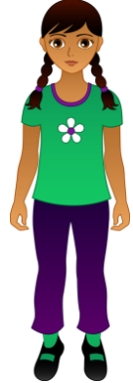
ysgwyddau
coesau
traed
llaw
pen

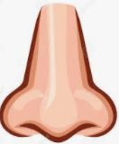
trwyn
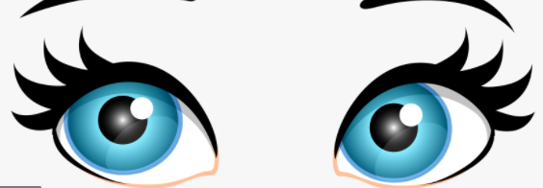
llygaidd

ceg

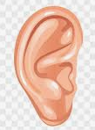
clustiau

Pen Ysgwyddau Coesau Traed/Head Shoulders Knees and Toes:
Can you remember the song that we sing during our Welsh sessions? See if you can sing along with the video.
https://www.youtube.com/watch?v=3RwgAYVntUg


