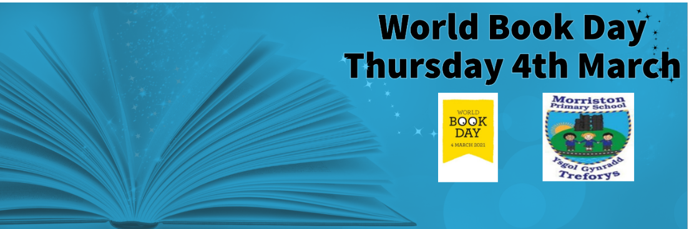
As part of our drive to maintain, promote and engage pupil interest in reading, the school is celebrating World Book day on Thursday 4th March. World Book Day is a brilliant opportunity for everyone within the school community to celebrate the joy of reading. During the day children will be participating in lots of exciting activities via a blended learning approach.
Although the learning offer will be different for Foundation Phase and Key Stage 2 pupils, the opportunities to take part in this celebration will be the same for all our learners. On this special day, we ask Foundation Phase children (3-7 years) to come to school dressed as a favourite character from any book.
For our Key Stage 2 learners we ask for parents, carers and guardians to share photographs of the children dress up as their favourite book character with their teacher via Class dojo/ email. The dressing up possibilities are endless: Postman Pat, Oliver Twist, Fantastic Mr Fox, Charlie and the Chocolate Factory, James and the Giant Peach, Danny- Champion of the World, Matilda, Goldilocks, Jack and the Beanstalk, The Twits, Cinderella, Gruffalo, Elmer the Elephant, Three little Pigs, Harry Potter etc
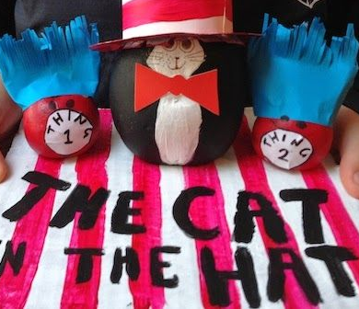
World Book Day Competition
We will also be running a run competition for all pupils. ‘Create a potato friend!’ Challenging pupils to turn a boring old potato (or egg) into a book character.
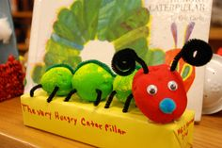
Asking children to be creative and use what is available around their home. All entries need to be with their teacher (or a picture if a Key Stage 2 learner) by Thursday 4 March.
There will be a prize for the best entry from Foundation Phase and Key Stage 2.
We all look forward to seeing pupils engaging in these celebrations
Thank you for your co-operation.
Mr. M. Bannister

