  1 |  |  |  | Theme: Pharaohs  Year group: Year 4/5 PPA Mrs Watts
Literacy     | Numeracy  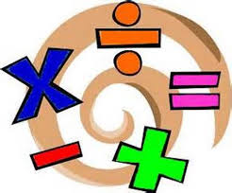   | Creative     | Thinking     |  | Healthy me    
 |  |  | R.E: The Bible  Look at ‘The Bible Powerpoint’. Use the information to complete the activity (in resources).  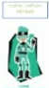 |  | P.E: Gymnastic skills  Complete the activity, ‘Sequence Champions’  Record your movements using Flipgrid:  https://flipgrid.com/4d312acb  If you have any questions/problems, email me:  Wattss11@hwbmail.net  Or, message me on Class Dojo, or Teams.

