Home Learning Tasks
Here are the activities that are set for you this week. The ‘Daily Do’ will stay the same each week and updated when needed. Each week a new set of activities will be posted for you to do with your child. Please remember to do these activities, you can complete them as and when you wish. Please share the activities that you have done through ‘Class Dojo’ and through your child’s ‘Hwb’ account if you do anything online. You can take pictures of your child doing the activity or pictures of their work and post these.
Daily Do Activities (Please do these activities everyday)
Activities that you have done can be shared on ‘Class Dojo’
- Reception
- Write your name remembering to use your ‘whoosh’ at the start of each letter. (Refer to the letters in the ‘Sound Book’ for support.
- Write your numbers to 20 (Refer to the numbers in the ‘Number Book’ for correct formation)
- Write your letter sounds (Refer to the ‘Sound Book’ for formation)
- Read and write simple CVC words e.g. mat, cat, sat (Look at the words previously given out from school) you can find more of these online.
- Read and write ‘High Frequency Words’ these are words that you need to learn and that you will see in books e.g. I, the, put, he, it. You can find a list of the first 100 here at www.highfrequencywords.org/
- Count up to 20 or further forwards and backwards.
- Keep a diary. Draw and write a sentence about what you have done that day.
- Read a range of stories, you can find many online or just read the books you have at home.
- Say the weather in Welsh and teach your parents, find out the day, date and month
- Get outside for fresh air whenever you can and have lots of fun.
Year 1
- Write your full name remembering to use your ‘whoosh’ at the start of each letter.
- Write your numbers to 100.
- Count to 100 in 2’s, 5’s, 10’s start at different points.
- Say double numbers and number bonds to10 and even 20.
- Write your letter sounds and remember to use a ‘whoosh’ at the start.
- Read and write ‘High Frequency Words’. You can find the list here www.highfrequencywords.org/
- Read and write the spelling words that you have been given previously in your ‘Spelling Book’. You can find more spelling ideas for Year 1 online.
- Keep a diary: Draw and write about what you have done that day. Remember to give details about what you have done and begin to write longer sentences/paragraphs. Don’t forget Capital letter, finger spaces and a full stop.
- Read a range of stories, you can find many online or just read the books you have at home.
- Say the weather in Welsh and teach your parents, find out the day, date and month
- Get outside for fresh air whenever you can and have lots of fun.
Week 5: 04/05/20
Literacy Activities
Rhyme: Songs
Rhyme Challenge:
As it is ‘Springtime’ learn the rhyme ‘Little Bo Peep’ and ‘Mary had a Little Lamb’. You can find the rhyme on ‘Class Pages’ or you can look for them online.

Reception: Learn the rhymes, record the rhyme and perform to your family. Why not video the performance and send to your friends and family.
Year 1: Learn the rhymes, record the rhyme and perform to your family. Why not video the performance and send to your friends and family.

Role Play
Set up a stage for your performance. Make posters and tickets to advertise the time and date of the performance. Dress up in your best performance clothes and put on a show.

Spelling
Reception: CVC words with the middle ‘a’ sound (Please see the sheet attached on the class page)
Year 1: Spelling Lists. Please see the spelling below, refer to the spelling in your child’s ‘Pink Book’ to see which phase they are on and work on these spellings.
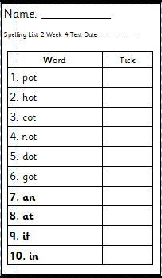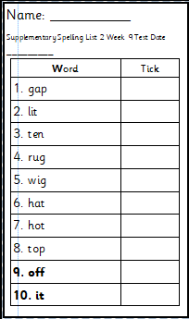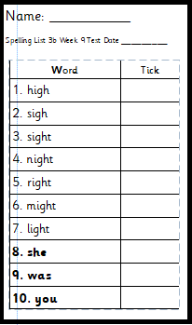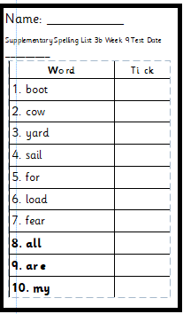
Phase 2 Phase 2 supplementary Phase 3b Phase 3b supplementary

Phase 4
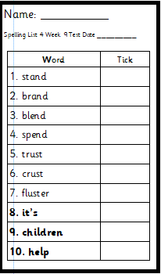

Storytime: Oxford Owl Website
Listen to the ‘Biff, Chip and Kipper’ stories on ‘Oxford Owl Storyteller’.
The Story: The Big Foot Mystery’
What is the story about? Who are the characters?
The link to the story is on ‘Class Pages’

Reading
Choose a book to read on ‘Oxford Owl’. Use the age, series or Oxford level to help you find a book. How many can you read?

Puppet Show
Make some puppets using anything you can find at home. Make different characters. Put on a show using your puppets.

Why not make:
- A sign advertising your show
- Posters saying ‘Time’, ‘Date’ and ‘Venue’
- Tickets for the audience
- A program for everyone to know what your show is about
- A script to say what the characters will say

Pobble 365
Look at this picture and discuss. See the additional discussion ideas on ‘Class Pages’
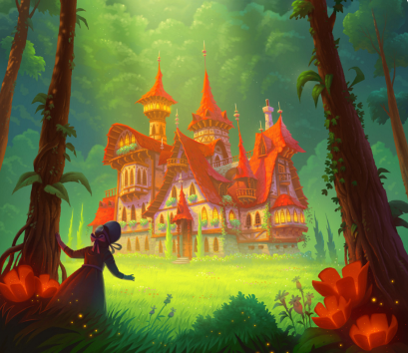

Numeracy Activities
Subtraction
Here are some activities on subtraction. Look for items at home that you can use to make two sets to subtract. Use these to help you work out subtraction sums. Make sure that you use the - and = symbols when you write the sum.

Rec: Find different objects and put them into two different piles. Count how many you have in each pile and find out how many are left when you take some away. Draw a picture of your maths work.
Year 1: Subtraction number sentences: Remember to use ‘Counting Back’ to help you work out the answer. Remember you must put the biggest number first. If you are unable to print you could write some subtraction sums for your child. (Please see the sheet attached on the class page). Can your child make their own subtraction sum?

Topic Activity
Food
Look in your cupboard in the kitchen what can you find?
- Make a list of all the food you can find.
- Sort the food into healthy and unhealthy
- Find out about the different food groups and which food belongs to each group.

Take part in the ‘Healthy Lunchbox’ activity see the link on ‘Class Pages’

Food Diary
Keep a ‘Food Diary’ of which food you eat each day. Draw and write about them.

Parts of a Plant
Now that spring is here, and plants are starting to grow, what can you find out about the different parts of a plant?
Reception: Draw a picture of a plant and label.
Year 1: Draw a picture of a plant and label. Find out some information about what each part does.

What do plants need to grow?
Find out what plants need to help them grow. Do the activity online see the link on ‘Class Pages’

Creative: Design
For you to put on your ‘Puppet Show’ you need somewhere to perform. Make a puppet theatre. What resources can you use? Search online for some ideas.

Physical Activities
Take part in ‘Cosmic Yoga’. Look at the website and choose which ‘Yoga’ you would like to do. Keep a record of which ones you do.

Welsh
Beth ydy’r amser? (What is the time)
Can you remember the activities that Tedi Twt and Doli Glwt did in school? You can use these at home to say what you are doing. Make your own ‘Home Timetable’ using the vocabulary. See the vocabulary below to help.

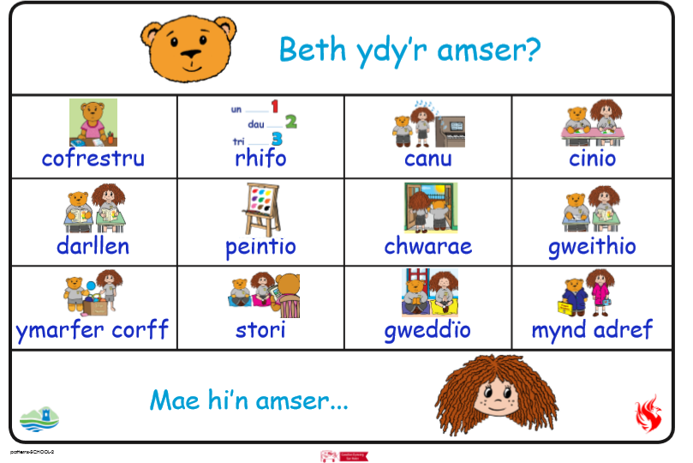

Cofrestru: Register
Rhifo: Counting
Canu: Sing
Cinio: Dinner
Darllen: Reading
Peintio: Painting
Chwarae: Play
Gweithio: Work
Ymarfer Corff: Physical activity
Stori: Story
Gweddio: Pray
Mynd Adref: Go home

Challenges:
Here is a list of challenges for you to keep working on:
Reception:
- Learn to do up zips and buttons.
- Put on and take off your jumper on your own.
- Put on and take off your own socks and shoes.
- Dress and Undress yourself

Year 1:
- Learn to tie a knot.
- Learn to do a shoelace.
- Learn your home address and telephone number
- Set the table for breakfast, dinner and tea

