Home Learning Tasks
Here are the activities that are set for you this week. The ‘Daily Do’ will stay the same each week and updated when needed. Each week a new set of activities will be posted for you to do with your child. Please remember to do these activities, you can complete them as and when you wish. Please share the activities that you have done through ‘Class Dojo’ and through your child’s ‘Hwb’ account if you do anything online. You can take pictures of your child doing the activity or pictures of their work and post these.
Daily Do Activities (Please do these activities everyday)
Activities that you have done can be shared on ‘Class Dojo’
- Reception
- Write your name remembering to use your ‘whoosh’ at the start of each letter. (Refer to the letters in the ‘Sound Book’ for support.
- Write your numbers to 20 (Refer to the numbers in the ‘Number Book’ for correct formation)
- Write your letter sounds (Refer to the ‘Sound Book’ for formation)
- Read and write simple CVC words e.g. mat, cat, sat (Look at the words previously given out from school) you can find more of these online.
- Read and write ‘High Frequency Words’ these are words that you need to learn and that you will see in books e.g. I, the, put, he, it. You can find a list of the first 100 here at www.highfrequencywords.org/
- Count up to 20 or further forwards and backwards.
- Keep a diary. Draw and write a sentence about what you have done that day.
- Read a range of stories, you can find many online or just read the books you have at home.
- Say the weather in Welsh and teach your parents, find out the day, date and month
- Get outside for fresh air whenever you can and have lots of fun.
Year 1
- Write your full name remembering to use your ‘whoosh’ at the start of each letter.
- Write your numbers to 100.
- Count to 100 in 2’s, 5’s, 10’s start at different points.
- Say double numbers and number bonds to10 and even 20.
- Write your letter sounds and remember to use a ‘whoosh’ at the start.
- Read and write ‘High Frequency Words’. You can find the list here www.highfrequencywords.org/
- Read and write the spelling words that you have been given previously in your ‘Spelling Book’. You can find more spelling ideas for Year 1 online.
- Keep a diary: Draw and write about what you have done that day. Remember to give details about what you have done and begin to write longer sentences/paragraphs. Don’t forget Capital letter, finger spaces and a full stop.
- Read a range of stories, you can find many online or just read the books you have at home.
- Say the weather in Welsh and teach your parents, find out the day, date and month
- Get outside for fresh air whenever you can and have lots of fun.
Week 6: 11/05/20
Literacy Activities
Rhyme: Songs
Rhyme Challenge:
As it is ‘Springtime’ learn the rhyme ‘Mary Mary Quite Contrary’. You can find the rhyme on ‘Class Pages’ or you can look for them online.

Reception: Learn the rhymes, record the rhyme and perform to your family. Why not video the performance and send to your friends and family.
Year 1: Learn the rhymes, record the rhyme and perform to your family. Why not video the performance and send to your friends and family.

Role Play
Set up a stage for your performance. Make posters and tickets to advertise the time and date of the performance. Dress up in your best performance clothes and put on a show.

Spelling
Reception: CVC words with the middle ‘e’ sound (Please see the sheet attached on the class page)
Year 1: Spelling Lists. Please see the spelling below, refer to the spelling in your child’s ‘Pink Book’ to see which phase they are on and work on these spellings.
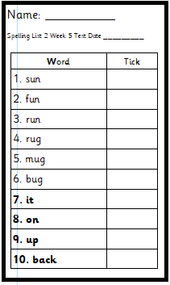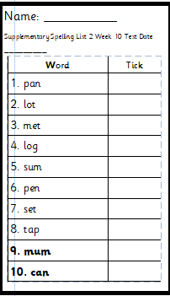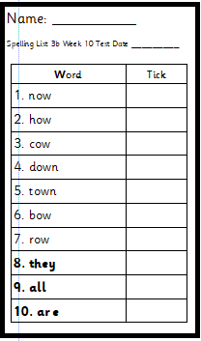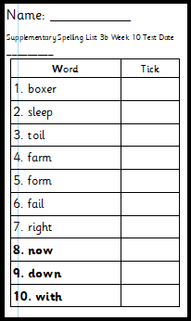
Phase 2 Phase 2 supplementary Phase 3b Phase 3b supplementary

Phase 4
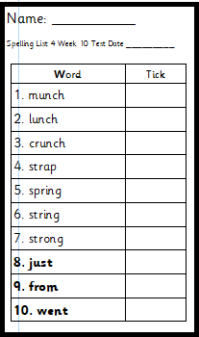

Storytime: Oxford Owl Website
Listen to the ‘Biff, Chip and Kipper’ stories on ‘Oxford Owl Storyteller’.
The Story: The Strange Old House’
What is the story about? Who are the characters?
The link to the story is on ‘Class Pages’

Reading
Choose a book to read on ‘Oxford Owl’. Use the age, series or Oxford level to help you find a book. How many can you read?

Pobble 365
Look at this picture and discuss. See the additional discussion ideas on ‘Class Pages’


Signs and Labels
Look at the picture showing ‘Signs and Labels’ what type of signs are they? Have a look outside your window can you see any sings? Look on the internet to see what different kinds of signs you can find.
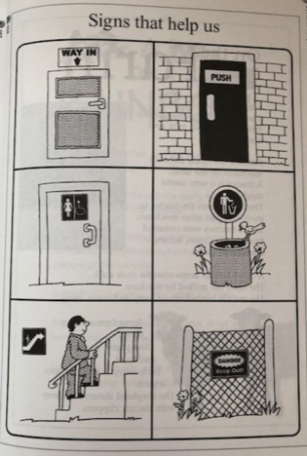
- Make signs for your home to tell people what to do e.g. wash hands, turn off the lights. Make your signs bright and colourful so everyone can see them.
- Make some signs for models that you make from building materials to show everyone what you have made.
Numeracy Activities
Measure: Weight
Go around your house and gather different objects and items.

Rec: Sort the objects/items into heavy and light. What has made you sort them like this?
Year 1: Make your own scales. Find items at home and weight them. Use some beads, blocks, buttons or whatever you can find to weigh the different items. How many do you need to make the scales balance? Make an estimate first and then weigh.
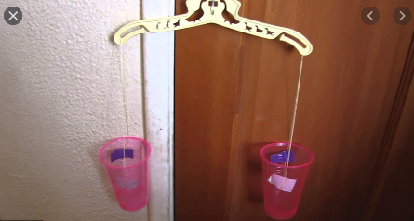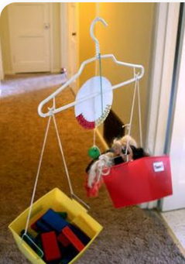

Time (Year 1)
Play the game ‘Telling the Time’ see link on ‘Class Pages’. How many can you get right? Remember to tell the time everyday at home.

Reception and Year 1
Why not go outside and play ‘What’s the Time Mr Wolf?’ can you get away before the wolf catches you?

Topic Activity
Seasons
Now that we are in ‘Spring’ and you have learnt about this season, let’s look at the other seasons.
- Learn the names of the seasons
- Find out what happens in each season and write a sentence to describe what happens.
- Draw pictures of the four seasons.

Fitness Diary
Keep a ‘Fitness Diary’ of which physical activity you do ach day. Draw and write about them.

Physical Activities
Take part in ‘Cosmic Yoga’. Look at the website and choose which ‘Yoga’ you would like to do. Keep a record of which ones you do.

Materials
We have learnt about different materials when we looked at ‘Recycling’. Now we are going to talk about materials and their properties. What do they look and feel like?

Material Hunt
Go on a material hunt around your home and garden, gather lots of different objects and items.
Reception: Sort your materials into hard and soft. You could do the activity sheet on ‘Class Pages’ if you want an additional activity.
Year 1: Sort your materials into as many different ways as you can. How many different ways can you describe materials e.g. hard/soft/smooth/rough. You could do the activity sheet on ‘Class Pages’ if you like.

Feely Bag Game
Play a game where you put items in a bag and you have to describe them. Remember to close your eyes when you put your hand in the bag. Feel around and describe and name the item.

Science Experiment
Do this experiment and find out what happens.
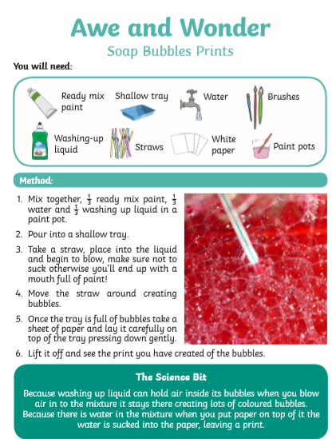

Welsh
Ga i… (Can I have)
Ask for things at home in Welsh using the pattern Ga i…
Here are some ideas for you. Find out some more Welsh words for things you might ask for at home.
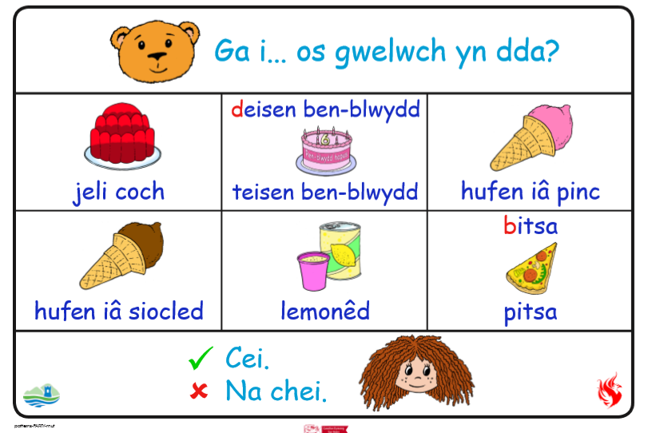

Challenges:
Here is a list of challenges for you to keep working on:
Reception:
- Learn to do up zips and buttons.
- Put on and take off your jumper on your own.
- Put on and take off your own socks and shoes.
- Dress and Undress yourself

Year 1:
- Learn to tie a knot.
- Learn to do a shoelace.
- Learn your home address and telephone number
- Set the table for breakfast, dinner and tea

