  01/03/2022 |  |  |  | Theme: Pharaohs  Year group: Year 4/5
Literacy     | Numeracy  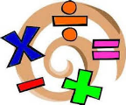   | Creative     | Thinking     |  | Healthy me    
‘What it means to be Welsh/ your own nationality’  I would like you to design and create a Calligram based on ‘What it means to be Welsh / your own nationality’  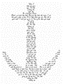  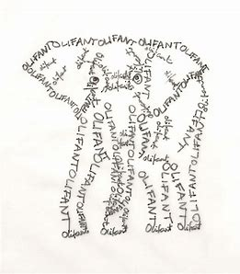  A Calligram is a word or piece of text in which the design and layout of the letters creates a visual image related to the meaning of the words themselves.  Your Calligram picture should be linked to Wales/ your home country e.g Leek, Dragon, Mountains etc.  You can present your information by hand or digital. This is up to you. Remember to share your Calligram with me via Dojo or email (BannisterM@hwbcymru.net)  World Book Day author event.  We have been invited to a live author event with local author David Brayley on Wednesday 3rd March. I will share the link to the meeting on our general feed of Teams. There will be several schools from across Swansea on this call.  There will be an opportunity to ask David questions about his life and career as an author.  Read the fact file based on David. After reading David’s fact file, I would like you to generate questions to ask him. Think about the types of questions and information you would like to find out, which is not stated within the fact file.  These questions need to be with me by the end of the school day on Tuesday 2nd March, as I need to send these to David for him to look over before Wednesday’s live event.  The school which generates the best questions will win a prize from Swansea FC  J2E Spell Blast  Log into Hwb and access J2E Spell Blast. Continue to practice your spelling patterns. / Mrs Lovering has also shared spelling with your parents and guardians via Class Dojo.  World Book Day 2021 recommendations  Use the following Flipgrid join code  https://flipgrid.com/989ad6ab  Record the following information:  - Which favourite children's book would you recommend to others?  - Who is the author?  Why is it such a good book?  - Which age would it be best for?  - How could you persuade your friends to enjoy reading it?  Share your book and reasons in less than 2 minutes.  Reading  Access your My Rising Stars accounts and catch up on your current allocations. If you require new texts/titles please get in contact with me and I will allocate you new texts/titles.  I have also included this week’s edition of First News within the resource pack. Enjoy the newspaper articles. You may want to do some shared reading with your parents and guardians.  Ms Davies’s Welsh Missions  - Read the story of Dewi Sant (St David)  - Complete the Welsh language wordsearch – some of the words may be tricky!  - Learn the Welsh words and their meaning  - Write 6 sentences including the Welsh words that are on the list. You will need to use your language patterns for this.  5. Write a third person profile on Dewi Sant using your language patterns. Use the examples set in past Welsh language missions to help you.  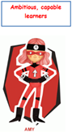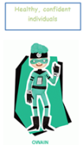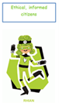 | Area  Use the following Oak Academy lessons based on area for each day: Watch the videos, complete the worksheets and quizzes for each day.  Monday :Understand that area is a measure of surface and is measured in square units  Tuesday: Understand that area is a measure of surface and is measured in square units (Part 2)  Wednesday: Calculate and compare the area of rectangles using square centimetres (cm²)  Thursday: Calculate and compare the area of rectangles using square metres (m²)  Friday: Investigate the relationship between area and perimeter and use this knowledge to solve problems  Share your daily evidence with me via an email BannisterM@hwbcymru.net  MyMaths  Log into MyMaths platform via  https://www.mymaths.co.uk/  You’ve all received new allocations linked to area. Remember to read the lesson materials before completing the quizzes  J2E TT Blast  Log into Hwb and access J2E TT Blast. Continue to practice your times tables.  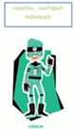 | Ms Davies’s Art Missions  Ruth Jên is a Welsh artist from Aberystwyth. Find some information about her. You do not have to write about her.  Look at the kind of work that she creates.  Try to create your own Welsh themed artwork using Ruth Jên’s work as a stimulus.  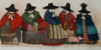  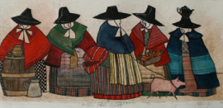  Ms Davies’s Music Missions  Listen to the song ‘International Velvet’ by Cerys Matthews and Catatonia  Catatonia international velvet.  Research the composer and create a short PowerPoint presentation about her.  Things you may want to consider are:  - Where she was born?  - Where she lived and where she lives now?  - What was the name of the band?  - Name some other songs she sang  - What else has Cerys Matthews done other than sing?  Find some pictures to put in to your PowerPoint  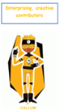 | Map of Wales  As this week is ‘Welsh Week’, I would like you to gain a better understanding of our country - Wales.  Use maps, atlases and globes to create your own map of Wales.  I have included an outline of Wales within the resource pack to help you.  Your map should include the following:  - Major rivers and mountains  - Counties  - Major towns and cities  - An information key  Share your maps with me via an email BannisterM@hwbcymru.net  Welsh Castles  Wales is sometimes called the ‘Castle capital of the World’.  Choose one Welsh castle and create a PowerPoint on it.  Include the following information:  - Date built  - Original purpose  - Current condition  - Interesting facts based on the castle  - Location  - Pictures  The story of Dewi Sant  Use the following link to gain a better understanding of Dewi Sant – the patron saint of Wales  Saint David — The patron saint of Wales |  | The Story of Gelert  Read the legend of Gelert. I have created a Teams assignment for you to show your comprehension of the story and answer the questions in full sentences.  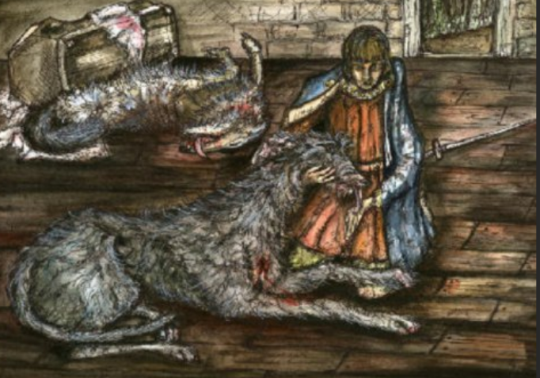  Mrs Watts’ P.E: Gymnastic skills  Watch and follow the instructions on the PowerPoint.  Record your movements using Flipgrid:  https://flipgrid.com/24123052  If you have any questions/problems, email me:  Wattss11@hwbmail.net  Or, message me on Class Dojo, or Teams.  Mrs Watts’ PSE: Similarities and Differences  UNCRC Article 30: You have the right to use your own language.  Watch the video clip about Owain:  Attitudes towards the Welsh language - KS2 PSHE and Citizenship - BBC Bitesize  The language we speak gives us a sense of identity and makes us unique.  1). Discuss discrimination by thinking about the issues raised by Owain's parents, regarding times when they have been asked or even told not to use their own language.  2). Why is it important to speak our own language?  3). Describe what it would be like if you were stopped from speaking your own language.  4). Record your response on Flipgrid:  https://flipgrid.com/d9b7612a  

