Home Learning Tasks
Here are the activities that are set for you this week. The ‘Daily Do’ will stay the same each week and updated when needed. Each week a new set of activities will be posted for you to do with your child. Please remember to do these activities, you can complete them as and when you wish. Please share the activities that you have done through ‘Class Dojo’ and through your child’s ‘Hwb’ account if you do anything online. You can take pictures of your child doing the activity or pictures of their work and post these.
Daily Do Activities (Please do these activities everyday)
Activities that you have done can be shared on ‘Class Dojo’
- Reception
- Write your name remembering to use your ‘whoosh’ at the start of each letter. (Refer to the letters in the ‘Sound Book’ for support.
- Write your numbers to 20 (Refer to the numbers in the ‘Number Book’ for correct formation)
- Write your letter sounds (Refer to the ‘Sound Book’ for formation)
- Read and write simple CVC words e.g. mat, cat, sat (Look at the words previously given out from school) you can find more of these online.
- Read and write ‘High Frequency Words’ these are words that you need to learn and that you will see in books e.g. I, the, put, he, it. You can find a list of the first 100 here at www.highfrequencywords.org/
- Count up to 20 or further forwards and backwards.
- Keep a diary. Draw and write a sentence about what you have done that day.
- Read a range of stories, you can find many online or just read the books you have at home.
- Say the weather in Welsh and teach your parents, find out the day, date and month
- Get outside for fresh air whenever you can and have lots of fun.
Year 1
- Write your full name remembering to use your ‘whoosh’ at the start of each letter.
- Write your numbers to 100.
- Count to 100 in 2’s, 5’s, 10’s start at different points.
- Say double numbers and number bonds to10 and even 20.
- Write your letter sounds and remember to use a ‘whoosh’ at the start.
- Read and write ‘High Frequency Words’. You can find the list here www.highfrequencywords.org/
- Read and write the spelling words that you have been given previously in your ‘Spelling Book’. You can find more spelling ideas for Year 1 online.
- Keep a diary: Draw and write about what you have done that day. Remember to give details about what you have done and begin to write longer sentences/paragraphs. Don’t forget Capital letter, finger spaces and a full stop.
- Read a range of stories, you can find many online or just read the books you have at home.
- Say the weather in Welsh and teach your parents, find out the day, date and month
- Get outside for fresh air whenever you can and have lots of fun.
Week 7: 18/05/20
Literacy Activities
Rhyme: Songs
Rhyme Challenge:
Learn these rhymes to perform to your family ‘The Queen of Hearts’ and ‘Little Miss Muffet’ You can find the rhyme on ‘Class Pages’ or you can look for them online.

Reception: Learn the rhymes, record the rhyme and perform to your family. Why not video the performance and send to your friends and other family.
Year 1: Learn the rhymes, record the rhyme and perform to your family. Why not video the performance and send to your friends and other family.

Role Play
Set up a stage for your performance. Make posters and tickets to advertise the time and date of the performance. Dress up in your best performance clothes and put on a show.

Spelling
Reception: CVC words mixed pictures and words. Can you match the word and picture? Can you write the word? (Please see the sheet attached on the class page)
Year 1: Spelling Lists. Please see the spelling below, refer to the spelling in your child’s ‘Pink Book’ to see which phase they are on and work on these spellings.
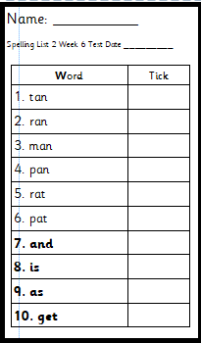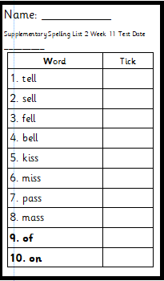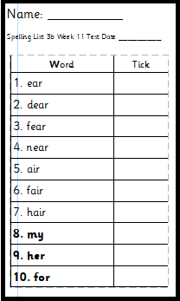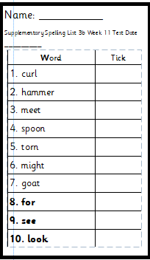
Phase 2 Phase 2 supplementary Phase 3b Phase 3b supplementary

Pha’se 4
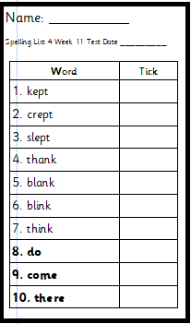

Storytime: Oxford Owl Website
Listen to the ‘Traditional Tales’ stories on ‘Oxford Owl Storyteller’.
The Story: Chicken Liken
What is the story about? Who are the characters?
The link to the story is on ‘Class Pages’

Reading
Choose a book to read on ‘Oxford Owl’. Use the age, series or Oxford level to help you find a book. How many can you read? Have a read of the RWI books that can also be found. The links are on the ‘Class Page’ for you.

Pobble 365
Look at this picture and discuss. See the additional discussion ideas on ‘Class Page’


Traditional Tale
Jack and the Beanstalk Story
Read/listen to the story ‘Jack and the Beanstalk’. What happens in the story? What characters are in the story? What are these characters like?

Character Description
Think about the characters Jack and the Giant, what words can you use to describe them? Think of as many words as you can. Draw a picture of each character and write your words. To help you there is an activity on the ‘Class Page’ with lots of words you could use.

Numeracy Activities
Capacity
Go around your house and gather different objects and items that you can fill.

Rec: Use the language full/empty/ half full/ half empty to fill your different containers. Fill your containers showing the different ways and make labels for your containers and match them up.
Try this challenge:
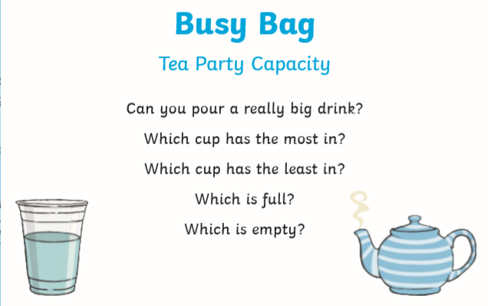

Year 1: Find items around your house and fill, what can you use to fill? How much does each container hold?
Try these challenges
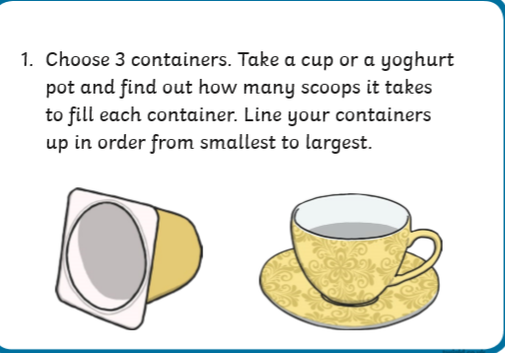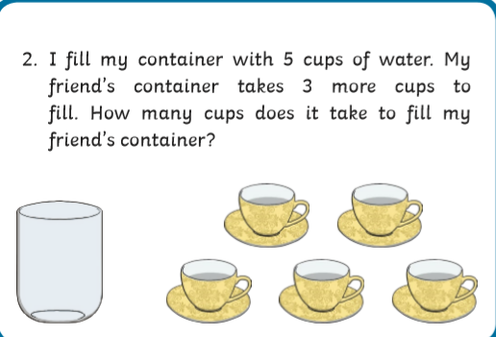

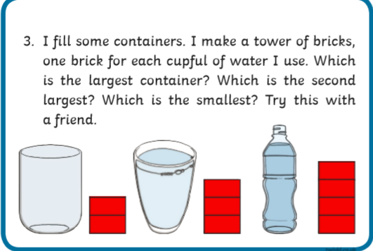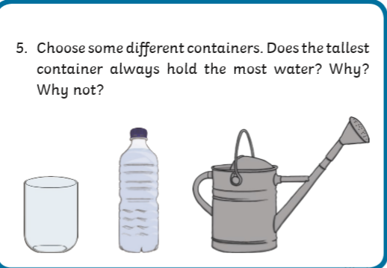

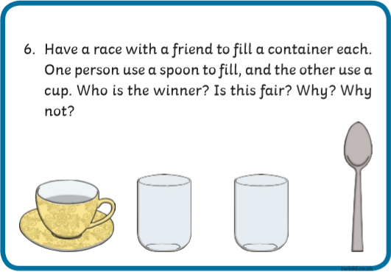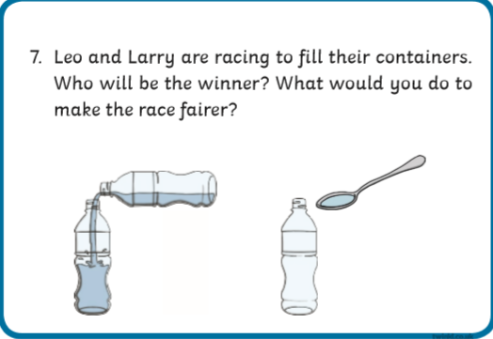

Problem Solving Activity
Can you help Finley Fish? Read the letter he has sent to find out more.
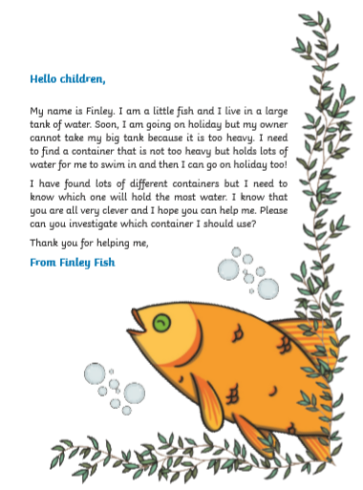

Year 1 Visit ‘White Rose Maths’ for some capacity activities, see the link on the website. When you visit the website look for Week 1 where you will find activities on capacity called ‘Introducing Capacity and Volume’

Number
Ordinal Numbers
Find things at home that you can put into a line. Label them using 1st, 2nd, 3rd and so on. Remember you must use the correct letters at the end of your numbers e.g st, nd, rd.

Reception: Can you order 10 objects and label them?
Year 1: Can you order 20 objects and label them?

Year 1: Try the additional activities on ‘Class Page’.

Topic Activity

Physical Activities
Take part in ‘Cosmic Yoga’. Look at the website and choose which ‘Yoga’ you would like to do. Keep a record of which ones you do.

Materials: Natural and Man Made
Remember the work we have done on materials and their properties, now we are going to look at ‘Natural and Man Made’ materials and find out about these. Find out what these words mean.
Look at the information that has been put on ‘Class Pages’ for you this will help you find out more.

Natural and Man Made Hunt
Go on a hunt around your home and garden, gather lots of different objects and items that are ‘Natural and Man Made’.

Sort your found treasures into two groups one natural and one man made, write labels for what you have found. Can you explain how and why you have sorted them this way? You could record your findings on ‘HWB’ by making a graph or pictogram to show what and how many you have found.

Morris the Magpie Challenge
Here is Morris again he has an activity for you. Read the letter to find out more.
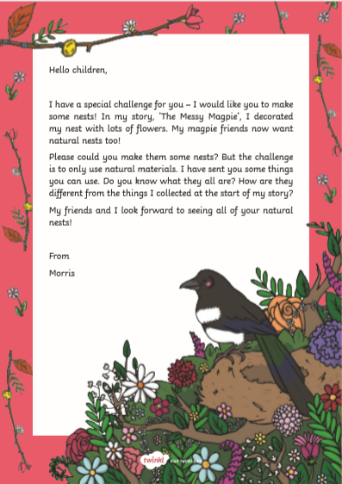

Feely Bag Game
Play a game where you put items in a bag and you have to describe them. Remember to close your eyes when you put your hand in the bag. Feel around and describe and name the item. Can you say if they are natural or man made?

Science Experiment
Do this experiment and find out what happens.
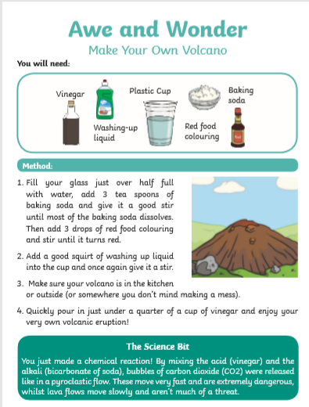

Knowledge and Understanding of the World:
Country, Town and Seaside
Think about these places, what would you find here? Look online or in books to help you.
Draw a picture of each place and add in what you would find there.


Country


Town

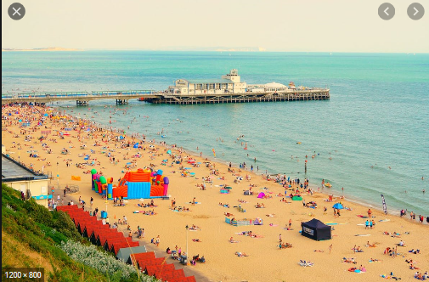
Seaside

Welsh
Beth wyt ti’n hoffi ( What do you like?)
Look at the pictures and name the different food items, have you any of these at home? Can you ask the question Beth wyt ti’n hoffi? (What do you like) and answer using Dw i’n hoffi (I like) and Dw i ddim yn hoffi (I don’t like). How many can you name? How many people can you ask?

Write down all the things you like and all the things you don’t like.

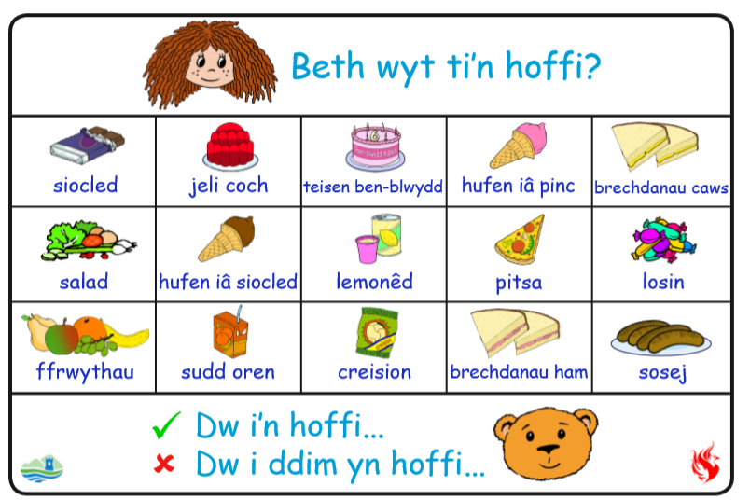

Personal and Social
Friends
Think about your friend (s) in school. Can you draw a picture of them? Write down information about them.
How old they are
What they look like
What you like about them
What do you and your friend like doing

Challenges:
Here is a list of challenges for you to keep working on:
Reception:
- Learn to do up zips and buttons.
- Put on and take off your jumper on your own.
- Put on and take off your own socks and shoes.
- Dress and Undress yourself

Year 1:
- Learn to tie a knot.
- Learn to do a shoelace.
- Learn your home address and telephone number
- Set the table for breakfast, dinner and tea

