Home Learning Tasks
Here are the activities that are set for you this week. The ‘Daily Do’ will stay the same each week and updated when needed. Each week a new set of activities will be posted for you to do with your child. Please remember to do these activities, you can complete them as and when you wish. Please share the activities that you have done through ‘Class Dojo’ and through your child’s ‘Hwb’ account if you do anything online. You can take pictures of your child doing the activity or pictures of their work and post these.
Daily Do Activities (Please do these activities everyday)
Activities that you have done can be shared on ‘Class Dojo’
- Reception
- Write your name remembering to use your ‘whoosh’ at the start of each letter. (Refer to the letters in the ‘Sound Book’ for support.
- Write your numbers to 20 (Refer to the numbers in the ‘Number Book’ for correct formation)
- Write your letter sounds (Refer to the ‘Sound Book’ for formation)
- Read and write simple CVC words e.g. mat, cat, sat (Look at the words previously given out from school) you can find more of these online.
- Read and write ‘High Frequency Words’ these are words that you need to learn and that you will see in books e.g. I, the, put, he, it. You can find a list of the first 100 here at www.highfrequencywords.org/
- Count up to 20 or further forwards and backwards.
- Keep a diary. Draw and write a sentence about what you have done that day.
- Read a range of stories, you can find many online or just read the books you have at home.
- Say the weather in Welsh and teach your parents, find out the day, date and month
- Get outside for fresh air whenever you can and have lots of fun.
Year 1
- Write your full name remembering to use your ‘whoosh’ at the start of each letter.
- Write your numbers to 100.
- Count to 100 in 2’s, 5’s, 10’s start at different points.
- Say double numbers and number bonds to10 and even 20.
- Write your letter sounds and remember to use a ‘whoosh’ at the start.
- Read and write ‘High Frequency Words’. You can find the list here www.highfrequencywords.org/
- Read and write the spelling words that you have been given previously in your ‘Spelling Book’. You can find more spelling ideas for Year 1 online.
- Keep a diary: Draw and write about what you have done that day. Remember to give details about what you have done and begin to write longer sentences/paragraphs. Don’t forget Capital letter, finger spaces and a full stop.
- Read a range of stories, you can find many online or just read the books you have at home.
- Say the weather in Welsh and teach your parents, find out the day, date and month
- Get outside for fresh air whenever you can and have lots of fun.
Week 8: 01/06/20
Literacy Activities
Rhyme: Songs
Rhyme Challenge:
Learn these rhymes to perform to your family ‘There’s a worm at the bottom of my garden’ and ‘Here is a Beehive’ You can find the rhyme on ‘Class Pages’ or you can look for them online.

Reception: Learn the rhymes, record the rhyme and perform to your family. Why not video the performance and send to your friends and family.
Year 1: Learn the rhymes, record the rhyme and perform to your family. Why not video the performance and send to your friends and family.

Role Play
Set up a stage for your performance. Make posters and tickets to advertise the time and date of the performance. Dress up in your best performance clothes and put on a show.

Spelling
Reception: CVC ‘Reading Words’. Can you read the word and draw a picture? (Please see the sheet attached on the class page)
Year 1: Spelling Lists. Please see the spelling below, refer to the spelling in your child’s ‘Pink Book’ to see which phase they are on and work on these spellings.
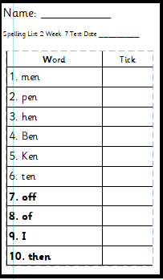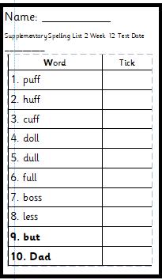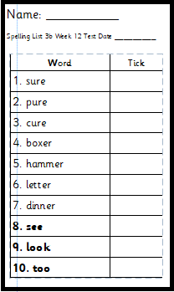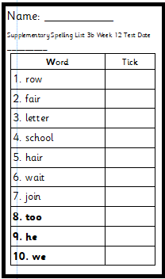
Phase 2 Phase 2 supplementary Phase 3b Phase 3b supplementary

Phase 4
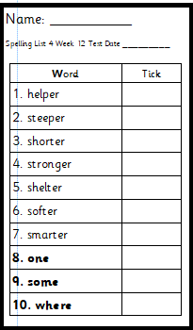

Storytime: Oxford Owl Website
Listen to the ‘Traditional Tales’ stories on ‘Oxford Owl Storyteller’.
The Story: East of the Sun and West of the Moon part 1 and 2
What is the story about? Who are the characters?
The link to the story is on ‘Class Pages’

Reading
Choose a book to read on ‘Oxford Owl’. Use the age, series or Oxford level to help you find a book. How many can you read? Have a read of the RWI books that can also be found. The links are on the ‘Class Page’ for you.

Pobble 365
Look at this picture and discuss. See the additional discussion ideas on ‘Class Page’
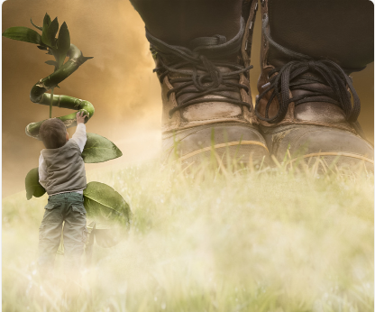

Traditional Tale
Jack and the Beanstalk Story
Recap the story ‘Jack and the Beanstalk’ that you started last week. What happens in the story? What characters are in the story? What are these characters like?

Story Map
Draw a ‘Story Map’ of the story using all the information you know. Remember to put the story in the correct order. Use your ‘Story Map’ to retell the story to your family, why not make some props to help you, make character props of the characters in the story.
Here are examples of a ‘Story Map’ for you to see
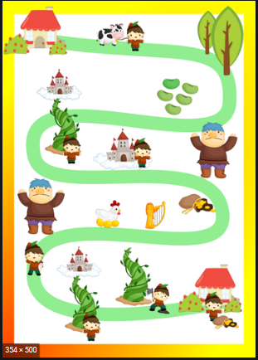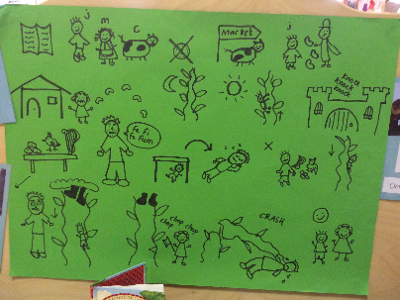

Numeracy Activities
Position and Direction
Start with a song. Look at the link to the BBC Bitesize website and listen to the ‘Position and Direction’ Song.
Rec: Look at the ‘Position’ PowerPoint on the ‘Class page’ to start.
Find your favourite toy, you are going to use this for the activity. You will need to use these words
In, on, under, next to, behind, in front, on top, between.
Using your favourite toy can you put it in these different positions? Can you use the words?
Ask someone to put your favourite toy in different places and you have to say where it is, swap over and take turns.

Little Red Riding Hood Spatial Awareness
Year 1: Using the ‘Power Point’ information on ‘Class Pages’ and the poster look at the pictures and think about what characters, animals, objects you see. What language can you use to describe these? Here are some questions to help.
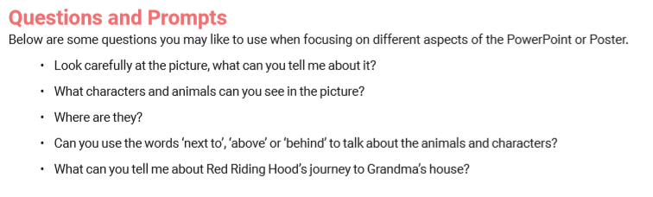
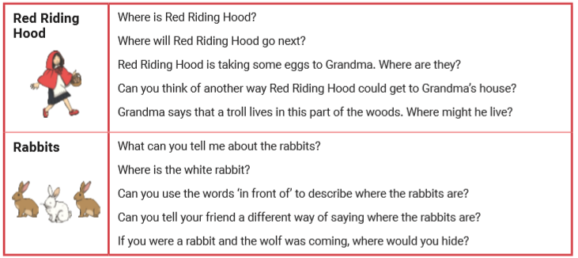
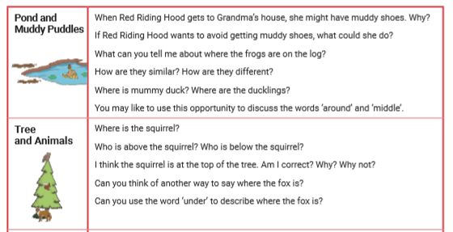

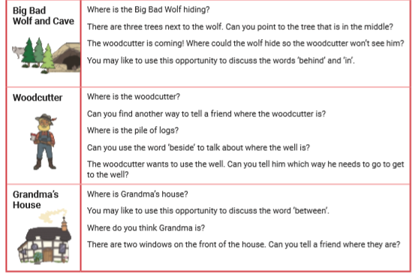

Try these activities
Draw a Map
Draw a map of the story ‘Little Red Riding Hood’. Talk about the different places on the map such as Red Riding Hood’s house, Grandma’s house, the pond and the woods. Draw a path connecting the two houses. Talk about different places and where they are What is next to Grandma’s house? Where could the Wolf live? What shall we draw below the trees?

Where is the Big Bad Wolf?
Hide a Wolf (or any soft toy), look for the toy and once it is found describe where you found it. Continue the game with different hiding places.

Months of the Year
Find out what the months of the year are, can you sing the song we sing in class? Look at the ‘Months’ PowerPoint on the ‘Class Page’, what do you notice about the months? What happens in each one?
Rec: Find out which month you get your birthday. Look for different things that happen in that month. You could draw pictures, find pictures online and print them or do a picture on HWB.
Year 1: Learn the order of the months, write them out on a paper, cut them up and jumble them around, can you put them back in the correct order? Write them out in the correct order.
Find out which month you get your birthday and draw all the things that happen in that month, what can you find out?

Topic Activity

Physical Activities
Take part in ‘Cosmic Yoga’. Look at the website and choose which ‘Yoga’ you would like to do. Keep a record of which ones you do.

Floating and Sinking
We have worked on materials and found out about these and now we are going to look at which materials and objects float and sink. Can you think of any objects?
Find some objects around the house and decide if you put them in water will they ‘Float or Sink’, sort them into two categories and make a list of what you think. Try the objects in water and see if you were correct, how many did you get right?

Pirate Ship Challenge
Make your own ‘Pirate Ship’ using materials you can find at home such as boxes and plastic trays. Make sure that you make it so that it can go into the water. Find some spare coins and see how many you can put in the ship before it sinks.

Sea Pollution
Look at the information on ‘Class Page’ about ‘Sea Pollution and Plastic’ What have you learnt?
Listen to the story ‘Somebody swallowed Stanley’ the link is on ‘Class Page’, think about what has happened in the story.

Can you make a poster to remind people not to throw plastic into the sea and to remember to put it in the bin. Make sure that you include lots of information and that your poster is bright and colourful.

There are some pictures on the website to help you.

Where I live: My Community
Think about where you live. What is it called? Where is it? What do you know about the place? What is there?
Can you find out about where you live? Draw a picture of your house and describe it.
Find out what is in your community, go on a walk and make a note of what you see.
Draw a map of the route you took on your walk, draw everything you saw.

Welsh

Choose a toy to spend your time with. Using the vocabulary on the next few pages on the ‘Penwythnos gyda ffrind’ sheet (A weekend with my friend) write down what you did in Welsh.
You could:
Take a picture of your activities
Draw a picture of your activities
Write down what you have done using the vocabulary to help you.

Reception Vocabulary

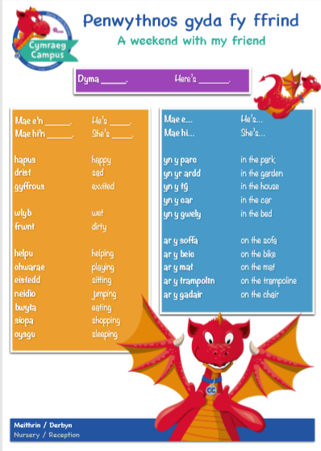

Year 1 Vocabulary
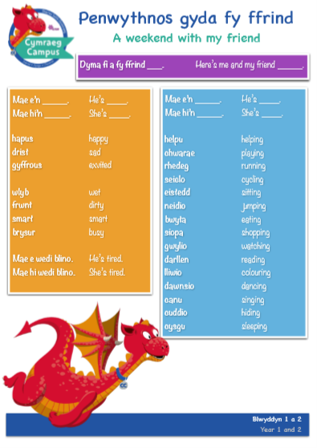

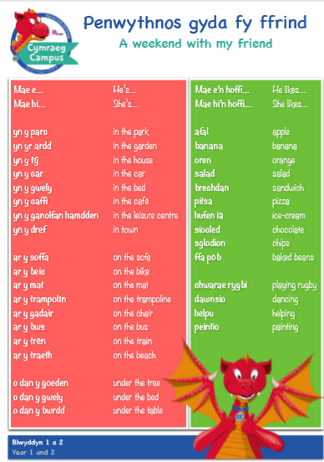

Challenges:
Here is a list of challenges for you to keep working on:
Reception:
- Learn to do up zips and buttons.
- Put on and take off your jumper on your own.
- Put on and take off your own socks and shoes.
- Dress and Undress yourself

Year 1:
- Learn to tie a knot.
- Learn to do a shoelace.
- Learn your home address and telephone number
- Set the table for breakfast, dinner and tea

