Home Learning Tasks
Here are the activities that are set for you this week. The ‘Daily Do’ will stay the same each week and updated when needed. Each week a new set of activities will be posted for you to do with your child. Please remember to do these activities, you can complete them as and when you wish. Please share the activities that you have done through ‘Class Dojo’ and through your child’s ‘Hwb’ account if you do anything online. You can take pictures of your child doing the activity or pictures of their work and post these.
Daily Do Activities (Please do these activities everyday)
Activities that you have done can be shared on ‘Class Dojo’
- Reception
- Write your name remembering to use your ‘whoosh’ at the start of each letter. (Refer to the letters in the ‘Sound Book’ for support.
- Write your numbers to 20 (Refer to the numbers in the ‘Number Book’ for correct formation)
- Write your letter sounds (Refer to the ‘Sound Book’ for formation)
- Read and write simple CVC words e.g. mat, cat, sat (Look at the words previously given out from school) you can find more of these online.
- Read and write ‘High Frequency Words’ these are words that you need to learn and that you will see in books e.g. I, the, put, he, it. You can find a list of the first 100 here at www.highfrequencywords.org/
- Count up to 20 or further forwards and backwards.
- Keep a diary. Draw and write a sentence about what you have done that day.
- Read a range of stories, you can find many online or just read the books you have at home.
- Say the weather in Welsh and teach your parents, find out the day, date and month
- Get outside for fresh air whenever you can and have lots of fun.
Year 1
- Write your full name remembering to use your ‘whoosh’ at the start of each letter.
- Write your numbers to 100.
- Count to 100 in 2’s, 5’s, 10’s start at different points.
- Say double numbers and number bonds to10 and even 20.
- Write your letter sounds and remember to use a ‘whoosh’ at the start.
- Read and write ‘High Frequency Words’. You can find the list here www.highfrequencywords.org/
- Read and write the spelling words that you have been given previously in your ‘Spelling Book’. You can find more spelling ideas for Year 1 online.
- Keep a diary: Draw and write about what you have done that day. Remember to give details about what you have done and begin to write longer sentences/paragraphs. Don’t forget Capital letter, finger spaces and a full stop.
- Read a range of stories, you can find many online or just read the books you have at home.
- Say the weather in Welsh and teach your parents, find out the day, date and month
- Get outside for fresh air whenever you can and have lots of fun.
Week 9: 08/06/20
Literacy Activities
Rhyme: Songs
Rhyme Challenge:
Learn these rhymes to perform to family ‘There was an old lady’ and ‘Miss Polly had a dolly’ You can find the rhyme on ‘Class Pages’ or you can look for them online.

Reception: Learn the rhymes, record the rhyme and perform to your family. Why not video the performance and send to your friends and family.
Year 1: Learn the rhymes, record the rhyme and perform to your family. Why not video the performance and send to your friends and family.

Role Play
Set up a stage for your performance. Make posters and tickets to advertise the time and date of the performance. Dress up in your best performance clothes and put on a show.

Spelling
Reception: ‘I Spy’ Sheet How many CVC words can you find and write? (Please see the sheet attached on the class page)
Year 1: Spelling, Punctuation and Grammar Mats: Mat 1 and Mat 2 (Please see the sheet attached on the class page)

Storytime: Oxford Owl Website
Listen to the ‘Traditional Tales’ stories on ‘Oxford Owl Storyteller’.
The Story: The Frog Prince
What is the story about? Who are the characters?
The link to the story is on ‘Class Pages’

Reading
Choose a book to read on ‘Oxford Owl’. Use the age, series or Oxford level to help you find a book. How many can you read? Have a read of the RWI books that can also be found. The links are on the ‘Class Page’ for you.

Word of the Day: Monday -Thursday
Look at a different word each day and find out the meaning, find a picture that might help you. Write the word and make it into a sentence.
Monday’s word: stove
Tuesday’s word: rusty
Wednesday’s word: chalkboard
Thursday’s word: roasting

Pobble 365
Look at this picture and discuss. See the additional discussion ideas on ‘Class Page’
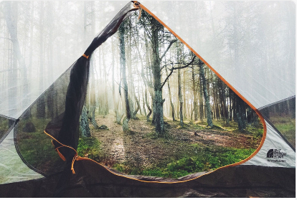

Traditional Tale
Jack and the Beanstalk Story
Recap the story ‘Jack and the Beanstalk’ that you started last week. What happens in the story? What characters are in the story? What are these characters like?

Story Writing Jack and the Beanstalk
Remember the ‘Story Map’ you did last week to retell the story, using this map can you write the story in the correct order. Remember to use the language First, Next, Then, Finally.
Reception: Draw a picture form the story and write a sentence.
Year 1: Write the story using as much detail as you can. Remember to sequence the story correctly and use capital letters, finger spaces and full stops.

Numeracy Activities
Position and Direction
Rec: Remember the words you learnt last time ‘In, on, under, next to, behind, in front, on top, between’.
Using these words try some of these fun activities.
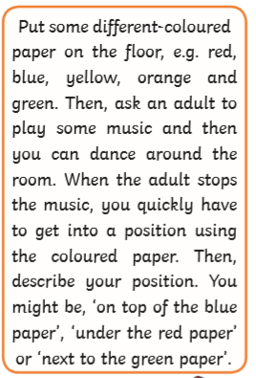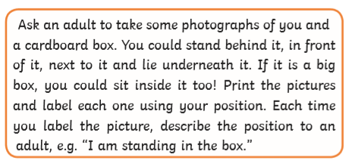

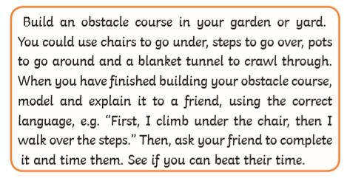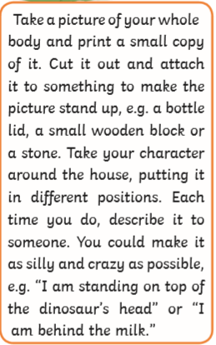
Year 1
Remember last time you looked at activities to do with Little Red Riding Hood, you looked at objects in the forest on the map. Now you are going to use the same language ‘In, on, under, next to, behind, in front, on top, between’ but you are also going to use ‘Right and Left’. Find out which is your ‘Right Hand’ and which is your ‘Left Hand’. Get an adult to help you learn which is which.
Game:
Get an adult to ask you to turn in different ways can you go right and can you go left? Turn to different objects in your house e.g turn right and take 3 steps forward to the table.
Whole and Half Turns
Now that you know ‘Right and Left’ can you try and turn a ‘Whole turn’ and ‘Half a turn’ and add these to your game.
Activities:
Try some of the fun activities on the ‘Class Page’ you will find activity sheets called ‘Activity Cards Describing Position’ and a ‘Directions in the City’ map activity.

Money
Find different coins in your house, which ones have you found? How many have you got? Gather different objects/toys to make a shop, make some price tags for the objects/toys, decide how much each one will cost e.g. 5p, 7p,10p, 12p,15p.
Play a game with an adult, decide who will be the shopkeeper and who will be the customer. You can then swap over.

Rec: Pay for items using 1p, 2p, 5p and 10p
Year 1: Pay for items making different combinations up to 20p.

Try the interactives games and songs on the ‘Class Page’.

Topic Activity

Physical Activities
Take part in ‘Cosmic Yoga’. Look at the website and choose which ‘Yoga’ you would like to do. Keep a record of which ones you do.

The Lightbulb
I have planned few activities for you related to the theme of a ‘Lightbulb’, you are going to find out about the lightbulb through finding some facts about it, find out how it is used and who invented it.

ICT
Using the internet find out as many facts as you can about a ‘Lightbulb’ You might want to look at who invented it or what they are made form.

Story: The Light House Keeper’s Lunch
Listen to the story ‘The Lighthouse keeper’s Lunch’ (The link to the story is on the ‘Class Page’) Think about where Mr Grinling lives, what type of place is it? What is it like? What would it be like to live there?

Mumbles Lighthouse
In Mumbles we have our very own ‘Lighthouse’ can you find as much information as you can about the lighthouse. Why is it there? What does it do? Why is there a light at the top? Draw a picture and write your facts.

Lighthouses around the world
Find out as much information as you can about the different types of lighthouses there are around the world. Where are they? What do they look like? Are they different from each other?

Use the information on the ‘Class Page’ to help you find out more.

Make a Lighthouse
Mr Grinling has sent a letter read it and find out more. Are you up for the challenge he has set? What materials will you use? Can you put a light in your lighthouse?
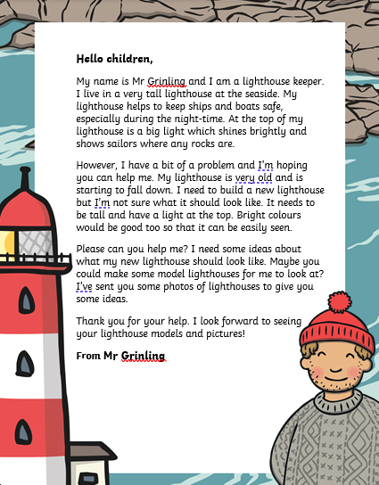

Electricity Safety Poster
Go around your house looking for items that use electricity, can you name them? Think of all the ways that you must stay safe around electricity, look at the poster below and discuss what it shows.

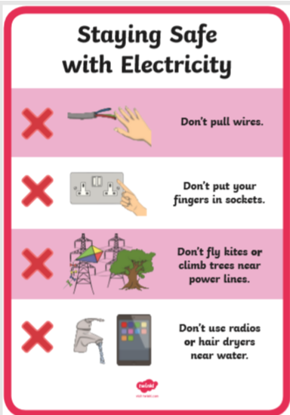
Make a poster telling people how to stay safe around electricity. Remember to make your poster bright and colourful so that everybody can see it.

Spot the electric dangers
Look at the picture below and see if you can spot all the dangers in the picture. Make a list of al the things that you can see that are dangerous.

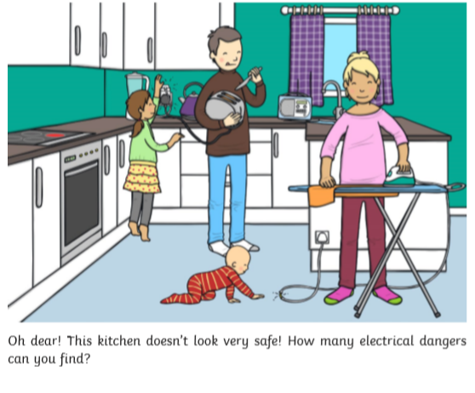
Welsh
Yn yr Ardd (In the garden)

Prepositions
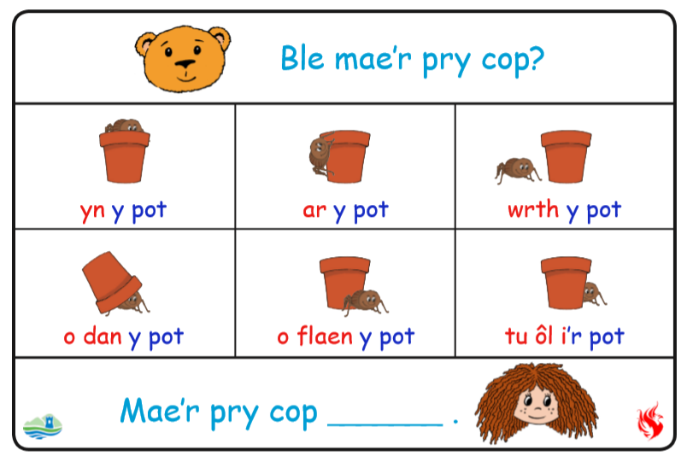
Can you say where the spider is? Learn the Welsh words for the prepositions. Why not try hiding something of your own in the garden?

Translation

Yn y pot: In the garden
Ar y pot: On the pot
Wrth y pot: By the pot
O dan y pot: Under the pot
O flaen y pot: in front of the pot
Tu ol y pot: behind the pot

Beth sy yn yr ardd? ( What is in the garden)
Learn the names of the creatures found in the garden, can you find any in your garden?
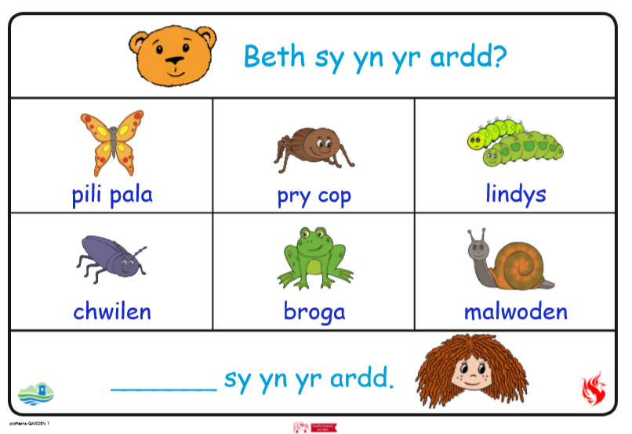
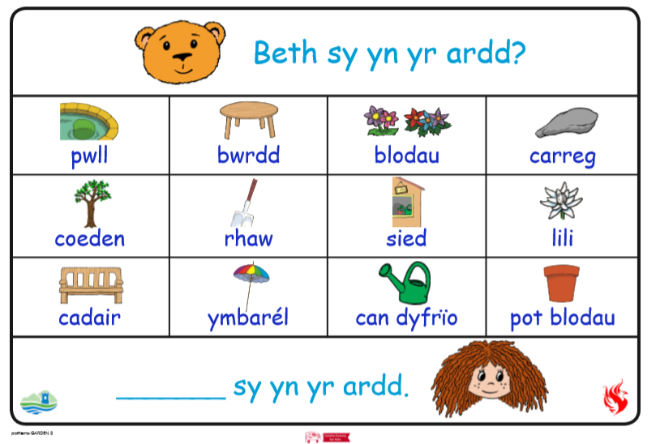
Can you find any of these items in your garden? If you can why not make a label for them in Welsh. Use the vocabulary to help you. Can you use the sentence pattern?

Challenges:
Here is a list of challenges for you to keep working on:
Reception:
- Learn to do up zips and buttons.
- Put on and take off your jumper on your own.
- Put on and take off your own socks and shoes.
- Dress and Undress yourself

Year 1:
- Learn to tie a knot.
- Learn to do a shoelace.
- Learn your home address and telephone number
- Set the table for breakfast, dinner and tea

