Home Learning Tasks
Here are the activities that are set for you this week. The ‘Daily Do’ will stay the same each week and updated when needed. Each week a new set of activities will be posted for you to do with your child. Please remember to do these activities, you can complete them as and when you wish. Please share the activities that you have done through ‘Class Dojo’ and through your child’s ‘Hwb’ account if you do anything online. You can take pictures of your child doing the activity or pictures of their work and post these.
Daily Do Activities (Please do these activities everyday)
Activities that you have done can be shared on ‘Class Dojo’
- Reception
- Write your name remembering to use your ‘whoosh’ at the start of each letter. (Refer to the letters in the ‘Sound Book’ for support.
- Write your numbers to 20 (Refer to the numbers in the ‘Number Book’ for correct formation)
- Write your letter sounds (Refer to the ‘Sound Book’ for formation)
- Read and write simple CVC words e.g. mat, cat, sat (Look at the words previously given out from school) you can find more of these online.
- Read and write ‘High Frequency Words’ these are words that you need to learn and that you will see in books e.g. I, the, put, he, it. You can find a list of the first 100 here at www.highfrequencywords.org/
- Count up to 20 or further forwards and backwards.
- Keep a diary. Draw and write a sentence about what you have done that day.
- Read a range of stories, you can find many online or just read the books you have at home.
- Say the weather in Welsh and teach your parents, find out the day, date and month
- Get outside for fresh air whenever you can and have lots of fun.
Year 1
- Write your full name remembering to use your ‘whoosh’ at the start of each letter.
- Write your numbers to 100.
- Count to 100 in 2’s, 5’s, 10’s start at different points.
- Say double numbers and number bonds to10 and even 20.
- Write your letter sounds and remember to use a ‘whoosh’ at the start.
- Read and write ‘High Frequency Words’. You can find the list here www.highfrequencywords.org/
- Read and write the spelling words that you have been given previously in your ‘Spelling Book’. You can find more spelling ideas for Year 1 online.
- Keep a diary: Draw and write about what you have done that day. Remember to give details about what you have done and begin to write longer sentences/paragraphs. Don’t forget Capital letter, finger spaces and a full stop.
- Read a range of stories, you can find many online or just read the books you have at home.
- Say the weather in Welsh and teach your parents, find out the day, date and month
- Get outside for fresh air whenever you can and have lots of fun.
Week 10: 15/06/20
Literacy Activities
Rhyme: Songs
Rhyme Challenge:
Learn these rhymes to perform to family ‘The Grand Old Duke of York’ and ‘Sing a Song of Sixpence’ You can find the rhyme on ‘Class Pages’ or you can look for them online.

Reception: Learn the rhymes, record the rhyme and perform to your family. Why not video the performance and send to your friends and family.
Year 1: Learn the rhymes, record the rhyme and perform to your family. Why not video the performance and send to your friends and family.

Role Play
Set up a stage for your performance. Make posters and tickets to advertise the time and date of the performance. Dress up in your best performance clothes and put on a show.

Spelling
Reception: ‘CVC Peg Match’ Sheet How many CVC words can you read? (Please see the sheet attached on the class page)
Year 1: Spelling, Punctuation and Grammar Mats: Mat 3 and Mat 4 (Please see the sheet attached on the class page)

Storytime: Oxford Owl Website
Listen to the ‘Traditional Tales’ stories on ‘Oxford Owl Storyteller’.
The Story: The Magic Paintbrush
What is the story about? Who are the characters?
The link to the story is on ‘Class Pages’

Reading
Choose a book to read on ‘Oxford Owl’. Use the age, series or Oxford level to help you find a book. How many can you read? Have a read of the RWI books that can also be found. The links are on the ‘Class Page’ for you.

Word of the Day: Monday -Thursday
Look at a different word each day and find out the meaning, find a picture that might help you. Write the word and make it into a sentence.
Monday’s word: disappoint
Tuesday’s word: velvet
Wednesday’s word: luxurious
Thursday’s word: fourteen

Pobble 365
Look at this picture and discuss. See the additional discussion ideas on ‘Class Page’


Traditional Tale
Jack and the Beanstalk: The Magic Bean
Think of Jack in the story and the magic bean he found.
What would you do with a magic bean?
Write down what you would do, use the sentence starter ‘If I had a magic bean….
Think about:
What would you do?
Where did you find it?
What did you feel like?
Where did you find it?

Numeracy Activities
Data Handling: Minibeasts
You are going to need an outside space for your activity. You are going to go on a minibeast hunt to find as many small creatures as you can. Make a list of all the creatures you might find and then go into your outside space and look for them. Write down your results to make a chart. You could use numbers, pictures or a tally or you could use all three ways of keeping a record.
Next you could make a graph of your results using Hwb. Here is a step by step guide to help you:

Log into hwb
Go to Just2easy 

Go to Jit 

Go to chart (yr1) and pictogram (rec)

Year 1: 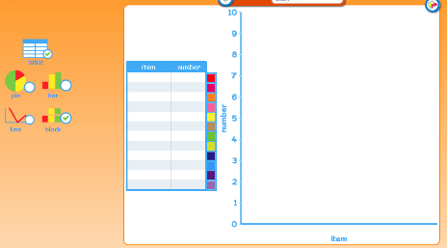
Choose either block or graph to record
your results. Write the names and number
of your creatures in the box.

Rec 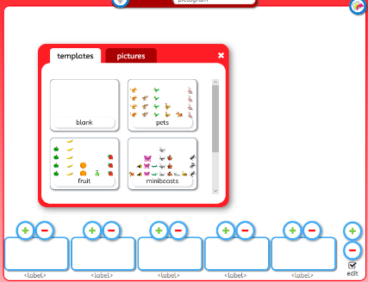 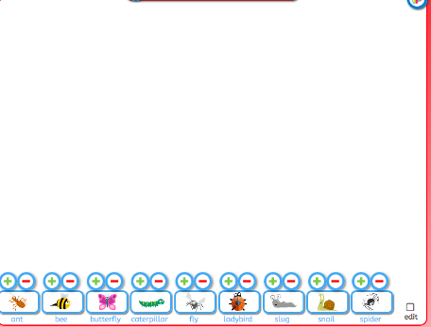

Save and name your work using the icon 

Problem Solve: Money
Try these activities
Reception
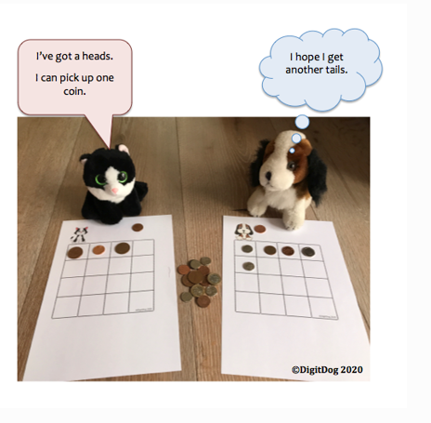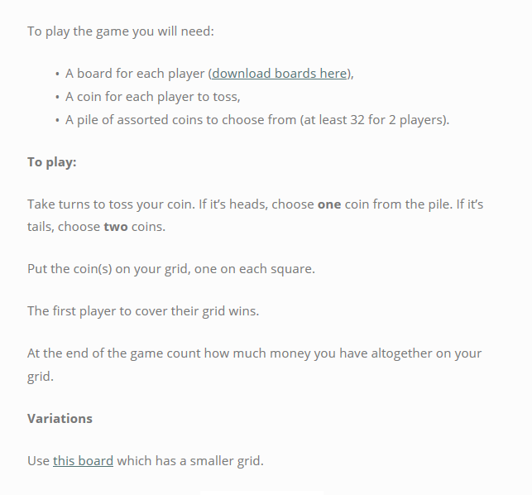

Year 1:
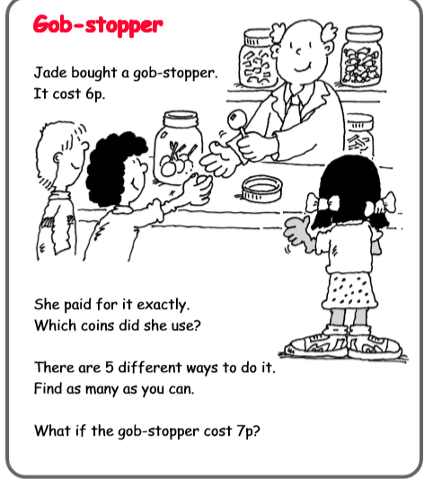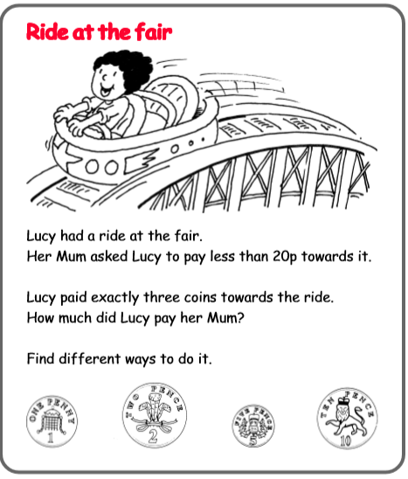

Topic Activity

Physical Activities
Take part in ‘Cosmic Yoga’. Look at the website and choose which ‘Yoga’ you would like to do. Keep a record of which ones you do.

The Lightbulb: Grace Darling
Grace Darling is famous for helping save people when a boat crashed in stormy weather.
Find as many facts as you can about Grace Darling and write an ‘Information Factfile’ about her. Here are some ideas for you to include:
Date of birth:
Where she lived:
What she did

Search for information using the internet or use the information on ‘Class pages’ to help you.

Grace Darling Timeline:
Can you sequence the events of Grace Darling’s life Put the pictures in the correct order. Find the timeline activity sheet on ‘Class pages’.

Thomas Edison
Thomas Edison was famous for inventing the lightbulb.
Find 5 facts about him and write them down.

You can search using the internet or use the information on ‘Class pages’ to help you.
Lightbulb Experiment
Try this fun activity. Remember to be carful and ask an adult to help you.
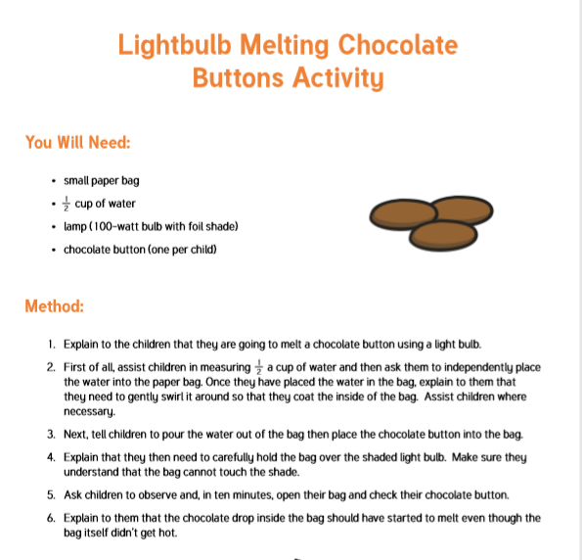

Story: The Light House Keeper’s Lunch
Mr Grinling’s Lighthouse: Light Problem
Mr Grinling has a problem. The light in his lighthouse has gone out. He needs you to help him think of what else he could use as a light while he fixes the proper light. The light needs to be bright enough to show the passing boats.
Have a look around your house to see if you can find anything, he could use. Why do you think what you have choose is a good idea?

Welsh
Y Traeth (The Beach)
Ga i… (Can I have)
Using the sentence pattern ‘Ga i’ talk about what you would like. If you have any of these items at home you could use them to help you.

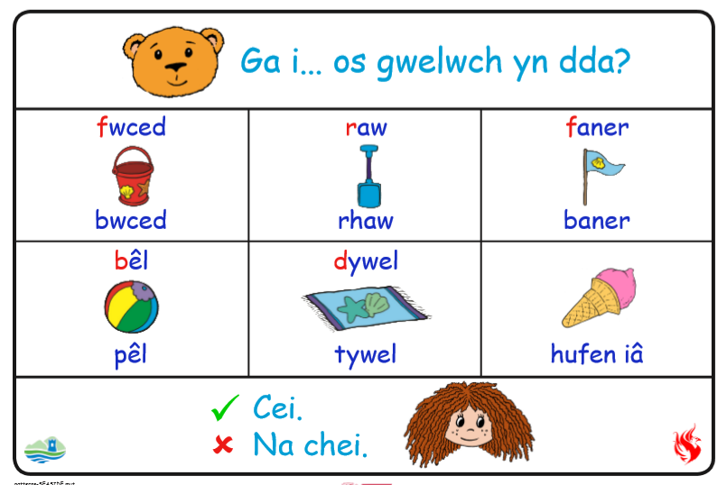

Challenges:
Here is a list of challenges for you to keep working on:
Reception:
- Learn to do up zips and buttons.
- Put on and take off your jumper on your own.
- Put on and take off your own socks and shoes.
- Dress and Undress yourself

Year 1:
- Learn to tie a knot.
- Learn to do a shoelace.
- Learn your home address and telephone number
- Set the table for breakfast, dinner and tea

