Home Learning Tasks
Here are the activities that are set for you this week. The ‘Daily Do’ will stay the same each week and updated when needed. Each week a new set of activities will be posted for you to do with your child. Please remember to do these activities, you can complete them as and when you wish. Please share the activities that you have done through ‘Class Dojo’ and through your child’s ‘Hwb’ account if you do anything online. You can take pictures of your child doing the activity or pictures of their work and post these.
Daily Do Activities (Please do these activities everyday)
Activities that you have done can be shared on ‘Class Dojo’
- Reception
- Write your name remembering to use your ‘whoosh’ at the start of each letter. (Refer to the letters in the ‘Sound Book’ for support.
- Write your numbers to 20 (Refer to the numbers in the ‘Number Book’ for correct formation)
- Write your letter sounds (Refer to the ‘Sound Book’ for formation)
- Read and write simple CVC words e.g. mat, cat, sat (Look at the words previously given out from school) you can find more of these online.
- Read and write ‘High Frequency Words’ these are words that you need to learn and that you will see in books e.g. I, the, put, he, it. You can find a list of the first 100 here at www.highfrequencywords.org/
- Count up to 20 or further forwards and backwards.
- Keep a diary. Draw and write a sentence about what you have done that day.
- Read a range of stories, you can find many online or just read the books you have at home.
- Say the weather in Welsh and teach your parents, find out the day, date and month
- Get outside for fresh air whenever you can and have lots of fun.
Year 1
- Write your full name remembering to use your ‘whoosh’ at the start of each letter.
- Write your numbers to 100.
- Count to 100 in 2’s, 5’s, 10’s start at different points.
- Say double numbers and number bonds to10 and even 20.
- Write your letter sounds and remember to use a ‘whoosh’ at the start.
- Read and write ‘High Frequency Words’. You can find the list here www.highfrequencywords.org/
- Read and write the spelling words that you have been given previously in your ‘Spelling Book’. You can find more spelling ideas for Year 1 online.
- Keep a diary: Draw and write about what you have done that day. Remember to give details about what you have done and begin to write longer sentences/paragraphs. Don’t forget Capital letter, finger spaces and a full stop.
- Read a range of stories, you can find many online or just read the books you have at home.
- Say the weather in Welsh and teach your parents, find out the day, date and month
- Get outside for fresh air whenever you can and have lots of fun.
Week 11: 22/06/20
Literacy Activities
Rhyme: Songs
Rhyme Challenge:
Learn these rhymes to perform to family ‘Alice the Camel’ and ‘Doctor Foster’ You can find the rhyme on ‘Class Pages’ or you can look for them online.

Reception: Learn the rhymes, record the rhyme and perform to your family. Why not video the performance and send to your friends and family.
Year 1: Learn the rhymes, record the rhyme and perform to your family. Why not video the performance and send to your friends and family.

Role Play
Set up a stage for your performance. Make posters and tickets to advertise the time and date of the performance. Dress up in your best performance clothes and put on a show.

Spelling
Reception: ‘CVC Snakes and Ladders’ Sheet. How many CVC words can you read? (Please see the sheet attached on the class page)
Year 1: Spelling, Punctuation and Grammar Mats: Mat 5 and Mat 6 (Please see the sheet attached on the class page)

Storytime: Oxford Owl Website
Listen to the ‘Traditional Tales’ stories on ‘Oxford Owl Storyteller’.
The Story: Finn MacCool
What is the story about? Who are the characters?
The link to the story is on ‘Class Pages’

Reading
Choose a book to read on ‘Oxford Owl’. Use the age, series or Oxford level to help you find a book. How many can you read? Have a read of the RWI books that can also be found. The links are on the ‘Class Page’ for you.

Word of the Day: Monday -Thursday
Look at a different word each day and find out the meaning, find a picture that might help you. Write the word and make it into a sentence.
Monday’s word: wearing
Tuesday’s word: collectable
Wednesday’s word: dusk
Thursday’s word: eerie

Pobble 365
Look at this picture and discuss. See the additional discussion ideas on ‘Class Page’


Traditional Tale
Jack and the Beanstalk: The Giant
Think about the Giant in the story. What do you think he would do everyday?
Pretend that you are the giant from the story and write a diary.
Reception: Choose one day to write about
Year 1: Write a weekly diary

Numeracy Activities
Doubling Numbers
Reception
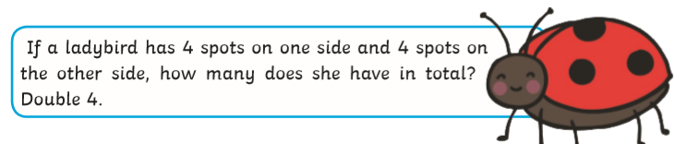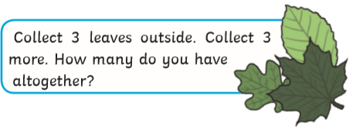
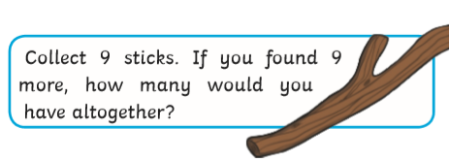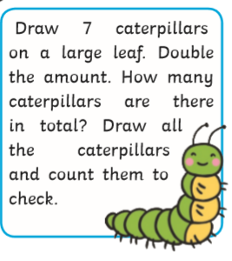

Year 1
Think of the tall beanstalk in the story and the leaves that grow on it.
Draw a tall beanstalk and draw and cut out some leaves to add to your beanstalk. You are going to add some leaves to one side of your beanstalk and then the same amount to the other side to work out the doubles. Write down the sum that you do. Work on doubles to 10. Can you extend to more? How many more doubles can you make? Can you go to 20?

Data Handling
How many of these activities can you do?
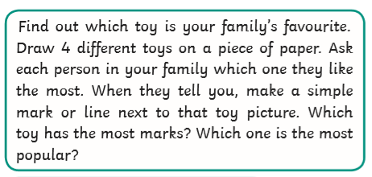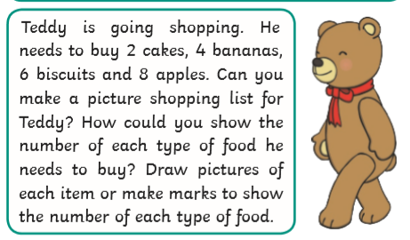

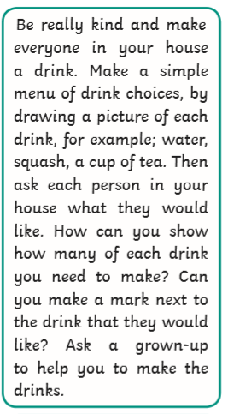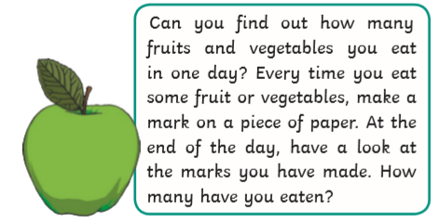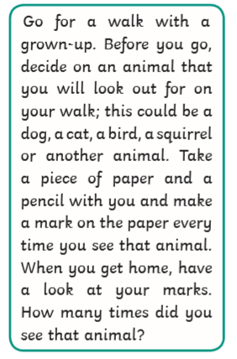

Topic Activity

Physical Activities
Take part in ‘Cosmic Yoga’. Look at the website and choose which ‘Yoga’ you would like to do. Keep a record of which ones you do.

The Lightbulb: Light
Can you find the answers to these questions? Make an ‘Information Booklet’ to show your answers.
Questions:
What is light?
Where does light come from?
How do we use light?

Lighthouse Painting: famous Painter Joseph Mallord William Turner
Look at these images of lighthouses painted by the famous artist Joseph M W Turner. What do you notice about the paintings? What colours are used? How do they make you feel?

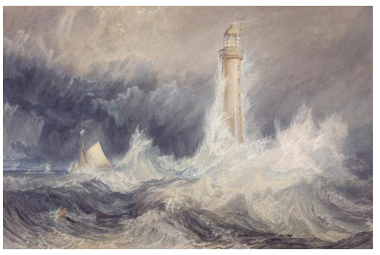
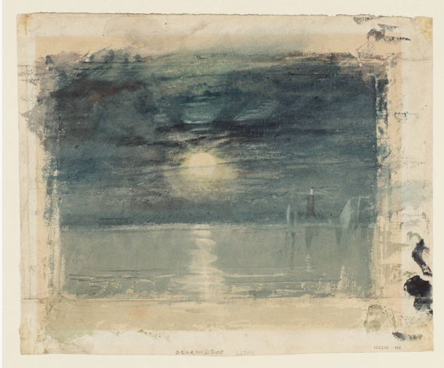

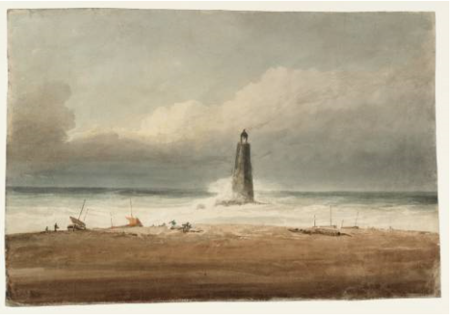

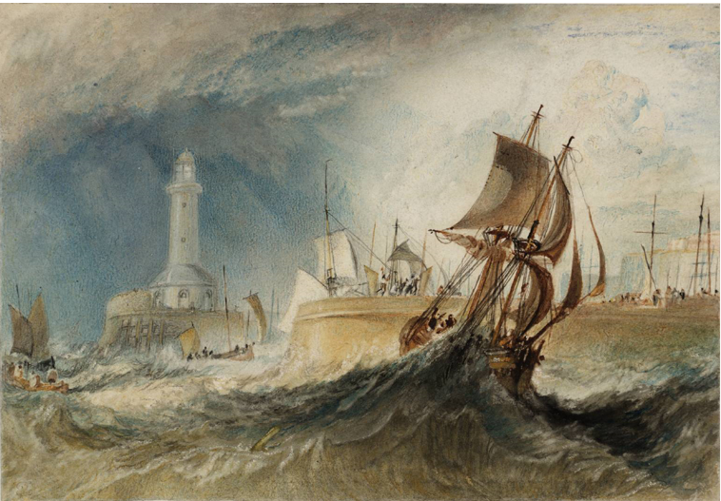

Can you paint a picture of a lighthouse in the style of J M W Turner?

You can search using the internet or use the information on ‘Class pages’ to help you.

Light Experiment
Try these fun activities. Remember to be careful and ask an adult to help you.
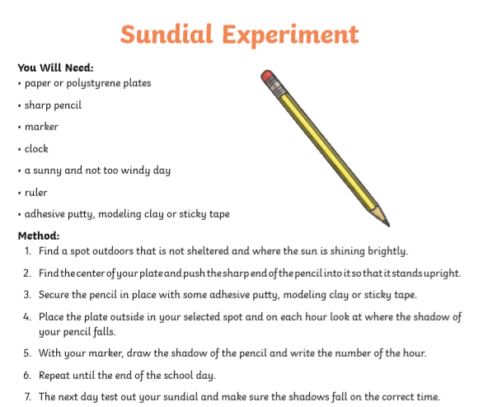
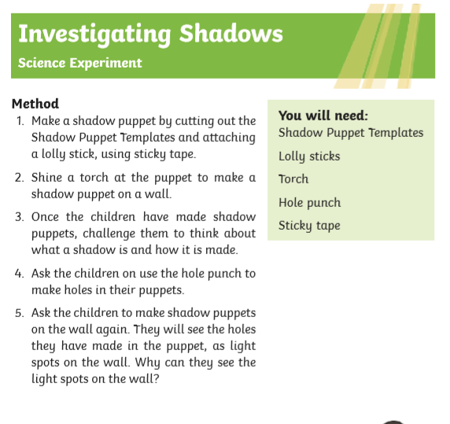
Swansea Jack: The famous dog
Swansea Jack was a famous dog who rescued a little boy and lots of people from the river.

Search on the internet to find out what you can about the famous dog.

Listen to the story on the link on the ‘class page’, in the story you will found out about all the local landmarks and sights in Swansea.

Challenges:
Here is a list of challenges for you to keep working on:
Reception:
- Learn to do up zips and buttons.
- Put on and take off your jumper on your own.
- Put on and take off your own socks and shoes.
- Dress and Undress yourself

Year 1:
- Learn to tie a knot.
- Learn to do a shoelace.
- Learn your home address and telephone number
- Set the table for breakfast, dinner and tea

