  1 |  |  |  | Theme: Pharaohs  Year group: Year 4/5 PPA Mrs Watts
Literacy     | Numeracy  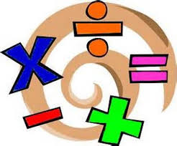   | Creative     | Thinking     |  | Healthy me    
PSE: Similarities and Differences
UNCRC Article 30: You have the right to use your own language.
Watch the video clip about Owain: Attitudes towards the Welsh language - KS2 PSHE and Citizenship - BBC Bitesize
The language we speak gives us a sense of identity and makes us unique.
1). Discuss discrimination by thinking about the issues raised by Owain's parents, regarding times when they have been asked or even told not to use their own language.

2). Why is it important to speak our own language?

3). Describe what it would be like if you were stopped from speaking your own language.

4). Record your response on Flipgrid:
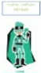
https://flipgrid.com/d9b7612a

P.E: Gymnastic skills
Watch and follow the instructions on the powerpoint.
Record your movements using Flipgrid:
https://flipgrid.com/24123052
If you have any questions/problems, email me:
Wattss11@hwbmail.net
Or, message me on Class Dojo, or Teams.

