  Date: 13/07/20 |  |  |  | Theme: Rio De Vida  Year group: Reception/Year 1
Literacy      This Photo by Unknown Author is licensed under CC BY-NC-ND   | Numeracy     | Creative     | Thinking     |  | Healthy me    
Story: Oxford Owl Stories  Songbirds: Choose a story to listen to.  Chapter books: Choose a story to listen to.  Spelling:  Rec: Dittie 3: A man and a dog  RWI: Green and Red words Green 5+6 Red set 4 (Read and Spell words)  Oxford Owl RWI: Set 1 Slideshow and Set 1 Speedy Green Words.  Year 1: Summer Spelling Mat 5+6  Oxford Owl RWI: Set 2 Speedy Green and Set 3 Speedy Green.  Links to the word slideshows will be on the website.  Little Red Riding Hood  Recap and listen to the story Little Red Riding Hood and discuss what it is about.  The story is on the ‘Shared File’  On Hwb.  Story Map  Think of the story and what happens, where is it set and who are the characters.  Draw a story map to retell the story. Here is an example for you.  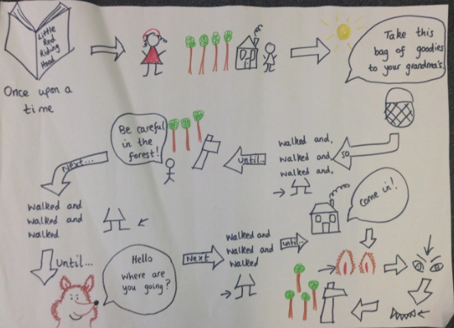  Write down any key words that will help you to retell the story.  Welsh  Postcard from Brazil  Imagine that you are on holiday in Brazil. Write a postcard to someone in your family telling them about your holiday.  Use the pattern:  Es i…. (I went)  Gwelais i….. (I saw)  Bwytais i…. (I ate)  Reception: Write one sentences for each.  Year 1: Write two sentences for each.  Please see example postcard attached. | Addition and Subtraction  Reception: Addition  My Fish Tank  My fish tank needs cleaning, some fish are blue, and some fish are red. To clean my tank, I need to move the fish into two smaller tanks. I can’t put all the fish in one of the smaller tanks because they won’t fit.  What can I do?  Can you separate the red and blue fish? Write down the sum that you make. You could draw red and blue fish to help you.  Please see the information on the ‘Shared Files’ on Hwb to help.  Addition and Subtraction  Year 1:  The Great Outdoors  Find some natural resources that you can use to do some addition and subtraction sums.  Make your sum and write your answers.  Activity:  The ‘Great Outdoors’ question cards.  How many of these questions can you answer?  Please see the cards attached | Samba Headdress/Mask  To take part in a carnival you need a headdress or a mask. This needs to be colourful and bright so you can be seen in the carnival.  Can you make your own carnival headdress or mask?  Carnival Time  You have listened to carnival music, danced to music and made a headdress or mask. It is now time to takes part in a ‘Carnival’.  Put on your headdress, choose your music and play your instrument. Dance around and pretend you’re at the carnival.  Video your carnival to share with your friends and family and don’t forget to share with Miss Rees.  Brazil  Listen to the Brazilian National Anthem. Find out what language it is sung in. | Brazil  Brazil is a country in South America and it has a carnival called ‘Mardis Gras’.  Can you find as many facts as you can about Brazil and write them down? You can draw pictures or print pictures.  Write an ‘Information Fact File’ about Brazil.  Things to think about:  Capital city  Population  Currency  Language famous landmarks |  | Outdoor Activities  Take part in outdoor activities of your choice.  Cosmic Yoga  Try some of the yoga activities on the website.

