Literacy
Reception
Dittie 1: a man and a dog
Please read through this Dittie with your child.
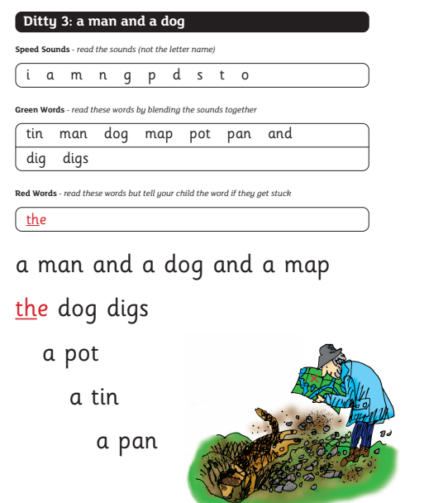

Green Words Set 1: Word Time 5
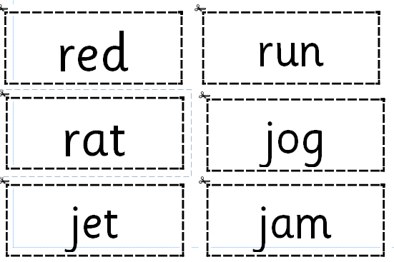
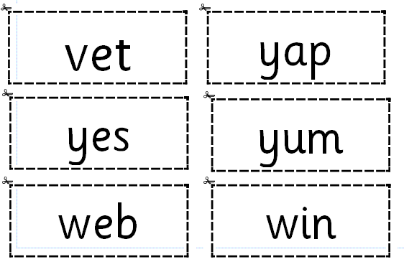
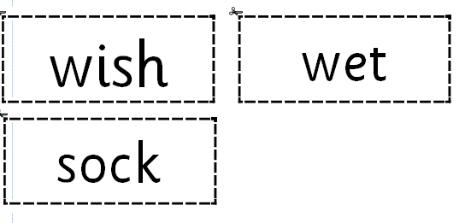

Word Time 6

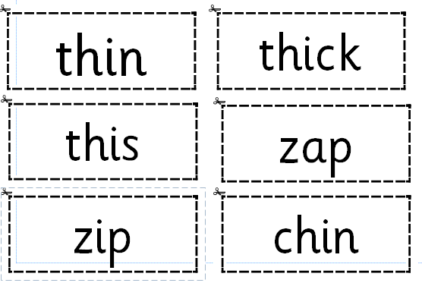
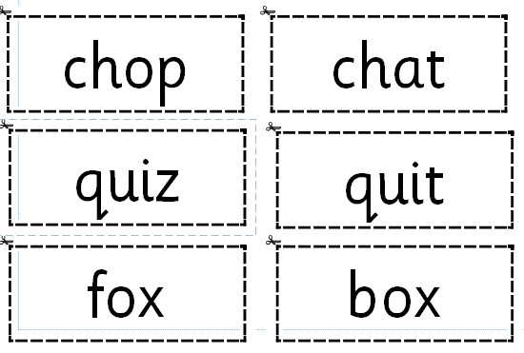
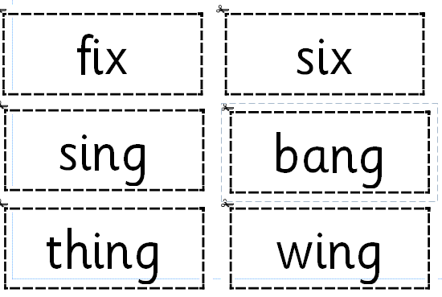
Red Words Set 4
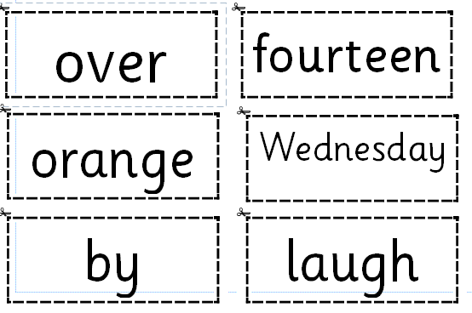
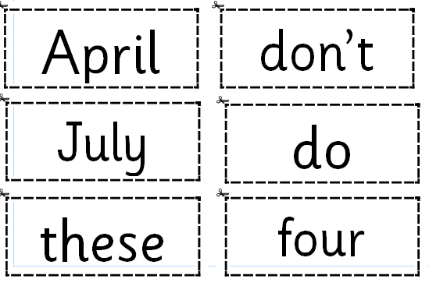
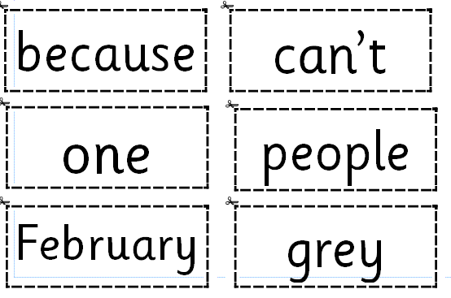

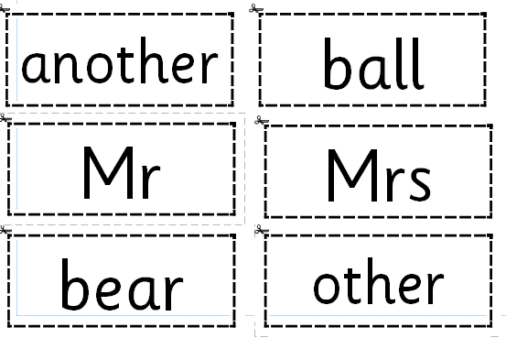
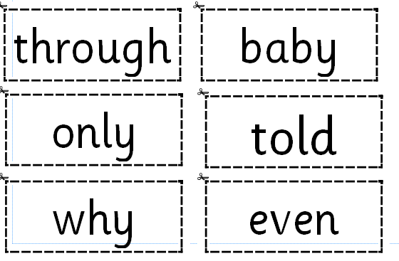
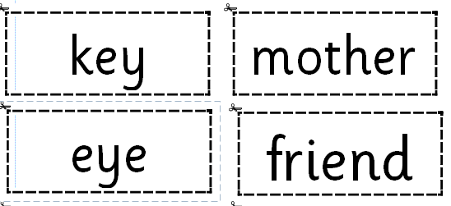

Numeracy
Addition
Please see the presentation on ‘Shared Files in Hwb to help
Here is the fish tank that you need to use to help with the red and blue fish. Put some in one bowl and some in the other bowl and work out how many you have altogether. You can use anything to make the bowls, you could use tow bowls from home.

In the main tank you have all your fish and in the two smaller bowls you put red in one side and blue in the other side.

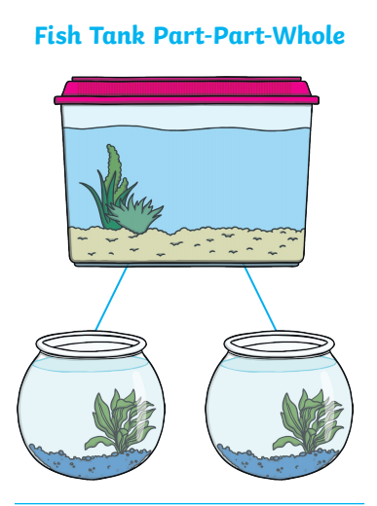

Carnival Headdress/Mask
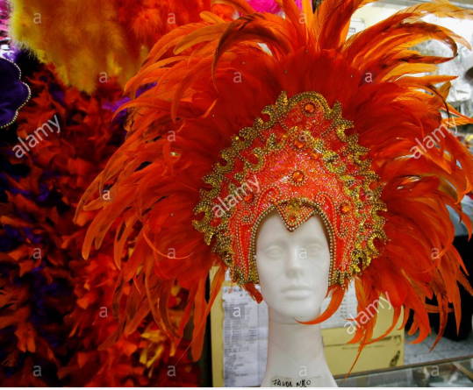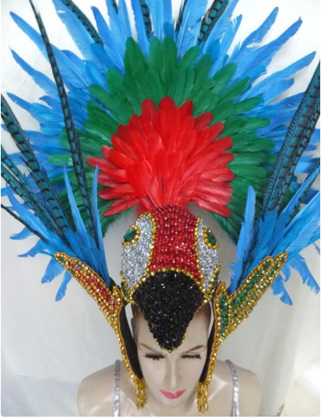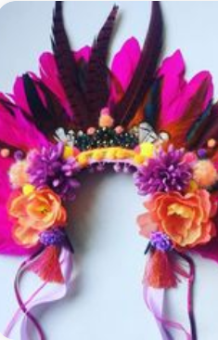

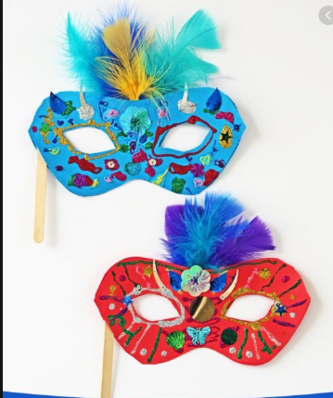

Welsh Postcard from Brazil
Here is an example postcard to help you.
Annwyl Mam (Dear Mum)  Es i Brazil. (I went to Brazil)  Es i gem pel droed (I saw a football game)  Gwelais i y traeth Copacabana (I saw Copacabana beach)  Bwytais i sglodion. (I ate chips)  Oddi Wrth (From)  Miss Rees | 

