Numeracy
Addition
The Great Outdoors
Try these activities and then make up your own addition and subtraction sums.
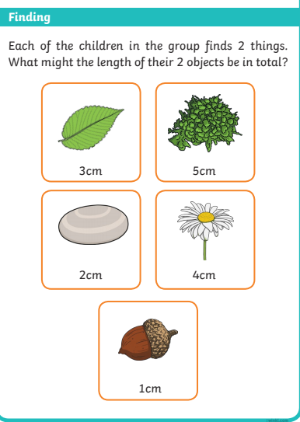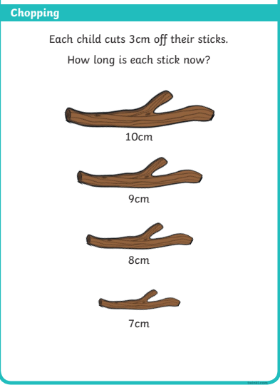
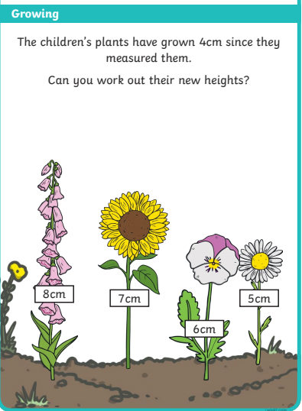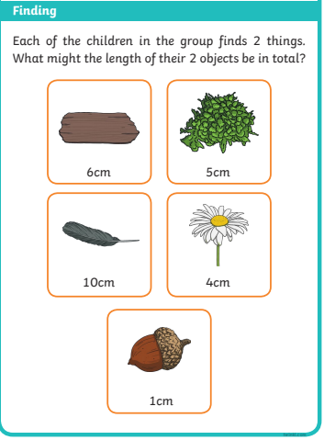

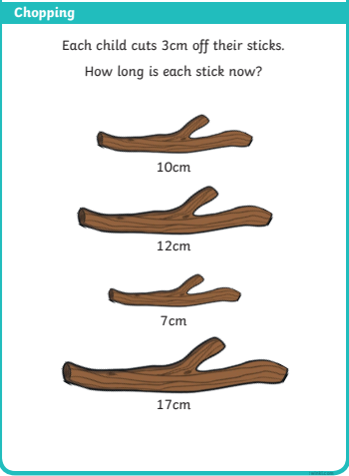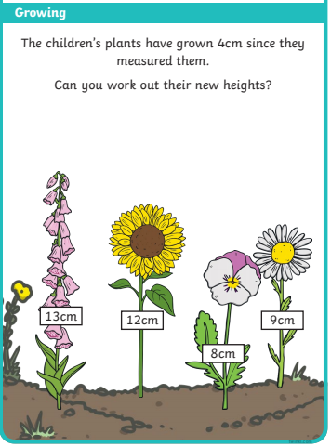

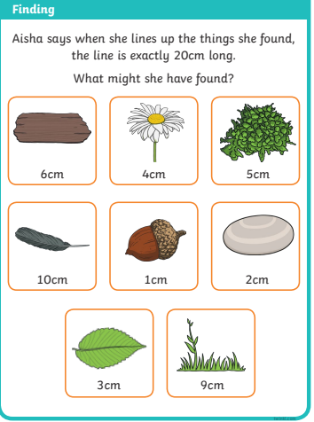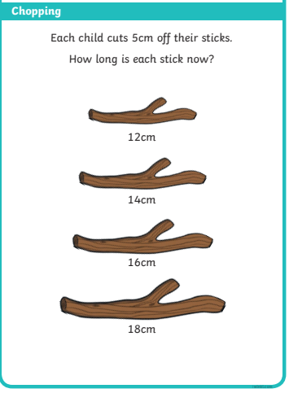

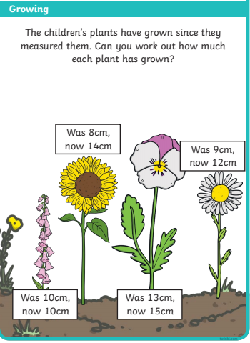

Carnival Headdress/Mask
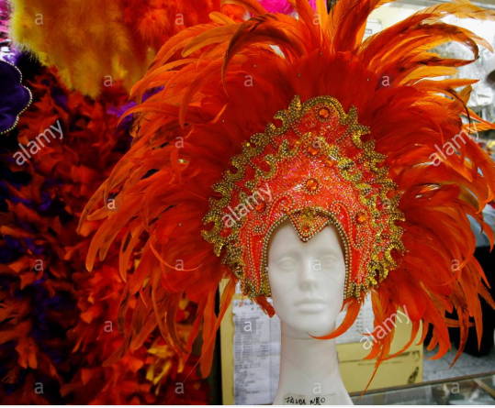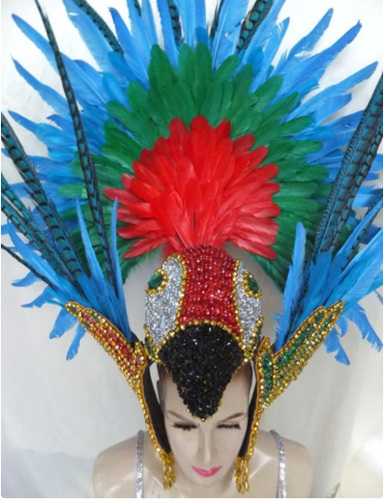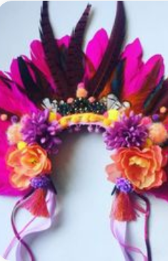

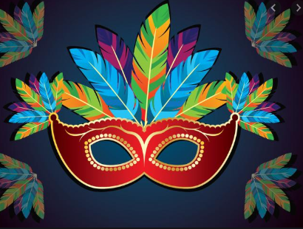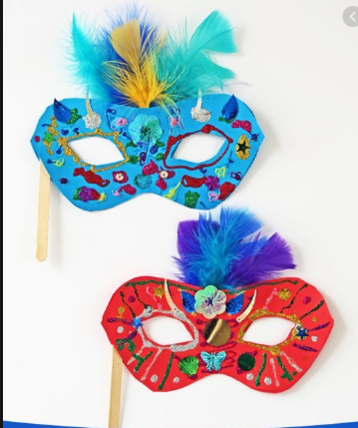
Welsh Postcard from Brazil
Here is an example postcard to help you.
Annwyl Mam (Dear Mum)  Es i Brazil. (I went to Brazil)  Es i ar awyren (I went on a plane)  Es i gem pel droed (I saw a football game)  Gwelais i y traeth Copacabana (I saw Copacabana beach)  Gewlais i mynydd Sugar Loaf ( I saw Sugar Loaf Mountain)  Bwytais i sglodion. (I ate chips)  Bwytais i teisen. ( I ate a cake)  Oddi Wrth (From)  Miss Rees | 

