  25/01/2021 |  |  |  | Theme: Pharaohs  Year group: Year 4/5
Literacy     | Numeracy  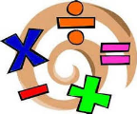   | Creative     | Thinking     |  | Healthy me    
Reading Behaviours – Phoenix Code  Read chapter 1 (only) of the ‘Phoenix Code’.  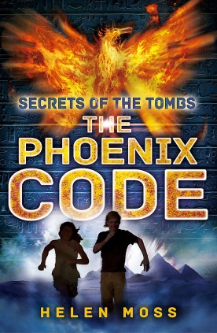  There are some tricky words within the chapter. Remember your reading strategies if you ‘clunk’ / get stuck.  If you find the text a little difficult, do some shared reading with your parents and guardians.  Reading behaviours - Visualisation  Good readers use all their five senses to create pictures in their heads. Try to ‘see’ pictures that you can draw from the words you are reading.  Good readers even hear themselves reading the words. When they get to harder bits they slow their voice down, or turn their voice up, so they can hear it better. When you read, try to ‘hear’ your reading voice in your head.  After reading chapter 1, I would like you to use your visualisation skills to create a detailed picture that depicts chapter 1. Make sure you included all the relevant details.  Share your visualisation with me via an email BannisterM@hwbcymru.net  Senses  Imagine you were in the tomb with Ryan. Use the senses grid to note what you can see, hear, smell, taste and touch.  Once you have made notes on each sense, use these to create your own paragraph(s) about the tomb. You can follow the plot of chapter 1 or be imaginative and create your own.  J2E Spell Blast  Log into Hwb and access J2E Spell Blast. Continue to practice your spelling patterns.  Ms Davies’s Welsh Missions  Open the Yr Eifftwyr (Egyptians) PowerPoint in the Teams assignment.  Complete the given tasks within the PowerPoint. The PowerPoint is editable for you to add your own information.  Once completed select return.  If you have any questions or queries please email me DaviesL1542@Hwbcymru.net or  message me on Teams. I will respond as soon as possible.  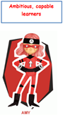 | Percentages  This week our Mathematics and Numeracy will focus on percentages. Percentages have a close link to our focuses during Week 1 (fractions) and Week 2 (decimals) respectively.  I have had positive feedback from some of you who have been using the Oak Academy resources last week. Therefore, we will continue to use these resources to help us understand mathematical concepts and topics.  Use the following Oak Academy lessons based on percentages for each day: Watch the videos, complete the worksheets and quizzes for each day.  Monday : Understand what a percentage is and its connection to fractions  Tuesday: Recall and use equivalences between fractions, decimals and percentages  Wednesday: Solve problems involving the calculation of percentages of amounts  Thursday: Solve problems involving the use of percentages for comparison  Friday: Understanding percentage  Share your daily evidence with me via an email BannisterM@hwbcymru.net  J2E TT Blast  Log into Hwb and access J2E TT Blast. Continue to practice your times tables. | Ms Davies’s Music Missions  Mission 1  Benjamin Britten – A New Year Carol  Listen to the song using the YouTube link below:  A New Year Carol - Benjamin Britten - YouTube  Research the composer and create a short PowerPoint presentation about him. Things  you may want to consider are:  1. Where he was born and where he lived  2. What year he died  3. What kinds of music did he compose  4. Name some of his works (you could even listen to some of his other pieces and  compare them)  5. Find some facts that you may find interesting and add them to your biography.  6. You can also find some pictures and add them to the biography.  Mission 2  Answer the questions about the song that you have been listening to using the editable  PowerPoint attached to the assignment.  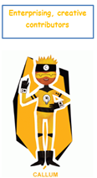 | Egyptian Gods and Goddesses  Watch the following video based on Egyptian Gods and Goddesses:  KS2 History: Ancient Egypt. Gods and goddesses - BBC Teach  Conduct some independent research into Egyptian Gods and Goddesses.  Create ‘Top Trump’ style playing cards based on each of the God and Goddesses  Use the following success criteria when creating your ‘Top Trump’ cards:  - Each playing card must be colourful and attractive for audience of 8-10 year olds.  - Each playing card must have the following : their name, God / Goddesses of, features /popularity/ appearance  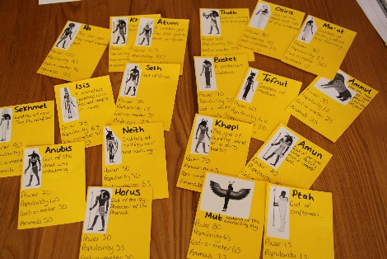  Light sources  The Egyptians worshipped the sun god Ra. Egyptians thought Ra was the most important God because he gave light and warmth.  Create an Adobe Spark post to investigate the following questions:  - What light sources can you identify apart from the sun?  - Which is the brightest?  - The Sun produces warmth as well as light. Do you think other light sources also produce warmth? Can you find some examples.  R.E: Special People  To understand why Jesus was special to Christians, we need to think about why people are special to you. Create a picture of your hero and write about why you like/ admire/ are inspired by them. What qualities do they have that make them a good role model?  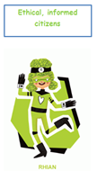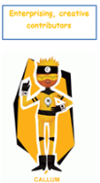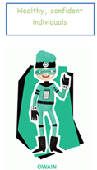 |  | Healthy Eating  Last week we learnt about the eating habitats of the ancient Egyptians.  We know having a balanced diet helps us stay fit and healthy. Use the following website to learn more about a balanced diet:  What is a balanced diet? - BBC Bitesize  Once you have a better understanding of a balanced diet. I would like you to keep a food diary this week. Use the editable document on Teams to log everything you eat and drink throughout the week.  At the end of the week reflect, how balanced is your diet? Are you eating too little/much of a certain food group?  P.E  Click on the link to take part in a freestyle dance lesson:  PE Lesson at Home! KS2 Lesson 1 - YouTube  Let me know what you thought of the lesson and the changes you noticed to your body after the lesson. Have fun!

