Home Learning Tasks
Here are the activities that are set for you this week. The ‘Daily Do’ will stay the same each week and updated when needed. Each week a new set of activities will be posted for you to do with your child. Please remember to do these activities, you can complete them as and when you wish. Please share the activities that you have done through ‘Class Dojo’ and through your child’s ‘Hwb’ account if you do anything online. You can take pictures of your child doing the activity or pictures of their work and post these.
Daily Do Activities (Please do these activities everyday)
Activities that you have done can be shared on ‘Class Dojo’
- Reception
- Write your name remembering to use your ‘whoosh’ at the start of each letter. (Refer to the letters in the ‘Sound Book’ for support.
- Write your numbers to 20 (Refer to the numbers in the ‘Number Book’ for correct formation)
- Write your letter sounds (Refer to the ‘Sound Book’ for formation)
- Read and write simple CVC words e.g. mat, cat, sat (Look at the words previously given out from school) you can find more of these online.
- Read and write ‘High Frequency Words’ these are words that you need to learn and that you will see in books e.g. I, the, put, he, it. You can find a list of the first 100 here at www.highfrequencywords.org/
- Count up to 20 or further forwards and backwards.
- Keep a diary. Draw and write a sentence about what you have done that day.
- Read a range of stories, you can find many online or just read the books you have at home.
- Say the weather in Welsh and teach your parents, find out the day, date and month
- Get outside for fresh air whenever you can and have lots of fun.
Year 1
- Write your full name remembering to use your ‘whoosh’ at the start of each letter.
- Write your numbers to 100.
- Count to 100 in 2’s, 5’s, 10’s start at different points.
- Say double numbers and number bonds to10 and even 20.
- Write your letter sounds and remember to use a ‘whoosh’ at the start.
- Read and write ‘High Frequency Words’. You can find the list here www.highfrequencywords.org/
- Read and write the spelling words that you have been given previously in your ‘Spelling Book’. You can find more spelling ideas for Year 1 online.
- Keep a diary: Draw and write about what you have done that day. Remember to give details about what you have done and begin to write longer sentences/paragraphs. Don’t forget Capital letter, finger spaces and a full stop.
- Read a range of stories, you can find many online or just read the books you have at home.
- Say the weather in Welsh and teach your parents, find out the day, date and month
- Get outside for fresh air whenever you can and have lots of fun.
Week 3: 06/04/20
Literacy Activities
Rhyming Words
Rhyme Challenge:
Let’s learn about words that Rhyme. Look at these words. Can you think of any words that rhyme with these? Make a list
dog | hen | pin | dig | cat
bun | man | bed | sock | bug

Reception: Using the picture cards can you match the rhyming words. If you can’t print you can write the words out and your child can match them up. (Please see the sheet attached on the class page)
Year 1: Cut out the picture cards and match them together to make a rhyming sentence. If you are unable to print you can write the sentences out and your child can match them up. (Please see the sheet attached on the class page).

Spelling
Reception: CVC words with the middle ‘o’ sound (Please see the sheet attached on the class page)
Year 1: Spelling Lists. Please see the spelling below, refer to the spelling in your child’s ‘Pink Book’ to see which phase they are on and work on these spellings.
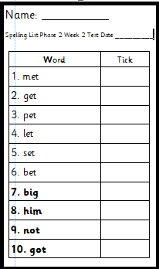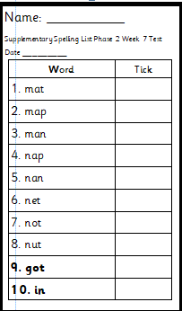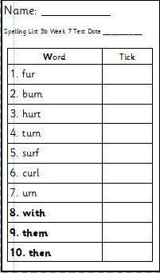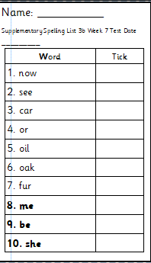
Phase 2 Phase 2 supplementary Phase 3b Phase 3b supplementary

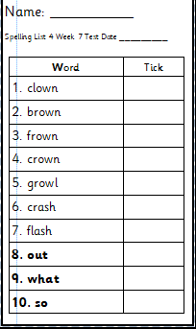 Phase 4
Storytime
Listen to some ‘Easter’ themed stories or any other stories that you like. Keep a record of the stories that you read/listen to.

Numeracy Activities
Addition
Here are some activities on addition. Look for items at home that you can use to make two sets to add together. Use these to help you work out addition sums. Make sure that you use the + and = symbols when you write the sum.

Rec: Find different objects and put them into two different piles. Count how many you have in each pile and find out how many altogether. Draw a picture of your maths work.
Year 1: Addition number sentences: Remember to use ‘Counting On’ to help you work out the answer. Remember the biggest number in your head. If you are unable to print you could write some addition sums for your child. (Please see the sheet attached on the class page). Can your child make their own addition sum?

Topic Activity
Easter
Find as many facts as you can about ‘Easter’.
Reception: Draw and label your picture.
Year 1: Make a list of all the facts you find about Easter. Write your facts in a sentence.

Creative
Make an Easter Craft
Have a look online and find a craft you would like to make or just think of your own idea. Send a picture on ‘Class Dojo’ of your craft

Welsh
Easter Egg Colours
Draw some Easter eggs, colour them in different colours.
Reception: Write the Welsh colour names next to your egg. Use the sentence pattern Dw i’n hoffi.. (I Like) and write which colours you like. How many can you write?
Year 1: Use the sentence pattern Dw i’n hoffi… (I like) and Dw i ddim yn hoffi. (I don’t like) and write about which colours you like and which you don’t like. How many can you write?
You could even video your child saying their colours.

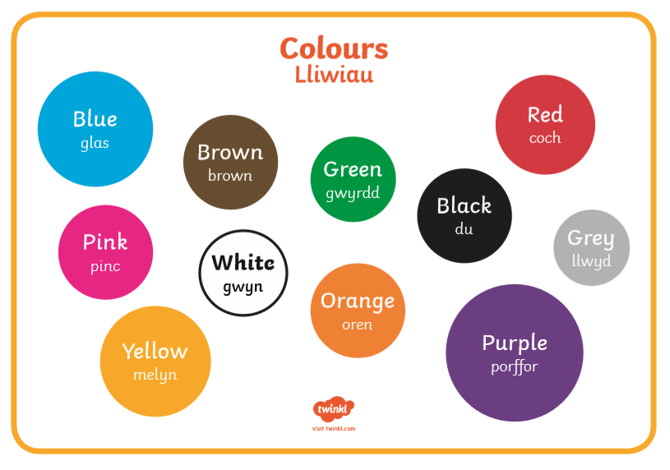
Recycling
Remember the story ‘Morris the Magpie’ and what he learnt about recycling. Can you remember the different colour bins and the items that go into them?
Sorting the recycling:
At home help to recycle the rubbish and put it into the correct bins with your parents.
Draw a picture of each bin and draw what goes into each one. Here are the bins names.
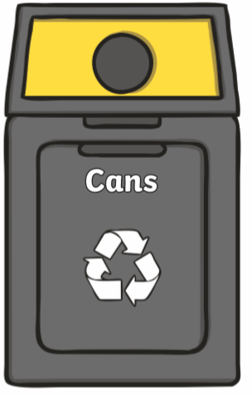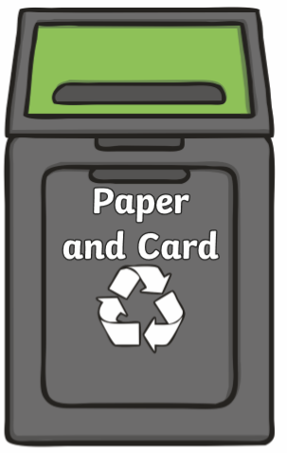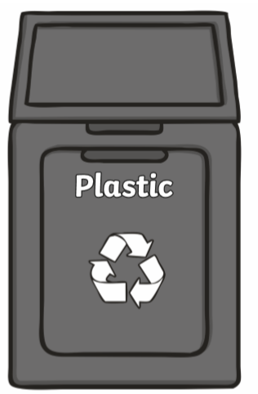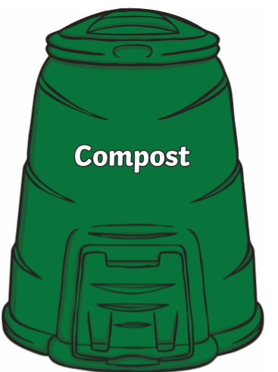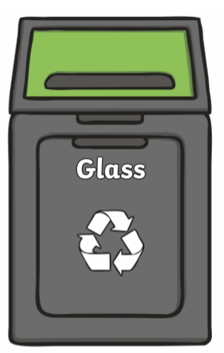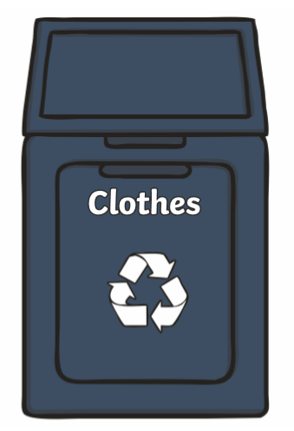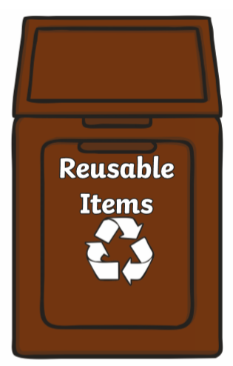

Challenges:
Here is a list of challenges for you to keep working on:
Reception:
- Learn to do up zips and buttons.
- Put on and take off your jumper on your own.
- Put on and take off your own socks and shoes.

Year 1:
- Learn to tie a knot.
- Learn to do a shoelace.
- Learn your home address and telephone number

