Home Learning Tasks
Here are the activities that are set for you this week. The ‘Daily Do’ will stay the same each week and updated when needed. Each week a new set of activities will be posted for you to do with your child. Please remember to do these activities, you can complete them as and when you wish. Please share the activities that you have done through ‘Class Dojo’ and through your child’s ‘Hwb’ account if you do anything online. You can take pictures of your child doing the activity or pictures of their work and post these.
Daily Do Activities (Please do these activities everyday)
Activities that you have done can be shared on ‘Class Dojo’
- Reception
- Write your name remembering to use your ‘whoosh’ at the start of each letter. (Refer to the letters in the ‘Sound Book’ for support.
- Write your numbers to 20 (Refer to the numbers in the ‘Number Book’ for correct formation)
- Write your letter sounds (Refer to the ‘Sound Book’ for formation)
- Read and write simple CVC words e.g. mat, cat, sat (Look at the words previously given out from school) you can find more of these online.
- Read and write ‘High Frequency Words’ these are words that you need to learn and that you will see in books e.g. I, the, put, he, it. You can find a list of the first 100 here at www.highfrequencywords.org/
- Count up to 20 or further forwards and backwards.
- Keep a diary. Draw and write a sentence about what you have done that day.
- Read a range of stories, you can find many online or just read the books you have at home.
- Say the weather in Welsh and teach your parents, find out the day, date and month
- Get outside for fresh air whenever you can and have lots of fun.
Year 1
- Write your full name remembering to use your ‘whoosh’ at the start of each letter.
- Write your numbers to 100.
- Count to 100 in 2’s, 5’s, 10’s start at different points.
- Say double numbers and number bonds to10 and even 20.
- Write your letter sounds and remember to use a ‘whoosh’ at the start.
- Read and write ‘High Frequency Words’. You can find the list here www.highfrequencywords.org/
- Read and write the spelling words that you have been given previously in your ‘Spelling Book’. You can find more spelling ideas for Year 1 online.
- Keep a diary: Draw and write about what you have done that day. Remember to give details about what you have done and begin to write longer sentences/paragraphs. Don’t forget Capital letter, finger spaces and a full stop.
- Read a range of stories, you can find many online or just read the books you have at home.
- Say the weather in Welsh and teach your parents, find out the day, date and month
- Get outside for fresh air whenever you can and have lots of fun.
Week 4: 13/04/20
Literacy Activities
Rhyme: Songs
Rhyme Challenge: Hot Cross Buns
As it is the time of year for Easter and new beginnings why not learn the rhyme ‘Hot Cross Buns’. You can find the rhyme on ‘Class Pages’ or you can look for one online.

Reception: Learn the rhyme ‘Hot Cross Buns’, record the rhyme and perform to your family. Why not video the performance and send to your friends and family.
Year 1: Learn the rhyme ‘Hot Cross Buns’, record the rhyme and perform to your family. Why not video the performance and send to your friends and family.

Role Play
Set up a stage for your performance. Make posters and tickets to advertise the time and date of the performance. Dress up in your best performance clothes and put on a show.

Spelling
Reception: CVC words with the middle ‘u’ sound (Please see the sheet attached on the class page)
Year 1: Spelling Lists. Please see the spelling below, refer to the spelling in your child’s ‘Pink Book’ to see which phase they are on and work on these spellings.
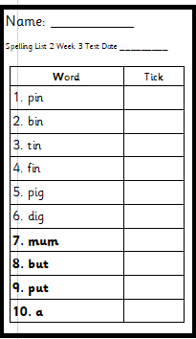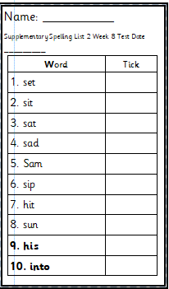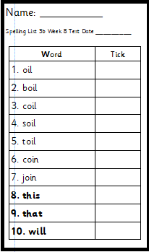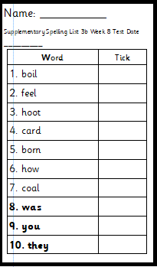
Phase 2 Phase 2 supplementary Phase 3b Phase 3b supplementary

Phase 4
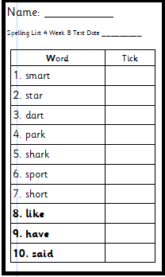
Storytime
Listen to some stories that you like. Keep a record of the stories that you read/listen to.

Numeracy Activities
Problem Solving
Addition
Here are some activities that will help you to use your maths skills to work out the answers.

Rec: Below is the challenge for you.

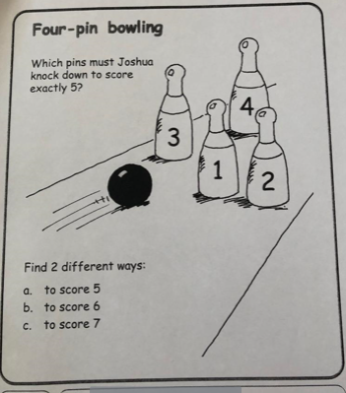

Year 1: Below is the challenge for you
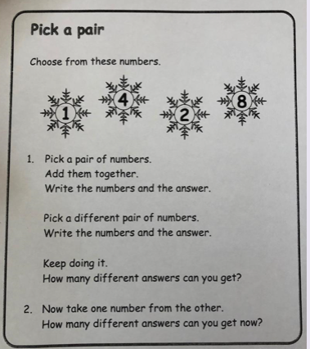

Topic Activity
Spring
Go for a walk or look out of the window what can you see? Look for signs of spring.
Reception: Draw and label your picture how many things can you find?
Year 1: Draw a picture of what you can see, use the sentence pattern ‘In the spring I can see…. To write about what you have drawn.

Weather Diary
Keep a ‘Weather Diary’ for the week (or longer). Draw and write what the weather is like each day. Can you write the weather in English and in Welsh? Use the sentence patterns:
English: ‘Today the weather is…’
Welsh: ‘Mae hi’n……’
Here is a reminder of the weather in Welsh
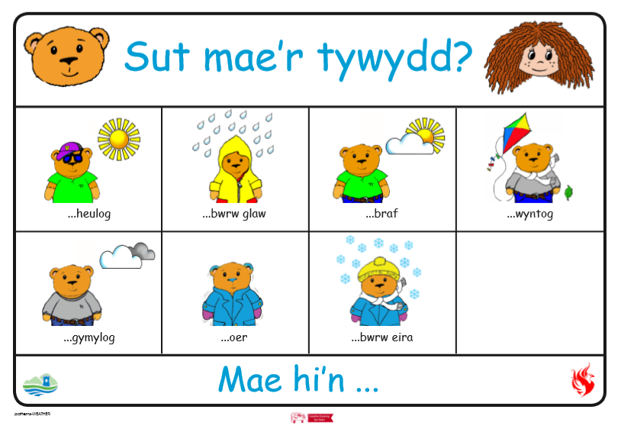

Welsh
Clothes
Which clothes can you wear in the spring?
Reception: Draw a picture of the clothes you can wear in the spring. You could draw a picture of you wearing the clothes. Label your clothes or your picture to show what the clothes are called.
Year 1: Draw a picture of the clothes you can wear in the spring. You could draw a picture of you wearing the clothes. Label you picture using the sentence pattern ‘Dw i’n gwisgo…’ (I am wearing). How many sentences can you write?
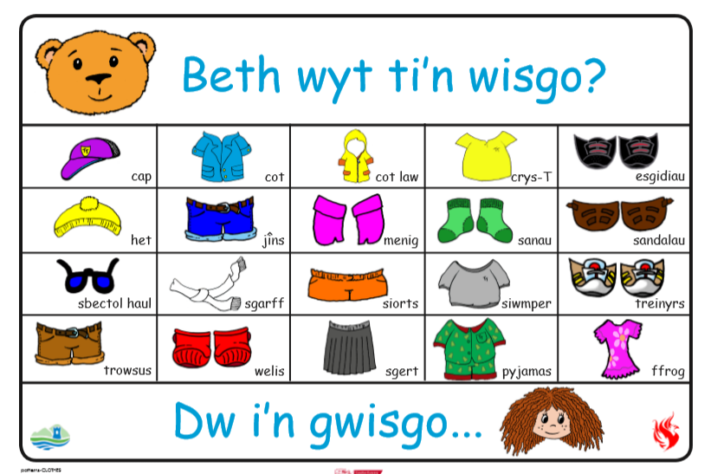

Dress up
You could dress up in some spring clothes and orally say what you are wearing, video your Welsh and listen to it again.

Recycling
Recycling Poster
Remember the pictures of the ‘Recycling Bins’ from last time? Can you remember what goes in each bin?
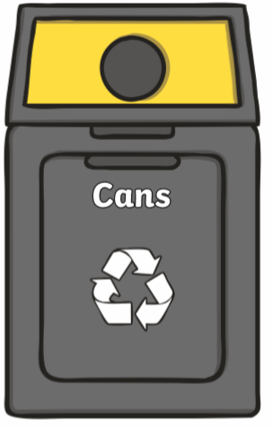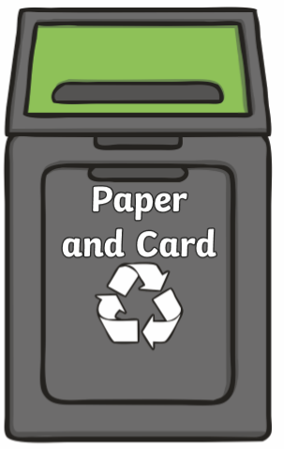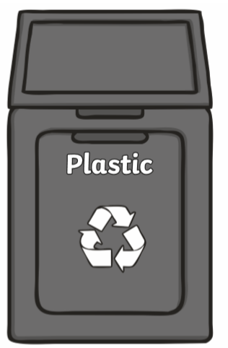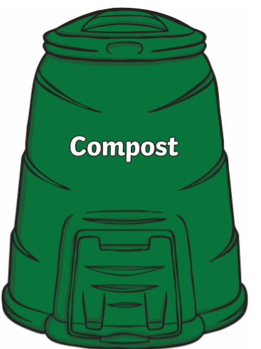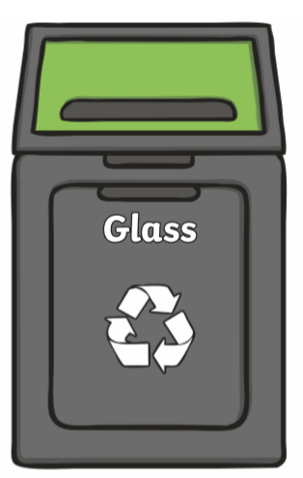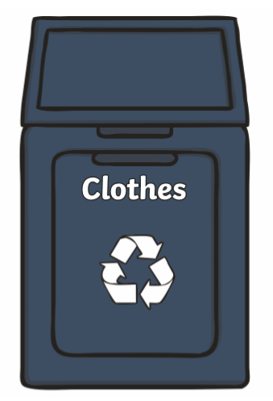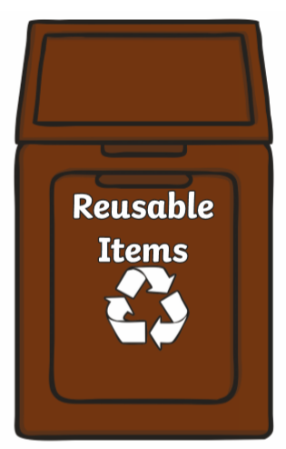

Design a poster to display in a room of your home to encourage members of your family to recycle. You could even make a poster to display on your recycling bin (if you have one)

Challenges:
Here is a list of challenges for you to keep working on:
Reception:
- Learn to do up zips and buttons.
- Put on and take off your jumper on your own.
- Put on and take off your own socks and shoes.

Year 1:
- Learn to tie a knot.
- Learn to do a shoelace.
- Learn your home address and telephone number

