  Date: Week of June 28th 2021 |  |  |  | Theme: Are carrots orange?  Year group: Nur/Rec/Yr1
Literacy      This Photo by Unknown Author is licensed under CC BY-NC-ND   | Numeracy     | Creative     | Thinking     |  | Healthy me    
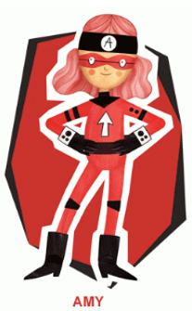 Ambitious Amy  She will help you do anything if you work hard enough. She will help with all these activities.  Nursery/Reception/Year 1  Little Red Riding Hood  Listen to the story of ‘Little Red Riding Hood’ you can find this online. What happens in the story?  Activity: Retell the story of Little Red Riding Hood through drawing pictures and writing sentences.  Nursery  Draw a picture from the story and retell an adult about what you have drawn.  Reception/Year 1:  Draw a picture of each key part of the story and write a sentence to go with your picture. | Ambitious Amy  She will help you do anything if you work hard enough. She will help with all these activities.  Nursery  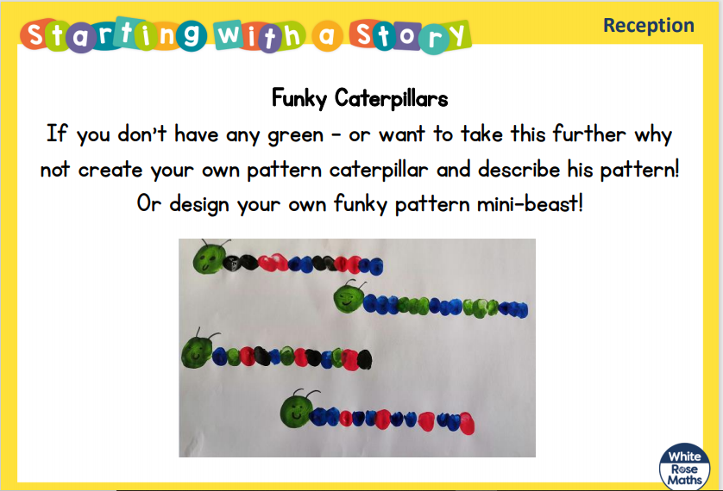  Pattern Making  Make your own repeating pattern caterpillar. What colours will you use?  Reception/Year 1  Number Bonds  How many numbers bonds to 10 can you think of? How many ways can you write these?  Addition and Subtraction  Make your own addition and subtraction sums. Remember to use the symbols + - =  Reception: Work within 10  Year 1: Work within 20 | 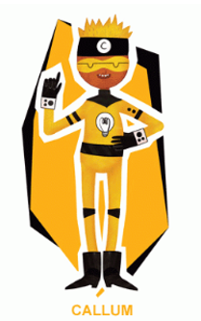 Creative Callum will help you be creative. He will help with these activities.  Nur/Rec/Year 1  Flight  Find out some information about aeroplanes, look at their designs, shapes and colours.  Activity: Design and build your own aeroplane of the future. What will it do? What will it look like? | Ambitious Amy  She will help you do anything if you work hard enough. She will help with all these activities.  Nur/Rec/Yr1  Amelia Earhart Information  Listen to the story of Amelia Earhart online and find out about her amazing life and achievement.  Activity: Draw and write a fact file about Amelia Earhart. What information have you found out? |  | 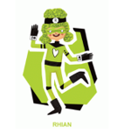 Rhian will help you look after each other and the environment.  Nur/Rec/Yr1  Paper Aeroplanes  Make your own paper aeroplane and fly it, how far will it travel? Measure the distance.

