  Date: Week of January 18th 2021 |  |  |  | Theme: Are carrots orange?  Year group: Nur/Rec/Yr1
Literacy      This Photo by Unknown Author is licensed under CC BY-NC-ND   | Numeracy     | Creative     | Thinking     |  | Healthy me    
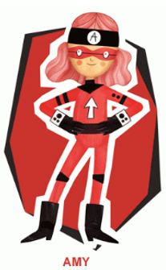 Ambitious Amy  She will help you do anything if you work hard enough. She will help with all these activities.  Nursery  Play the game ‘I hear with my little ear’. Wearing the giant ears you made last week play this game. With an adult take it in turns to make a sound and guess what sound you are making.  Make a collection of your own ‘noise makers’. Go around the house looking for things and put them in a box. With an adult play a game where you have to take it in turns to guess the hidden sound. Who will guess the most?  Reception  Write all the letter sounds that you have been learning so far. Remember to write using a ‘Whoosh’ at the beginning of your letter.  Previous Sounds  m,a,s,d,t,i,p,n,g,o,c,k,u,b,f,e,l,h,r,j,v  How many things in your house can you find starting with the letter sounds? Take pictures of what you find.  New Letter Sounds  y, w, z  Learn to form these letter sounds, remember the ‘Whoosh’ at the beginning.  What words start with these sounds?  Use the activity sheets to help you with formation. (See attached documents)  CVC  Write some CVC words, use the words with your letter sounds. Recap on the middle ‘a’ sound from previous weeks. Which words can you remember? Can you write some of the words in a sentence? E.g. A cat on the mat  A big red van. How many can you do?  Word Hunt  Write the words onto cards and get an adult to hide them for you. Can you find them? Read and write the words, how many can you find?  Read your book on ‘My Rising Stars’  Reception/Year 1  Ditties  Read the ‘Ditties’ 4,5,6. Make your own sentences.  Year 1  See the links on the website to some other RWI books to read.  Year 1  Learn/recap on previous spellings that you have been given. Can you read and draw the word? Write the words into sentences.  (see the activity sheet ‘Read and Draw’)  Capital letters for place names  Capital letters are not just for the start of a sentence they are used for names and places.  Write the names of the people in your family and remember the capital letter. Think of different places and write these and remember the capital letter.  Read your book on ‘My Rising Stars’  Reception/Yr1  The Enormous Turnip:  Instructions on How to grow a turnip  I wonder if you can write some instructions on growing a turnip. Remember to use the important words First, Next, Then, Finally.  Reception/Year 1: Put the pictures in order and write the instructions remembering to use the words First, Next, then, Finally and the bossy words plant, add, watch and pull.  Welsh  Dillad Tedi Twt  Tedi Twt is wearing his winter clothes, he wants to find out what they are called in Welsh. Using the clothes sheet and the recording information on Hwb can you help him?  Nursery  Can you draw a picture of Tedi Twt in his winter clothes?  Reception  Draw a picture of Tedi Twt in his Winter Clothes and label them.  Year 1  Draw a picture of Tedi Twt in his clothese and write the sentences Dw i’n gwisgo (I am wearing)  Dillad Tedi Twt Story  Dillad Tedi Twt - YouTube | Ambitious Amy  She will help you do anything if you work hard enough. She will help with all these activities.  Reception  Write the numbers all the numbers that we have learnt.  How many different things can you use to write them? Try pencils/pens/chalk/  water/paint  Year 1  Write your numbers as far as you can. Can you do beyond 20?  Nursery  Where is Teddy?  Find one of your teddies at home to use for this activity. I wonder if you can use the words  in, on, under, behind, in front.  Get an adult to ask you to put Ted in these places. Can you put Ted in these places on your own?  Listen to the story ‘We’re Going on a Bear Hunt’  Michael Rosen performs We're Going on a Bear Hunt - YouTube  Winter Activity  Why not try the session 4 activity on the ‘White Rose’ maths to do with winter. Where will you take Ted on a walk and what will you see?  Activity Week | White Rose Maths  See the activity sheet on shared files/website  Reception  Position and Direction: Spatial Awareness  We’re Going on a Bear Hunt  This activity is about position and direction. Listen to the story ‘We’re Going on a Bear Hunt’ what words can you hear in the story that tells you about a direction a way that you can go?  Make your own obstacle course, this can be indoors or outdoors can be big or small. Move around your course using the language in, on, under, through, in front, behind, over.  Make a video of your obstacle course and share on Hwb or dojo.  Michael Rosen performs We're Going on a Bear Hunt - YouTube  Look here on ‘White Rose’ maths for videos and an activity to help you. Go to session 4 & 5  It's Me 1, 2, 3! - Week 3 | White Rose Maths  Here you will find some activities and a video. See the activity idea she on shared files/website.  Winter Activity  Why not try the session 4 activity on the ‘White Rose’ maths to do with winter. Where will you take Ted on a walk and what will you see?  Activity Week | White Rose Maths  Year 1  Position and Direction  The Three Little Pigs  Listen to the story here  The Three Little Pigs - Animated Fairy Tales for Children - YouTube  Learn the words right, left, forward and back can you move in these different ways? Get an adult to call out these commands and then move in theses ways.  Make some arrows that show these directions and play a game where you/adult have to hold up the cards and move in these ways.  Think about the story ‘The Three Little Pigs’ who did the wolf visit? And which direction did he go? Using Hwb can you show the direction he took on a map?  Follow these instructions to find your activity  - Log into Hwb  - Find Just2easy  - Click on Jit  - Find ‘Turtle’ on the tab at the top and click.  - Choose the template ‘The Big Bad Wolf’  - Using the arrows forward, backward, left and right can you make the wolf move to all the houses?  - Remember to save your work in your file.  See the example activity on shared files  Additional Activity (Optional)  Little Red Riding Hood  Complete the map to help LRRH to visit all the different houses.  (See sheet on Hwb/website) | 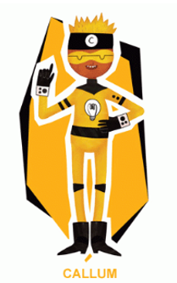 Creative Callum will help you be creative. He will help with these activities.  Nur/Rec/Yr1  Winter Colour Mixing  Talk about the colours that we see in the winter e.g. blues, whites etc. Discuss how these can be different shades like dark and light. With your paint get blue and white and discuss how we can make these different shades such as lighter and darker by mixing.  Make your own winter picture using different shades of blue.  If you don’t have paint you could find different shades of blue in colouring pencils or crayons.  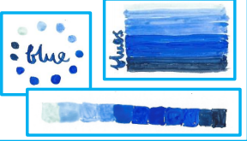  Snowflake Craft  Take a look at the pictures of snowflakes, what do you notice? What shapes can you see? What colours can you see?  Make your own snowflake using any resources that you have.  Here are a few ideas to help you.  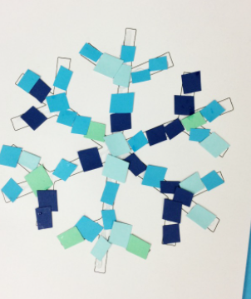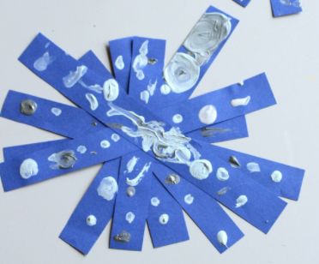  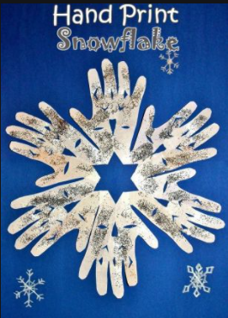 | 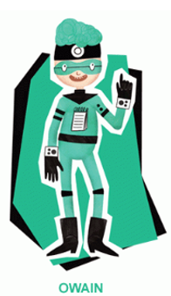 Owain will help you keep healthy and be active.  Nur/Rec/Yr1  When do I exercise?  Keep a diary of the exercise and activities you do over the week. You can draw the exercises on each day Remember to draw and label the exercises that you do or even take a picture of what you do and make an activity book for the week.  Write about what your body feels like before and after you do your exercise, what is the difference? Why do you think this is?  Winter Picture: Hwb  Make your own ‘Winter Picture’ on hwb using ‘Jit’. You can either choose a background in the ‘Paint’ and drag and drop your pictures or you can make your own picture and choose what you want to put on there.  See my example in the ‘Shared File’  Science Experiment  Grow a balloon turnip  Try this experiment to grow a turnip, I wonder what will happen? How will the balloon grow? What will help it?  See the instruction for the experiment on the separate sheet on the share file/website. |  | Owain will help you keep healthy and be active.  Nur/Rec/Yr1  Squiggle Time  Lines  Put on the tune ‘ABC’ by the Jackson 5.  The Jackson 5 - ABC - YouTube  - Make the lines in the air using your arms. Make large and small lines changing direction.  - Get out some paper and crayons and make the lines on the paper. Make big and small lines moving fast and slow with the music.  Dough Disco  If you have playdough at home you can use this if not you can use a scrunched up piece of paper like a ball.  Follow some of the activities on here.  'I like to' playdough action song - YouTube  Dough dance/finger gym routine | Down in the Jungle | Nursery rhyme with playdough - YouTube  Fine motor development | Playdough song | If you're happy and you know it - YouTube  Cosmic Yoga  Try some of these lovely relaxing Yoga activities.  We’re going on a Bear Hunt  We're Going on a Bear Hunt | A Cosmic Kids Yoga Adventure! - YouTube  The Listening game  The Listening Game | Cosmic Kids Zen Den - Mindfulness for kids - YouTube  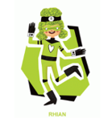Rhian will help you look after each other and the environment.  Big Schools Bird Watch  Take part in the ‘Big Schools Bird Watch’. Go outside and look for birds, how many can you see? What different types can you see? Find out the names for the birds you see.  Draw a picture of some of the birds that you have seen. Can you find the name of the bird and label?

