
Templed Gweithgaredd Cymraeg /Welsh Mission Template 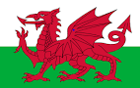

Welsh Language Mission :
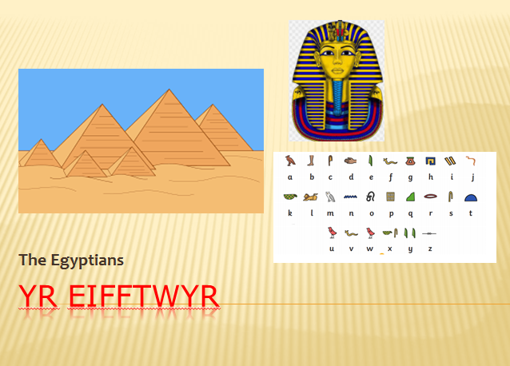

Open the Yr Eifftwyr (Egyptians) PowerPoint in the Teams assignment.
Complete the given tasks within the PowerPoint. The PowerPoint is editable for you to add your own information.
Once completed select return.
If you have any questions or queries please email me DaviesL1542@Hwbcymru.net or message me on Teams. I will respond as soon as possible.


