  Date: Week of February 8th 2021 |  |  |  | Theme: Are carrots orange?  Year group: Nur/Rec/Yr1
Literacy      This Photo by Unknown Author is licensed under CC BY-NC-ND   | Numeracy     | Creative     | Thinking     |  | Healthy me    
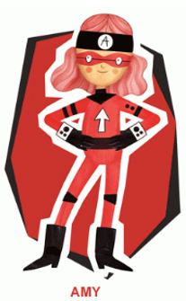 Ambitious Amy  She will help you do anything if you work hard enough. She will help with all these activities.  Nursery  Body Percussion  Rainy Forest  Play a game with an adult where you make sounds from the forest. How can you use your body to make these sounds?  These are some suggestions that could be used.  - rub hands together could be the wind in the leaves.  - clicking fingers or finger claps could be the rain,  - tapping hands on thighs to make the rain heavier and faster.  - jumping up and down to make thunder.  Reception  Letter Sounds  Write all the letter sounds that you have been learning so far. Remember to write using a ‘Whoosh’ at the beginning of your letter.  Previous Sounds  m,a,s,d,t,i,p,n,g,o,c,k,u,b,f,e,l,h,r,j,v, y, w, z, x sh, th, ch, qu, ng, nk  How many things in your house can you find starting with the letter sounds? Take pictures of what you find.  CVC  Middle ‘i’ sound words. Can you make these words and then write them out? Can you make a sentence?  Snakes and Ladders CVC Words  Play the ‘Snakes and Ladders’ game, how many words can you read?  Word Hunt  Write as many CVC words onto cards and get an adult to hide them for you. Can you find them? Read and write the words, how many can you find?  Read your book on ‘My Rising Stars’  Reception/Year 1  Ditties  Read the ‘Ditties’ 13,14,15. Make your own sentences.  Year 1  See the links on the website to some other RWI books to read.  Year 1  Learn/recap on previous spellings that you have been given.  Year 1  RWI  Previous Sounds  ay,ee,igh,ow,oo,oo,ar,,or,air,ir,,ou,oy  Recap on these sounds by looking back over the sheets. Can you remember the words? Can you spell these words?  Activities ow, oo, oo, ar  See the activity sheets for the sounds.  CVC Words  Can you make the word? Then write the word into a sentence.  (see the activity sheet ‘Phase 2 CVC Set 3’)  Read your book on ‘My Rising Stars’  Nursery/Reception/Yr1  Mr Wolf’s Pancakes: Instructions  How to make a Pancake?  Listen to the story ‘Mr Wolf’s Pancakes. Mr Wolf is having trouble with his pancakes and he has forgotten how to make them and he needs your help. Can you write some instructions on how to make a pancake?  Nursery  Draw a picture of the ingredients that Mr Wolf needs to make his pancakes.  Reception/Yr1  Put the pictures in order and write down what each picture shows.  Nur/rec/Yr1  Welsh  Food List: Rhestr Siopa  Using some of the words you have learnt about food can you make your own shopping list?  Nursery  Draw pictures of food  Rec/Yr1  Draw pictures and label your food. | Ambitious Amy  She will help you do anything if you work hard enough. She will help with all these activities.  Reception  Write the numbers all the numbers that we have learnt.  How many different things can you use to write them? Try pencils/pens/chalk/  water/paint  Year 1  Write your numbers as far as you can. Can you do beyond 20?  Nursery/Reception  Day and Night  Listen to the story Day Monkey and Night Monkey. What did the monkeys do?  Think about what we do in the day and what we do in the night.  Activity  Draw pictures of what you do in the day and what you do in the night.  See White Rose Maths for the video and Hwb/website for the example activity sheets.  See the video of Miss Rees on Hwb.  White Rose Maths Link to Website  Light and Dark - Week 3 | White Rose Maths  Session 4 and 5 for the activity  Year 1  Morning, Afternoon and Night  Think of what you do during the day and what you do at different parts of the day.  Activity  Get some paper and divide the paper into ‘Morning, Afternoon and Night’. Draw a picture of what you do in each part of the day.  My Day  Draw pictures of what you do in the day. Start with a picture of when you get up and draw what you do all day and finish with going to bed.  Extra Activity (If you want to)  My Week  Write down the days of the week in order and then draw a picture and label all the things you do in the week. | 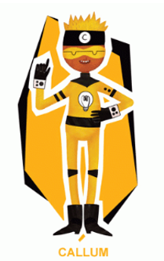 Creative Callum will help you be creative. He will help with these activities.  Nur/Rec/Yr1  Valentine’s Day  On February 14th it is Valentine’s Day, the day we show people how much we love them.  Kandinsky Heart Art  Can you make a heart art like this based on the famous artist Kandinsky? What colours will you use?  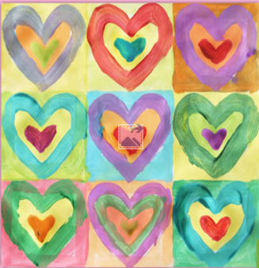  Symmetrical Heart  Symmetry means the same on both sides.  Make a heart that is the same on both sides. Cut out the shape and using some paint make a pattern on one side and then fold over, carefully open your heart and see your pattern on both sides. Does it look the same?  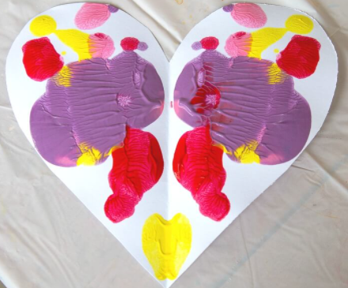  Love Heart Toast  Can you make ‘Love Heart Toast’? and give to someone you love.  Follow the instructions and see what happens.  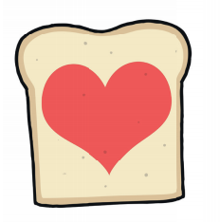  See the sheet on Hwb/website for instructions. | Ambitious Amy  She will help you do anything if you work hard enough. She will help with all these activities.  Nur/Rec/Yr1  Shrove Tuesday  February 16th 2021  This is the day when we make Pancakes to use up the ingredients in our cupboards.  Pancake Making  Make some pancakes. See the instruction on hwb/website  Pancake Topping  You can have any topping on your pancake. What will you choose?  Design your own pancake with your favourite topping. You can draw on paper or use Just2easy ‘Jit’ ‘Paint’ to make your pancake.  Chinese New Year  The year of the Ox  February 12th 2021  This is when people in China celebrate their new year and it is linked to an animal each year.  What can you find out about ‘Chinese New year’?  Chinese and Lunar New Year - CBeebies - BBC  Chinese Dragon Mask  During the festival dragons dance around.  Make your own ‘Dragon Mask’ to dance around to. Listen to the music and using your mask dance around like a dragon.  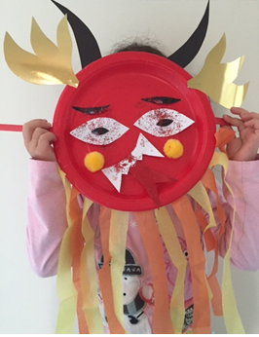  Chinese New Year Song for Kids | Chinese Dragon Dance for Children | Chinese New Year for Kids - YouTube  Internet Safety Day  February 9th  Listen to the story about ‘Smartie the Penguin’ and find out how he stays safe on the computer and the internet.  Can you remember what he said?  Make a poster to show how you stay safe on the internet. |  | 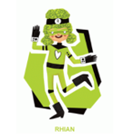 Rhian will help you look after each other and the environment.  Big Schools Bird Watch  Take part in the ‘Big Schools Bird Watch’.  Now that you have designed your ‘Bird House’ can you make it?  What will you use?  How big will it be?  Using your design make your ‘Bird House’  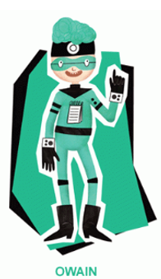Owain will help you keep healthy and be active.  Nur/Rec/Yr1  Pancake Race  On ‘Shrove Tuesday’ some people have a pancake race.  Find a frying pan in the kitchen, make your own pancakes these can be from paper/playdough and see who in your family wins the race.  Pancake Tossing Competition  Who can toss the most pancakes in 30 seconds?  Find a frying pan and make some pancakes real/paper or dough. How many will you toss?  - Keep a score of the results.  - You can use a tally.  - Make a graph of your results using pictogram or chart on Just2easy ‘Jit’ on hwb.

