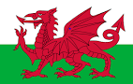
St David Welsh Words and their meaning

Dewi Sant – St David
Cennin Pedr – Daffodil
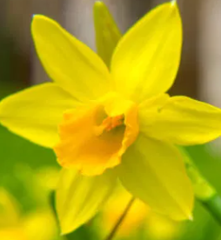
Cenhinen – Leek
Traddodiad – Tradition
Cawl – ‘Cawl’ a Welsh soup with vegetables and either lamb or beef
Cor – Choir
Cymru – Wales
Cymry – the Welsh people
Ty Ddewi – St Davids
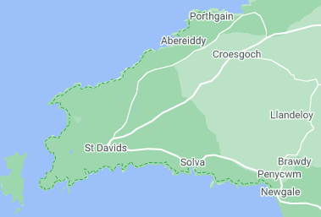
Ffrog – Dress
Het – Hat
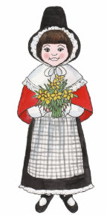
Draig – Dragon

