  Date: Week of February 1st 2021 |  |  |  | Theme: Are carrots orange?  Year group: Nur/Rec/Yr1
Literacy      This Photo by Unknown Author is licensed under CC BY-NC-ND   | Numeracy     | Creative     | Thinking     |  | Healthy me    
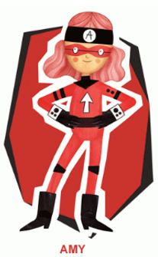 Ambitious Amy  She will help you do anything if you work hard enough. She will help with all these activities.  Nursery  Body Percussion  Follow the Leader  Play a game with an adult. One person chooses some body percussion e.g. pat knees, tap head, clap hands, you have to copy. Take turns to be the leader.  Voice Sounds  What different sounds can you make with your voice? Can you make a car sound? A dog sound?  Reception  Letter Sounds  Write all the letter sounds that you have been learning so far. Remember to write using a ‘Whoosh’ at the beginning of your letter.  Previous Sounds  m,a,s,d,t,i,p,n,g,o,c,k,u,b,f,e,l,h,r,j,v, y, w, z, x sh, th, ch, qu, ng, nk  How many things in your house can you find starting with the letter sounds? Take pictures of what you find.  CVC  Remember the words with middle ‘e’ sound that you did last week. Which words can you remember? Can you write these words and draw a picture to go with them?  I Spy CVC  Look at the activity sheet and see how many CVC words you can see. Write them down.  Word Hunt  Write as many CVC words onto cards and get an adult to hide them for you. Can you find them? Read and write the words, how many can you find?  Read your book on ‘My Rising Stars’  Reception/Year 1  Ditties  Read the ‘Ditties’ 10,11,12. Make your own sentences.  Year 1  See the links on the website to some other RWI books to read.  Year 1  Learn/recap on previous spellings that you have been given.  RWI  Previous Sounds  ay,ee,igh,ow,oo,oo,ar,,or,air  New Sounds  ir, ou, oy  See the accompanying sheet to support.  CVC Words  Can you make the word? Then write the word into a sentence.  (see the activity sheet ‘Phase 2 CVC Set 3’)  Unscramble Sentences  Sentences need to make sense and must have the words in order. Can you unscramble the words to make a sentence? Make sure it makes sense by reading it back.  Read your book on ‘My Rising Stars’  Reception/Yr1  The Enormous Turnip: Story Writing  Using your story map can you write out the story in the correct order?  Use pictures, words and sentences wite the story.  Nursery  Draw a picture of the story and mark make to retell what is happening.  Reception/Yr1  Use your map to help you and write a sentence for each part of the story to retell.  Welsh  Tedi Twt yn Siopa  Dw i ddim yn hoffi ( I don’t like)  Remember the story about Tedi Twt yn siopa. Can you remember the food in the story?  Make a list of all the food you don’t like.  Nursery  Draw pictures of the foods you don’t like.  Reception  Draw a picture of the foods you don’t like and label. Can you name them and say Dw i ddim yn hoffi.  Year 1  Draw a picture of the foods you don’t like and write the sentence Dw i ddim yn hoffi….  Tedi Twt yn Siopa Story  Tedi Twt yn Siopa - YouTube | Ambitious Amy  She will help you do anything if you work hard enough. She will help with all these activities.  Reception  Write the numbers all the numbers that we have learnt.  How many different things can you use to write them? Try pencils/pens/chalk/  water/paint  Year 1  Write your numbers as far as you can. Can you do beyond 20?  Nursery  Shopping List Counting  Can you follow the shopping list to make sure you have the correct amount of fruit to make a fruit salad?  Make a shopping bag for each one of the fruits. Count the fruits into the bag and label with the Numicon Shape and the numeral to show how many fruits are in the bag.  Can you think of anymore fruits you can draw and count?  Reception  One More and One Less  Hidden Objects  Find some objects around the house and a bag. Play a game with an adult, put a number of items in the bag e.g. 4. How many will you have if you add one more? How many will you have if you have one less. Play the game a few times with different numbers.  Make a list of the numbers. Write your starting number in the middle and your ‘One More’ on the right and ‘One Less’ on the left.  See White Rose Maths for the video and Hwb/website for the example activity sheets.  See the video of Miss Rees on Hwb.  White Rose Maths Link to Website  Light and Dark - Week 2 | White Rose Maths  Session 3 and 4 for the activity  Year 1  Subtraction: Counting Back  When you subtract you ‘Count Back’.  Make a numberline that you can lay out on the floor, write each number on a piece of paper and put in the correct order. You are now going to get physical, you are going to jump back to make your subtraction.  Think of a number to start on and how many you want to count back jump these on your number line and say the sum. E.g 8-2=6  Write a number sentence to show your sum . Repeat with different numbers, how many can you do?  Look at the video of Miss Rees on Hwb to help you with the activity.  White Rose Maths Link to Website  Autumn Week 8 - Number: Addition & Subtraction | White Rose Maths  Scroll to the bottom for the video ‘Counting Back’  Additional Activities  Have a go with these activities  See sheet on Hwb/website.  Forgetful Freddie Counting Back | 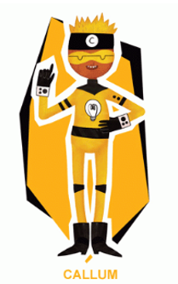 Creative Callum will help you be creative. He will help with these activities.  Nur/Rec/Yr1  Fruit Still Life Drawing  Go on a hunt around the kitchen and look for some fruit or help the adults in your house to think of some fruit that you could buy at the shop.  When you have your fruit look at it closely what do you see? Smell? Feel?  Put your fruit on the table and get out some pencils/pens or paint and draw your fruit.  You can draw more than one of you want.  Children’s Mental Health Week  The Colour Monster: Feelings Diary  Listen to the story ‘The Colour Monster’  The Colour Monster : Kids books read aloud by Books with Blue - YouTube  What was he feeling? What colours went with each feeling?  Everyday draw a picture of a feelings monster that shows what you are feeling on that day and keep a record in your own ‘Feelings Diary’.  Write about why you feel like this.  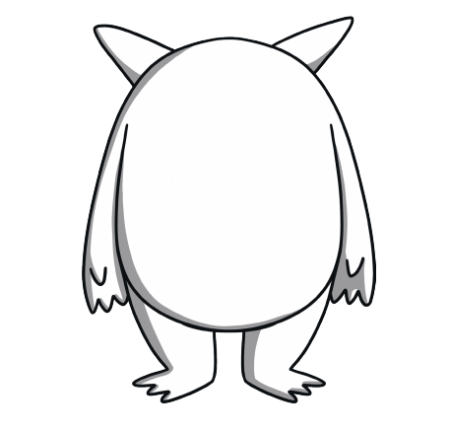 | Ambitious Amy  She will help you do anything if you work hard enough. She will help with all these activities.  Nur/Rec/Yr1  Science  Push and Pull Objects Hunt  In the story ‘The Enormous Turnip’ the characters had to pull and pull to get the turnip up.  Go around your house and look for all the things that you ‘Push’ and ‘Pull’, make a list of what you find.  Additional Activity  Sort the picture cards into push and pull. (See Hwb/Website for sheet)  How have I changed?  Find some pictures at home of you when you were younger and put them in the correct order to show how you have grown. Can you order the pictures from being a baby to now?  What could you do as a baby? And what can you do now?  Can you look for pictures of other people in your family how have they changed? |  | 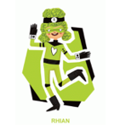 Rhian will help you look after each other and the environment.  Big Schools Bird Watch  Take part in the ‘Big Schools Bird Watch’.  Now we have looked at the birds and counted the birds now we are going to look at where birds live. Can you find out where they live?  Design a ‘Bird House’ for a bird to live in. Draw your design on paper. Remember to label up your design and say what you will use for each part.  What shape will it be?  What colour?  What designs?  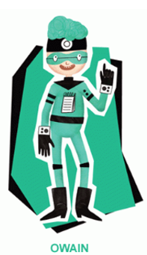Owain will help you keep healthy and be active.  Nur/Rec/Yr1  Squiggle Time  Humps    Put on the tune  Daydream Believer by Shonen Knife  Shonen Knife – 14 DAYDREAM BELIEVER - YouTube  - Make the humps in the air using your arms. Make large and small humps changing direction.  - Get out some paper and crayons and make the humps on the paper. Make big and small humps moving fast and slow with the music.  Dough Disco  If you have playdough at home you can use this if not you can use a scrunched up piece of paper like a ball.  Follow some of the activities on here.  Dough Disco | Walking On The Moon - YouTube  Finger Gym  Grandma's Glasses Funky Finger Workout | 3 minutes - YouTube  Learn to Dance  Try some of these fun dances  Preschool Learn to Dance: Pizza Dough Boogie - YouTube  Preschool Learn to Dance: Hot Potato - YouTube

