  Date: Week of January 11th 2021 |  |  |  | Theme: Are carrots orange?  Year group: Nur/Rec/Yr1
Literacy      This Photo by Unknown Author is licensed under CC BY-NC-ND   | Numeracy     | Creative     | Thinking     |  | Healthy me    
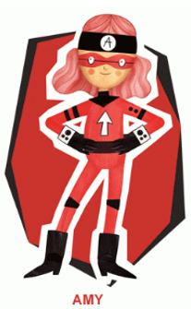 Ambitious Amy  She will help you do anything if you work hard enough. She will help with all these activities.  Nursery  Make some giant ‘Listening Ears’ to wear and then go on a listening walk around your house and in the outdoors. What sounds can you hear? Draw a picture of what you heard or take a picture.  Reception  Write all the letter sounds that you have been learning so far. Remember to write using a ‘Whoosh’ at the beginning of your letter.  How many things in your house can you find starting with the letter sounds? Take pictures of what you find.  New Letter Sounds  r, j, v  Learn to form these letter sounds, remember the ‘Whoosh’ at the beginning.  What words start with these sounds?  Use the activity sheets to help you with formation. (See attached documents)  Write some CVC words, use the words with your letter sounds. Recap on the middle ‘a’ sound from last week. Which words can you remember?  Read your book on ‘My Rising Stars’  Reception/Year 1  Ditties  Read the ‘Ditties’ 1,2,3. Make your own sentences.  Year 1  See the links on the website to some other RWI books to read.  Year 1  Learn/recap on previous spellings that you have been given.  Write CVC words and put these into sentences.  Capital Letters and Full Stops  Capital letters go at the beginning of a sentence and full stops go at the end. Can you add capital letters and full stops to the ‘Superhero Sentences’? (See the attached sheets documents) You can copy the sentences.  Read your book on ‘My Rising Stars’  Nur/Rec/Yr1  Listen to the story ‘The Enormous Turnip’. What happens in the story?  Extension to last week’s activity.  Nursery/Reception/Yr1  Character Puppets  Make your own puppets. With the characters you have drawn retell the story in your own words using your puppets. Record your story retell using a phone or an ipad and share via dojo or Hwb.  Welsh  Nursery  Can you draw and colour the food from the story?  Reception/Year 1  Recap on the story ‘Tedi Twt yn Siopa’ what food is he buying. Can you remember? Draw a picture and label the food like you did last week but this time can you describe the food using colours e.g. afal gwyrdd/coch, banana melyn.  Use the sentence pattern Ga i… (Can I have) e.g. Ga i afal coch  Use the ‘Colour Sheet’ to help you and listen to the colours being spoken on HWB.  Link to the story  Tedi Twt yn Siopa - YouTube | Ambitious Amy  She will help you do anything if you work hard enough. She will help with all these activities.  Reception  Write the numbers all the numbers that we have learnt.  How many different things can you use to write them? Try pencils/pens/chalk/  water/paint  Year 1  Write your numbers as far as you can. Can you do beyond 20?  Nursery 1,2,3,4,5  Go around the house and gather as many things as you can. Can you put the items into groups and count them? Get an adult to write some numbers for you, can you match the numbers with the group you have made?  Go on a number hunt around the house, how many numbers can you find? Take a picture of what you see and share on dojo or Hwb.  Reception  1,2,3 Representation  Remember what you did last week when you went around the house and gathered items and sorted into 1,2,3?  This week you are going to show how you can write/make 1,2,3 in lots of different ways. You can use the activity sheets from last week and the videos to help you. There are additional sheets to help you on Hwb/Website.  Here are some ideas:  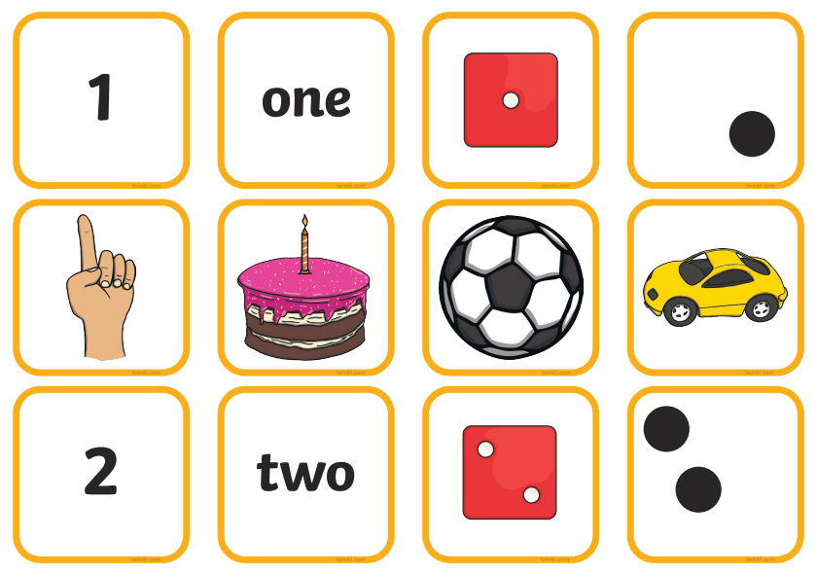  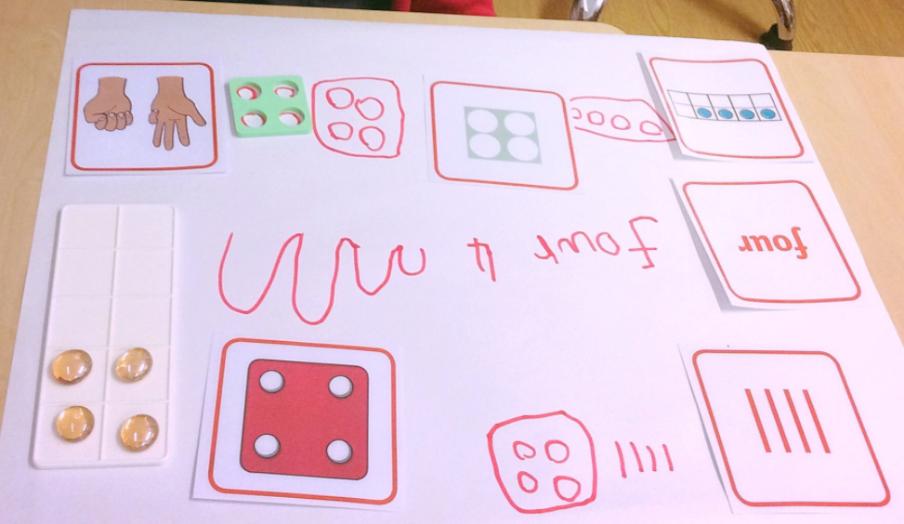  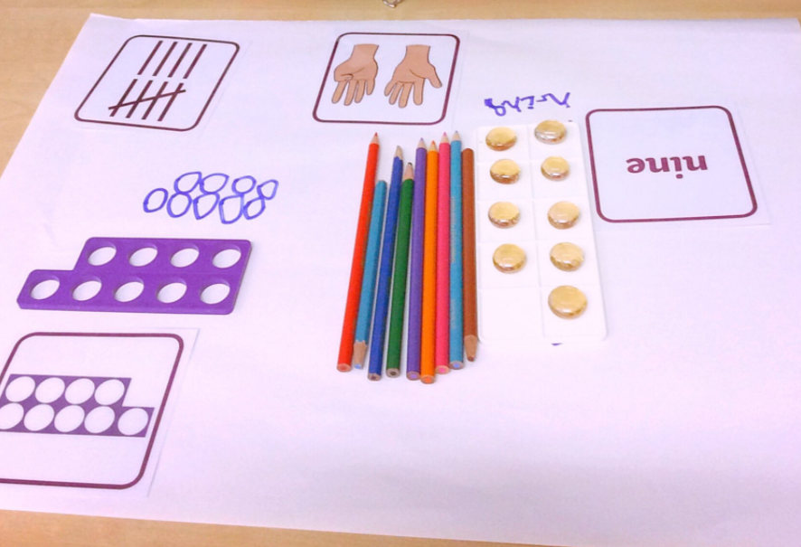  How else can you think of?  Have a look on It's Me 1, 2, 3! - Week 1 | White Rose Maths to help you. Look at the videos and use the activity sheets.  Making 1,2,3  How can you make these numbers? Which numbers make 1,2,3? Use the Numicon Shapes to make these numbers e.g. 1+1 = 2 and 1+2=3    You can draw these on paper.  Year 1  Number Bonds  Remind yourself of the Number Bonds to 10 from last week. How fast can you say them?  Listen to the number bond song.  Link below  I Know My Number Bonds with DJ Count | Number Bonds to 10 | Addition Song for Kids | Jack Hartmann - YouTube  Adding More  Counting on  When you add you ‘Count On’, hold the biggest number in you head and count on e.g. 4+2=6 hold the 4 in your head and count on 2 where do you land? On 6 this is the answer.  Make a numberline that you can lay out on the floor, write each number on a piece of paper and put in the correct order. You are now going to get physical and jump along the line to make an addition.  Think of a number to start on and how many you want to count on jump these on your number line and say the sum.  Write a number sentence to show your sum e.g. 4+2=6. Repeat with different numbers, how many can you do?  If you want to do any additional activities see the ‘Challenge Cards’ attached.  Have a look at Autumn Week 7 - Number: Addition & Subtraction | White Rose Maths  Watch the videos on here to help you with your counting on. | 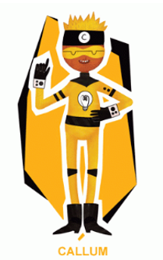 Creative Callum will help you be creative. He will help with these activities.  Nur/Rec/Yr1  Giuseppe Arcimboldo  Remember this artist from last week? What did he used to make his pictures can you remember? Last week you made a picture using the fruit/veg from your house.  This week can you make a picture of a ‘Fruit Face’ using either your own drawings of different fruit/veg for parts of the face or can you use ‘Jit’ on ‘Just2easy’ to make a face?  - Go to paint  - Find a black page  - Find ‘Food and Drink’ images in the drop down menu on the left.  - Make your picture  - Name and Save.  Winter Picture  Last week you looked for signs of winter and you wrote about what you saw. This week can you paint or create a picture that shows winter. What can you use? What colours will you use? What will you paint? | 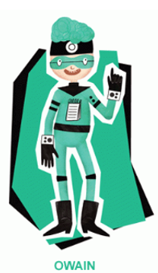 Owain will help you keep healthy and be active.  Nur/Rec/Yr1  What do I eat?  Keep a diary of the food you eat over the week. You can draw everything you eat on each day or you can choose some of the things you eat. Remember to draw and label the food. |  | Owain will help you keep healthy and be active.  Nur/Rec/Yr1  Squiggle Time  Circles  Put on the tune ‘Proud Mary’ by Tina Turner and along with the music make circles.  Tina Turner- Proud Mary - YouTube  - Make the circles in the air using your arms. Make large and small circles changing direction.  - Get out some paper and crayons and make the circles on the paper. Make big and small circles moving fast and slow with the music.  Dough Disco  If you have playdough at home you can use this if not you can use a scrunched up piece of paper like a ball.  Follow some of the activities on here.  Dough Disco Nursery Rhyme - The Muffin Man - YouTube  Dough Disco to Incy Wincy Spider Nursery Rhyme - YouTube  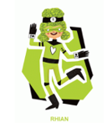Rhian will help you look after each other and the environment.  Big Schools Bird Watch  Take part in the ‘Big Schools Bird Watch’. Go outside and look for birds, how many can you see? What different types can you see? Find out the names for the birds you see.

