  Date: Week of January 25th 2021 |  |  |  | Theme: Are carrots orange?  Year group: Nur/Rec/Yr1
Literacy      This Photo by Unknown Author is licensed under CC BY-NC-ND   | Numeracy     | Creative     | Thinking     |  | Healthy me    
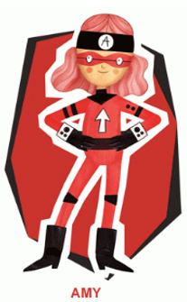 Ambitious Amy  She will help you do anything if you work hard enough. She will help with all these activities.  Nursery  Nosie Maker Instrument  Make your own noise maker. Find some empty boxes and some objects to put inside. Decorate your noise maker with different colours.  Play your noise maker.  Reception  Write all the letter sounds that you have been learning so far. Remember to write using a ‘Whoosh’ at the beginning of your letter.  Previous Sounds  m,a,s,d,t,i,p,n,g,o,c,k,u,b,f,e,l,h,r,j,v, y, w, z  How many things in your house can you find starting with the letter sounds? Take pictures of what you find.  New Letter Sounds  ch, qu, ng/nk  Learn to form these letter sounds, remember the ‘Whoosh’ at the beginning.  What words start with these sounds?  Use the activity sheets to help you with formation. (See attached documents)  CVC  Learn words with middle ‘e’ sound. Which words can you write?  Word Hunt  Write CVC words onto cards and get an adult to hide them for you. Can you find them? Read and write the words, how many can you find?  Read your book on ‘My Rising Stars’  Reception/Year 1  Ditties  Read the ‘Ditties’ 7,8,9. Make your own sentences.  Year 1  See the links on the website to some other RWI books to read.  Year 1  Learn/recap on previous spellings that you have been given.  RWI  ay,ee,igh,ow,oo,oo  Can you make the word? Then write the word into a sentence.  (see the activity sheet ‘Phase 2 CVC Set 2’)  Upper Case and Lower Case  Write out Capital Letters and Lower-Case letters. Use a different colour for the capital and lower case.  (See sheet for support)  Read your book on ‘My Rising Stars’  Reception/Yr1  The Enormous Turnip: Story Map  Make a story map to show what happens in the story.  Here is an example  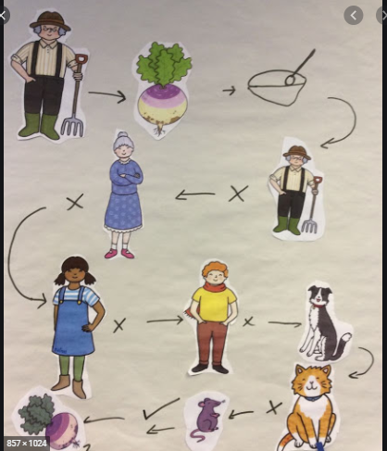  When you have done the story can you retell it?  Nur/ Reception/Year 1:  Make a story map and retell the story.  Reception/Yr1  Can you use some vocabulary from the story and add to your map?  Welsh  Tedi Twt yn Siopa  Dw i’n hoffi ( I Like..)  Remember the story about Tedi Twt yn siopa. Can you remember the food in the story?  Make a list of all the food you like.  Nursery  Draw pictures of the foods you like.  Reception  Draw a picture of the foods you like and label. Can you name them and say Dw i’n hoffi.  Year 1  Draw a picture of the foods you like and write the sentence Dw i’n hoffi….  Tedi Twt yn Siopa Story  Tedi Twt yn Siopa - YouTube | Ambitious Amy  She will help you do anything if you work hard enough. She will help with all these activities.  Reception  Write the numbers all the numbers that we have learnt.  How many different things can you use to write them? Try pencils/pens/chalk/  water/paint  Year 1  Write your numbers as far as you can. Can you do beyond 20?  Nursery  Catch and Count  Make some paper balls about 10 of them. Find a container that will catch your paper balls.  Throw the balls in the air and try and catch them in your basket. How many can you catch? Keep a record of your score.  Reception  4 + 5 Number Representation  Remember what you did last time when you went around the house and gathered items and sorted into 1,2,3?  Can you do this again, this time sorting into groups of 4 and 5.  Now can you show numbers 4 and 5 in lots of different ways.  There are additional sheets to help you on Hwb/Website.  Here are some ideas:  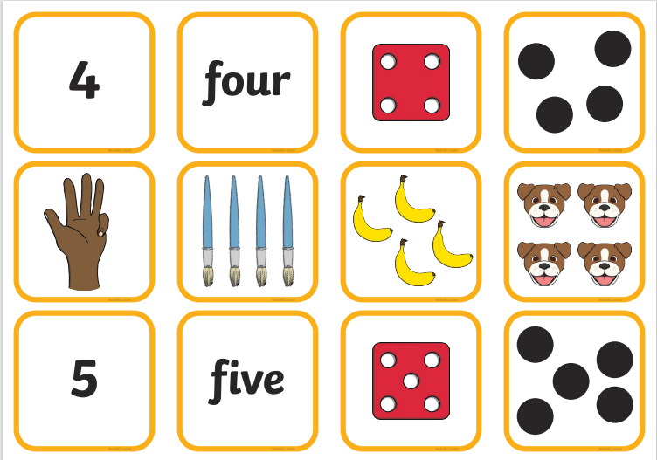  See White Rose Maths for the video and Hwb/website for the example activity sheets.  See the video of Miss Rees on Hwb.  Link to Website  Light and Dark - Week 1 | White Rose Maths  Year 1  Subtraction: How Many are Left?  Find some objects around your home to help you with this activity. Put out a number of your objects e.g 5 and then take another number away how many are left? Do this a few times with different combinations. Keep a record of your sum using the  Subtraction – symbol.  Make a board that looks like this to help you.  Look at the video of Miss Rees on Hwb to help you with the activity.  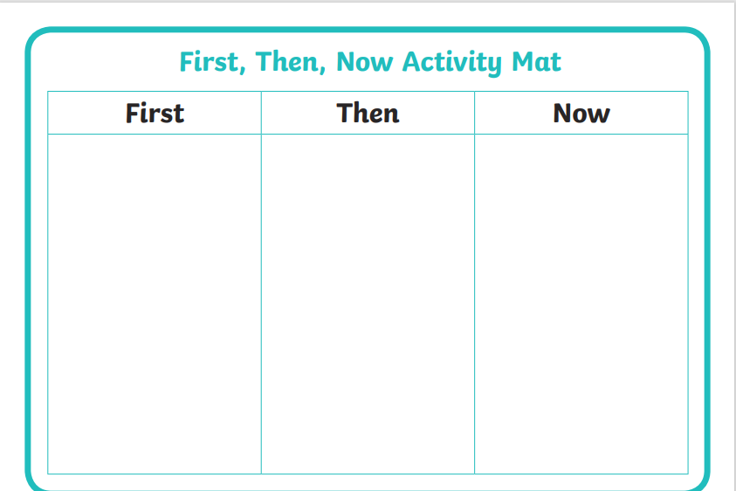  Have a go with these activities  See sheet on Hwb/website. | 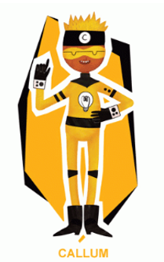 Creative Callum will help you be creative. He will help with these activities.  Nur/Rec/Yr1  Santes Dwynwen  Santes Dwynwen is the patron saint of Welsh love. On January 25th we celebrate this day in Wales. To celebrate people give each other gifts.  Listen to the story on Santes Dwynwen (See story on Hwb/website)  Make a ‘Love Spoon’ to give to someone that you love. You can make a shape of a spoon on paper and decorate.  Here are some ideas  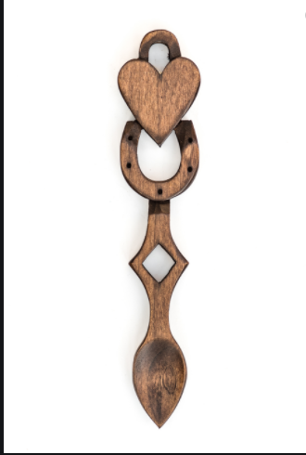  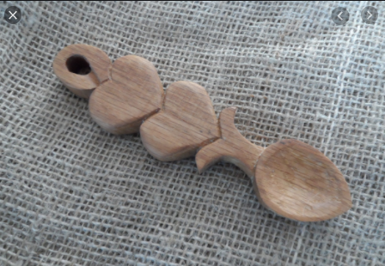  Santest Dwynwen Biscuits  Make some heart shapes biscuits to give to somebody you love.  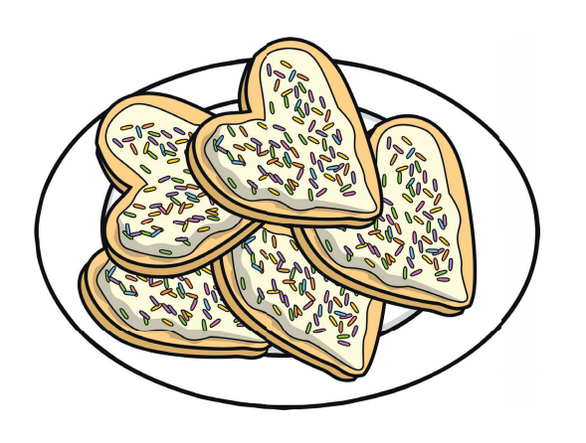  See the recipe on Hwb/Website. | 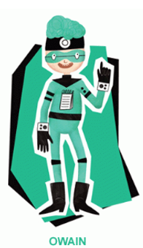 Owain will help you keep healthy and be active.  Nur/Rec/Yr1  Religious Education  Special People  Can you think of who is special to you?  Nursery  Draw a picture of your special people.  Reception  Draw and label all the people who are special to you.  Year 1  Draw and write about the people who are special to you. Who are they and why? Write sentences about them.  Can you find out who the special people/person is to Christians?  Food Tasting Game  Senses: Smell/Taste/Touch  Get an adult in your home to find 5 different foods. Make sure that some of the food is what you like and some are what you don’t like.  Put the food on a plate and hide it.  To play the game you must close your eyes and choose an item of food to taste and guess what it is. Say the name of the food before you open your eyes to see if you are correct.  Keep a score of what you get correct.  You can touch and smell the food before you taste it to help you with your guessing.  Fruit and Vegetable Sorting  Find some fruit and veg in your home and sort into two categories. Can you name the fruit and veg?  Draw the fruit and veg that you have found and label them. |  | Owain will help you keep healthy and be active.  Nur/Rec/Yr1  Healthy Pizza  Make healthy pizzas. Add tomato paste, cheese and some of your favourite  vegetables.  Take a picture of your pizza and share on dojo or Hwb.  Listen to the story ‘The Little Red Hen Makes a Pizza’  The Little Red Hen Makes a Pizza - Children's Books Read Aloud - YouTube  Nur/Rec/Yr1  Squiggle Time  Lines and Circles  Put on the tunes  Proud Mary - YouTube  The Jackson 5 - ABC - YouTube  Recap on the shapes that have been learnt.  - Make the lines/circles in the air using your arms. Make large and small lines/circles changing direction.  - Get out some paper and crayons and make the line/circles s on the paper. Make big and small lines moving fast and slow with the music.  Dough Disco  If you have playdough at home you can use this if not you can use a scrunched up piece of paper like a ball.  Follow some of the activities on here.  Pirate Playdough remix: Row your Boat, Pirate dance, Baby Shark Nursery Rhyme/Dough mashup - YouTube  Nursery Rhymes - Rock A Bye Baby Dough Disco Style - YouTube  Finger Gym  Winter clothing song for children - YouTube  In the Garden Funky Finger Workout | Nursery Rhymes and Fingerplays - YouTube  Cosmic Yoga  Try some of these lovely relaxing Yoga activities.  The Great Outdoors: Yoga Club (Week 10) | Cosmic Kids - YouTube  Winter Wonderland (Super Yoga) | Cosmic Kids - YouTube  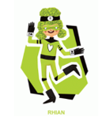Rhian will help you look after each other and the environment.  Big Schools Bird Watch  Take part in the ‘Big Schools Bird Watch’. Go outside and look for birds, how many can you see? What different types can you see?  Can you keep a record of the names and how many birds you see?  Nursery  Draw the number of birds and write the number.  Reception/Yr1  Write the name of the bird, make a tally and write the numeral.  You can record on paper or use the pictogram/graph on hwb.

