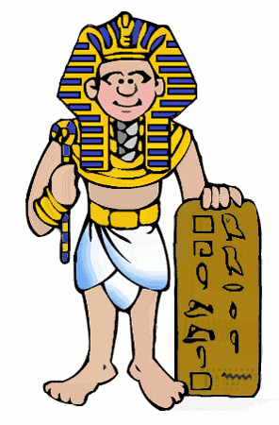
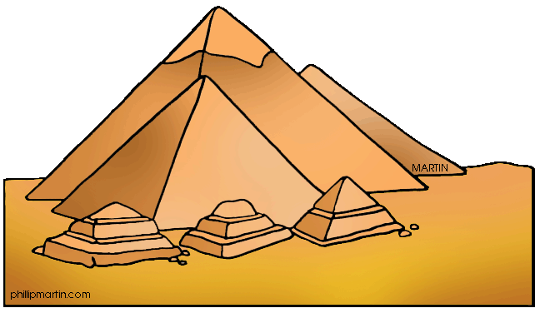
Pharaohs: KWL Grid
K  (What I know) | W  (What I want to know) | L  (What I have learnt)

