Reception and Year 1 – Music and Welsh
Blended Learning Week 6
The Very Hungry Caterpillar – Y Lindysyn Llwglyd Iawn
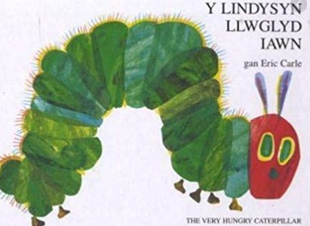
Listen to the story using the YouTube link.
https://www.youtube.com/watch?v=btFCtMhF3iI
The second link is the story narrated in Welsh. You can compare both if you would like and try to find some Welsh words that you know.
https://www.youtube.com/watch?v=1MxFr4tOGJ4
In the story the Lindysyn Llwglyd (the hungry caterpillar) is very very hungry and he eats his way through a lot of food every day. Some of the foods are healthy and some are not.

Year 1:
Sort which ones are healthy and which ones are not and write them into the table:
Reception:
Tell your family at home which ones you think are healthy and which ones may be unhealthy.
Healthy Food – Bwyd Iachus | Unhealthy Food – Bwyd Afiach

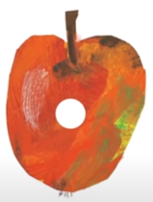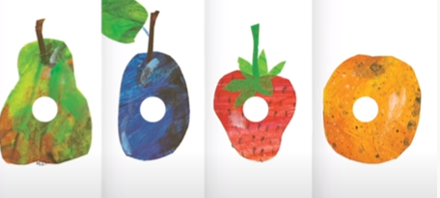
Apple – Afal
Pear – Peren
Plum – Eirin
Strawberry – Mefus
Orange – Oren

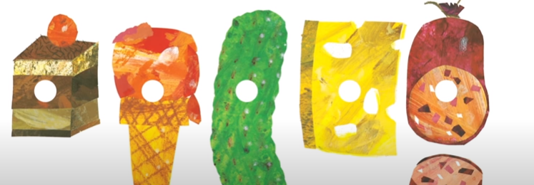
Choclolate Cake – Cacen Siocled
Ice Cream – Hufen Iâ
Pickle – Picl
Cheese – Caws
Salami – Salami
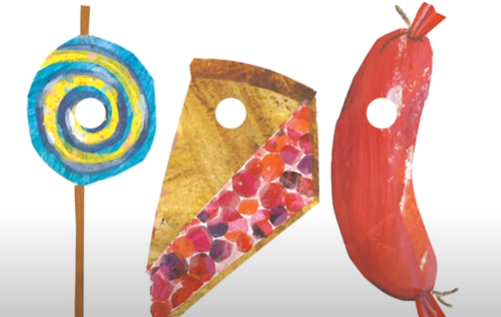
Lolly Pop – Loli Pop
Cherry Pie – Tarten Ceirios
Sausage – Selsig
Cup cake – Cacen
Watermelon – Melwn Ddwr

Days of the Week:
The caterpillar eats different foods on the different days of tthe week.
Dydd Llun - Apple – Afal
Dydd Mawrth - Pear – Peren
Dydd Mercher - Plum – Eirin
Dydd Iau - Strawberry – Mefus
Dydd Gwener - Orange – Oren

Dydd Sadwrn -
Choclolate Cake – Cacen Siocled
Ice Cream – Hufen Iâ
Pickle – Picl
Cheese – Caws Lolly Pop – Loli Pop
Cherry Pie – Tarten Ceirios
Sausage – Selsig
Cup cake – Cacen
Watermelon – Melwn Ddwr
Salami – Salami

Can you remember the days of the week in Welsh? Can you rememeber the song we sing in class to remind us what they are? Try to sing it at home.
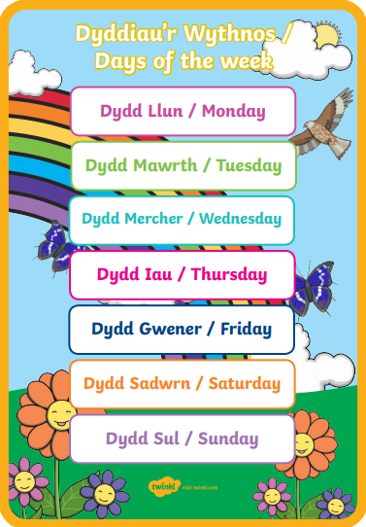
Listen to the CYW song to see if you can recognise the days of the week in Welsh
https://www.youtube.com/watch?v=EjSFKgGkSXs


