Year 5 and 6 Welsh Planning – Ms Davies
Week Beginning: 4.1.2021
Hedd Wyn

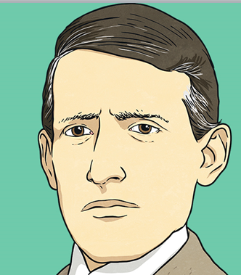
Hedd Wyn (Elis) was a Welsh poet who lived in a small village called Trawsfynydd in North Wales. Elis loved to write poetry and had already won a few prizes in local Eisteddfods.
Read his story by opening the PDF. You can also do some of your own research by typing Hedd Wyn into your search bar. There are also some useful resources on HWB to help you learn a little more about Hedd Wyn.
It is important that you have as much information about Hedd Wyn as possible as you will need to write a Third Person Profile on him.
Further Information:
World War 1 and the Battle of Passchendaele
Research a little into World War 1. Some good websites are:
https://kidskonnect.com/history/world-war-i/
https://www.natgeokids.com/uk/discover/history/general-history/first-world-war/
https://www.bbc.co.uk/bitesize/topics/zqhyb9q/articles/z8sssbk
https://en.wikipedia.org/wiki/Battle_of_Passchendaele
https://kids.kiddle.co/Battle_of_Passchendaele

- World was one was fought between 1914 and 1918 and it was called The Great War
- The war was mainly fought between the Germans and the British people.
- 8 million soldiers were killed in WW1
- Conditions for the soldiers on both sides were horrific.
- On the Western Front, the war was fought by soldiers in trenches.
- Trenches were long, narrow ditches dug into the ground where soldiers lived.
- They were very muddy, uncomfortable and the toilets overflowed. These conditions caused some soldiers to develop medical problems such as trench foot.
- There were many lines of German trenches on one side and many lines of Allied trenches on the other.
- In the middle was no man's land, which soldiers crossed to attack the other side.

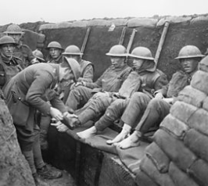
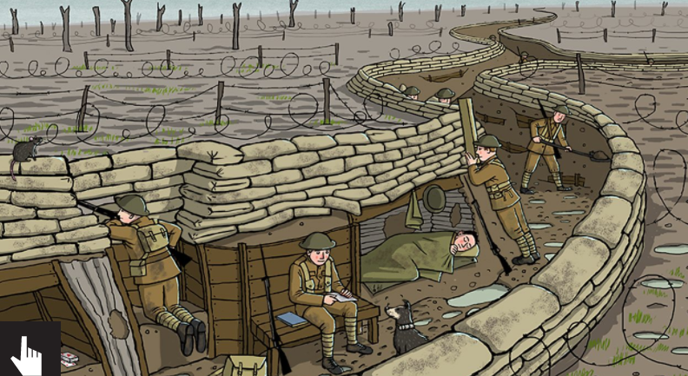
Hedd Wyn fought and died in the battle of Passchendaele
Over 70,000 soldiers died during the battle
The living conditions were horrific
The weather was cold and it rained a lot making living conditions even worse

Third Person Profile Focus:
Last year we learnt how to write a first person profile and what patterns that we need to use. This term we will be learning how to write a THIRD person profile where you are writing about someone.
Your task is to write about Hedd Wyn.
You need to include as much detail as possible using the things that you have learnt on through the websites that you have researched.
Look at the Welsh language patterns for your particular year group and also look at the examples provided.
Third Person

Dyma Catherine Zeta Jones.
Actores enwog ydy hi.
Mae Catherine nyn 52 mlwydd oed – mae ei phenblwydd ym mis Medi.
Mae gwallt brown a llygaid brown gyda hi.
Mae hi’n byw yn Hollywood mewn tŷ enfawr gyda’r teulu.
Mae hi’n mwynhau byw yn America achos mae hi’n heulog pob dydd.
Mae hi’n dwlu ar actio mewn ffilm achos mae’n hwyl, ond dydy hi ddim yn mwynhau reidio ceffyl achos mae hi’n ofnus.
Mae hi’n hoffi bwyta salad a ffrwythau ac mae hi’n mwynhau yfed sudd moron achos mae’n iach.
Ar y penwythnos mae hi’n gwisgo ffrog pert iawn achos mae’n ffasiynol.
Fy hoff ffilm Catherine Zeta Jones ydy Zorro achos mae’n sbri.

Missions:
Literacy
Think of the language patterns you could use to write a third person profile. Write them down in the back of your mission books and then beging to compose your own profile describing a friend. See examples to help you.

Creative
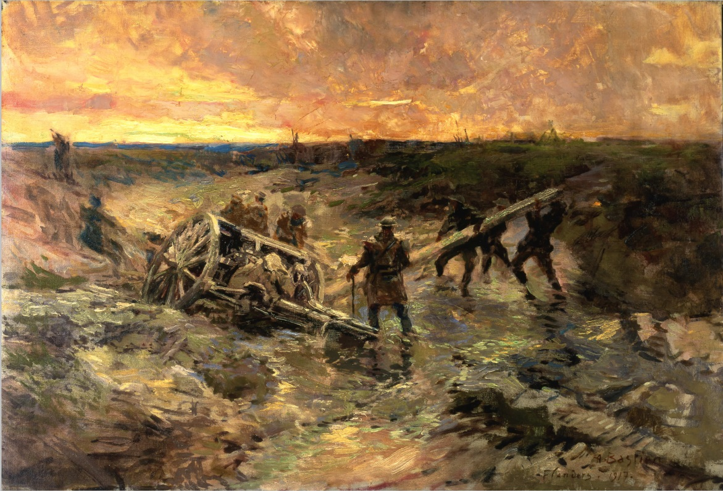
Use your imagination and the the images of the war in Passchendaele to sketch/draw your own version of the war. You can use any method from: chalks/pastels or charcaol (pencil). Look at the examples to help you



