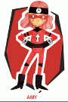
Amy – Ambitious and Capable Learners

Are Carrot Orange? / Pam fod Moron yn Oren?
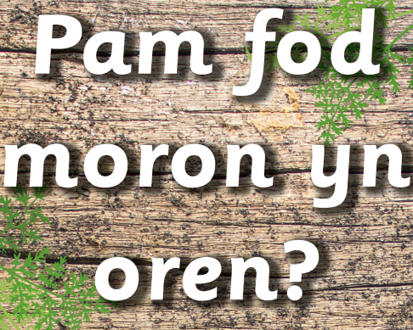
Healthy and Unhealthy Food:
Some foods are healthy and some are not so healthy.
You have been learning with Miss Rees all about the names of the different foods in Welsh. Can you remember their names? Here are some to remind you.
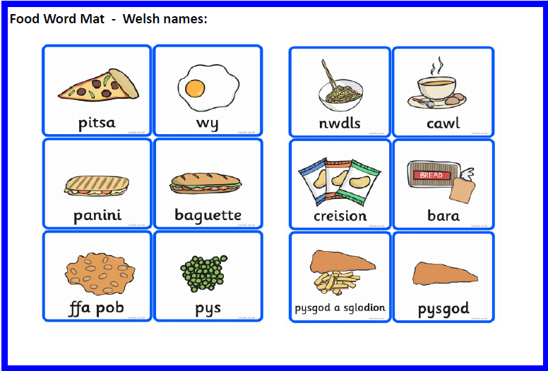
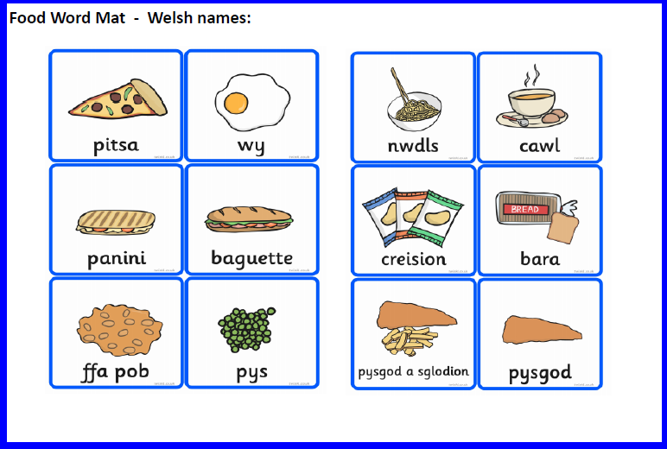
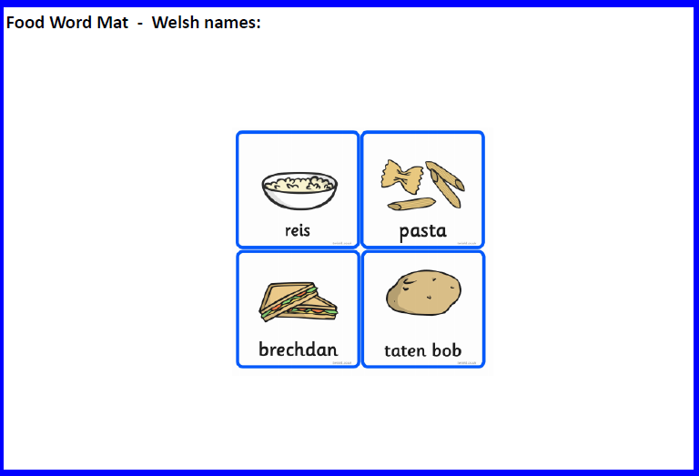
Can you make 2 plates of food – one a healthy plate and one an unhealthy plate (foods that are really nice but we shouldn’t eat all the time).
Reception and Year 1:
Draw the foods on to the plate and colour them in. Once you have finished try to label them in Welsh. If you have a printer at home you can print the plate template at the bottom of the page.
Underneath the picture of your plates write a few sentences to tell me what foods you like:
Ga i siocled
Ga I afal

Nursery:
Draw the pictures of the different foods on the two plates.
Plât Iachus / Healthy Plate

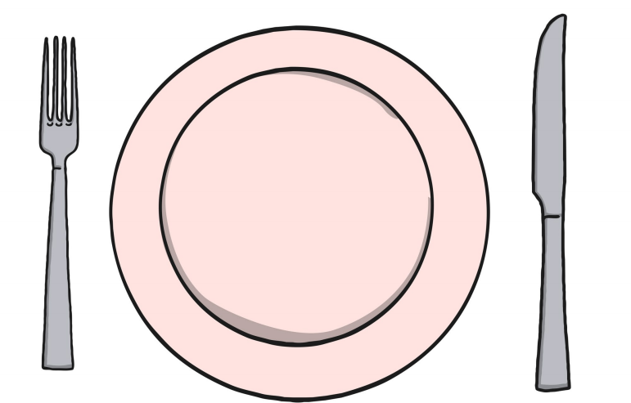

Plât Afiach / Unhealthy Plate

