
Amy = Ambitious and Capable Learners

Blended Learning
Welsh Themed Activities – Reception and Year 1

Sut Mae’r Tywydd Heddiw?
Can you remember the song that you sing with Miss Rees and Ms Davies?
Sut mae’r tywydd heddiw?
Sut mae’r tywydd heddiw? Sut mae’r tywydd heddiw?
Mae hi’n ………
Can you remember what the different weather types are in Welsh?
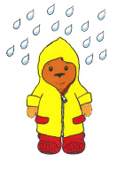
It is raining = mae hi’n bwrw glaw

It is sunny = mae hi’n heulog
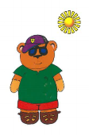

It is windy – mae hi’n wyntog
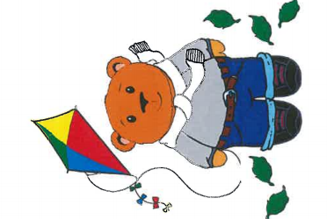
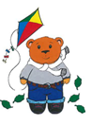
It is cold – mae hi’n oer

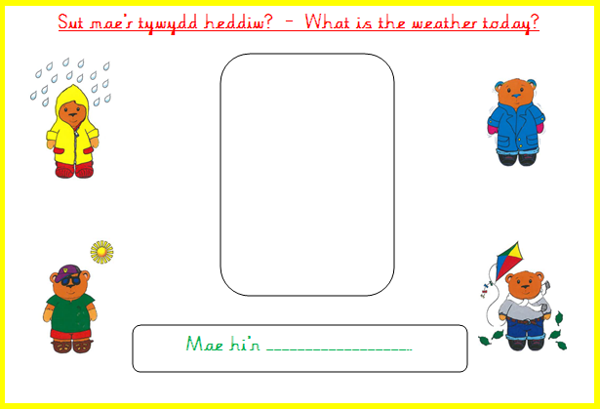

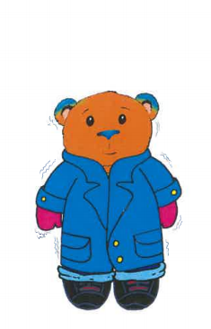
Year 1:
Try and write a sentence telling me what the weather is like today. Look at the PDF document to help you with your spellings.
Reception:
After listening to the song – try to sing along remembering to use the correct weather term. Listen to the song by clicking on the QR code to take you to J2e.


Lliwiau / Colours
Can you remember your colours in Welsh? Can you remember the game we play in class?
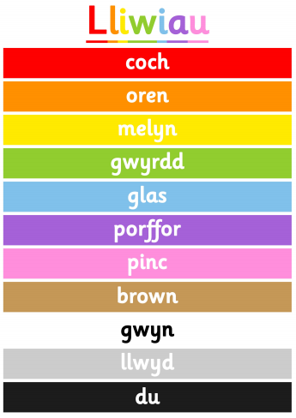
Have a hunt around your house looking for different coloured things – try to remember and say the Welsh colour for each one.
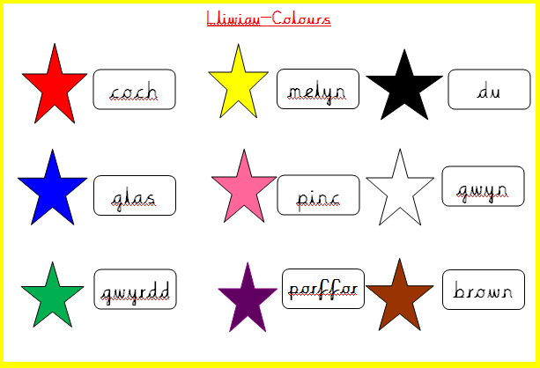

Shapes/Siapiau
Before Chrismtas we coloured in some Christmas themed pictures made out of shapes. Can you remember what they were in Welsh? Try to create a train or a flower using these shapes or why not create your own ideas?





