Reception/Year 1
Welsh Blended Learning – Week: 4.1.2021 (Ms Davies)

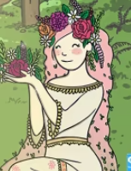
Blodeuwedd (which means Flower Face) was a beautiful princess who was created by magic out of flowers and lived in Wales many years ago.
She had a crown made of wild flowers, pink hair that fell to her knees and a long green dress made out of moss and wild flowers. She was very beautiful and everyone loved her.
Blodeuwedd loved to be outdoors with nature and all the animals loved her too.

Challenge 1:
Blodeuwedd loved spending time in the outdoors. Can you go out for a walk or take a look out of the window to see what you can find? Try and find the on the scavenger hunt and learn the names in Welsh. Listen to the recording of how to pronounce the names by clicking on the OR code.

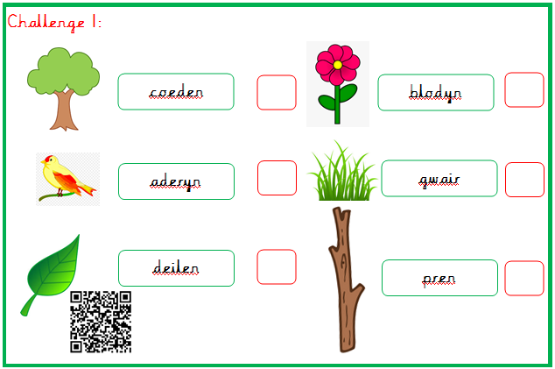

Challenge 2:
Did you have a wonderful Christmas? Did Sion Corn ( Father Christmas) bring you everything on your lists? I do hope so.
I can’t wait to see you all so that you can tell me all about it. In the meantime can you use your special Welsh language patterns to tell me what you had for Christmas?.
Use the list to find some of the things you may have had from Sion Corn (don’t worry if your presents are not on the list) and then try to learn the Welsh names for them and then use the language pattern:
Ces i ……..
Once you have done this try writing a sentence or two using the language pattern:
Ces i doli pinc
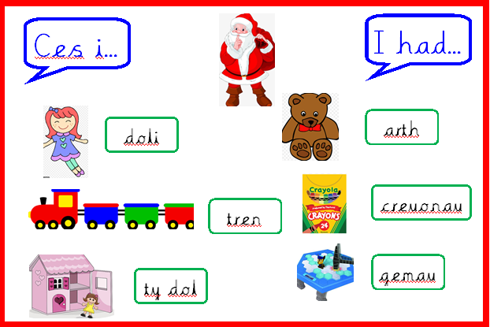

Challenge 3:
Create a crown similar to Blodeuwedd’s crown.
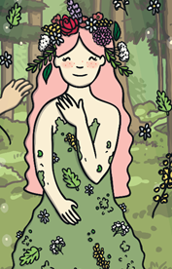
You will need:
- 1 long strip of paper or card and ask an adult to measure your head but don’t glue both ends together until the flowers have dried.
- Create your own flowers using card/paper and colouring pencils, felt pens or paint. You could also find some pictures of flowers in magazines. You can also print the flowers on the attached PDF and cut them out.
- Once cut glue them on to the crown.
- Wait for the glue to dry and then stick both ends of the band together.
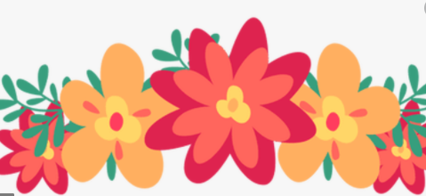
Challenge 4:
Draw a picture of Blodeuwedd.
Remember to draw a beautiful crown of flowers on her head. Once you have drawn your picture try to label the parts of her body in Welsh. Look at the word mat to help you.
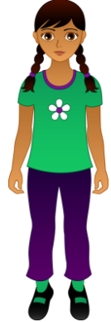
ysgwyddau
coesau
traed
llaw
pen

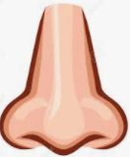
trwyn
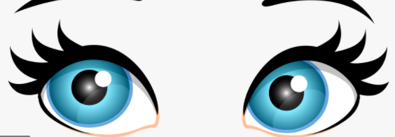
llygaidd
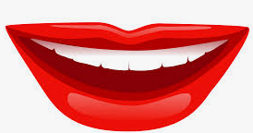
ceg

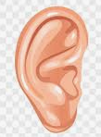
clustiau

Pen Ysgwyddau Coesau Traed/Head Shoulders Knees and Toes:
Can you remember the song that we sing during our Welsh sessions? See if you can sing along with the video.
https://www.youtube.com/watch?v=3RwgAYVntUg


