Nursery/Reception/Year 1
Newsletter

Autumn Term
Welcome Back
Welcome back after a long break, we all hope that you have had a fun and exciting summer break and have enjoyed the time to explore and take part in different activities. The staff are all relaxed and rested and are ready for a hard working, fun filled term, we hope that you will join us on our learning journey. We would like to welcome all our lovely children back, to those continuing with us in Year 1 and to those new children in Nursery and Reception to whom school is a new learning adventure. We look forward to continuing with
children and families that we already know and getting to know others of you.

As staff we are looking forward to working with the children again this year and further developing their
learning. We would like to welcome Miss O’Connor to the class and she will be working with us every morning.
Reception/ Year 1 Staff
Miss A Rees: Class Teacher
Mrs S Foale: Teaching Assistant
Mrs D Samuel: Teaching Assistant (am only)
Miss D O’Connor: Teaching Assistant (am only)

Settling in
The first half of the term will be about settling the children back into class routines
especially our Nursery children many of whom are in school for the first time and for our Reception children as they get used to being in school full time. During this time the children will be exploring their environment both indoors and outdoors. We want to make the class a happy and exiting place to be and a fun learning environment for all the children. We want to make our children as independent as possible and will be
offering lots of exciting activities. We will be asking the children for their ideas/likes/dislikes as part of their learning.

Entering and Exiting
Entering
The drop off in the morning will be at the main yard gate. Your child will be met by a member of staff and it will not be possible for you to come onto the school yard in the mornings as we need to ensure social distancing. When you arrive at the school gate you will need to queue maintaining a 2m distance from the person in front of you.

Exiting
When you arrive to pick you child at the end of the school day, there will be a
designated area to line up on the school yard. Demarcations will be 2m apart and there will be a requirement to maintain social distancing at all times. Your child will then be released by us and you can make your way out of the gate maintaining a 2 m distance at all times.

Pick-up points

Please queue at the designated pick-up point, maintaining 2m distance at all times. Please see the designated pick-up point below.

Nursery – small yard in car park

Rec-Y1 – by external wall to main road on main yard
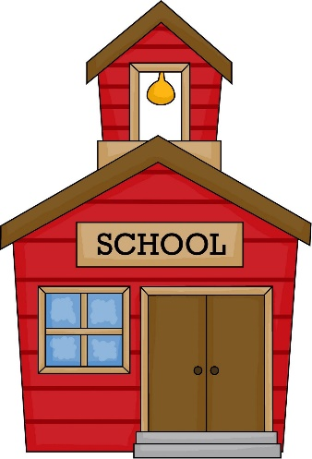

Autumn Term Topic
Marvellous Me
As we begin our journey in school we want to focus on the children and to ensure their well-being. We will be for the first half term as we get to know the children be focusing on the topic ‘Marvellous Me’. We will talk about our bodies through songs and rhymes, find out how our bodies move and talk about our feelings. We will share information about our families and talk about what we like and dislike. We will enjoy learning about ‘Marvellous Me’ and our new friends.


Physical Education
This year our PE Day is a Wednesday.
We will be using the outdoor for our PE weather permitting therefore please ensure that your child is dressed appropriately for the weather.

Please could your child wear their PE clothes to school on the above day.

PE Clothes
Here are some suggestions about what clothes your child could wear.
• T-shirt
• Jumper
• Leggings
• Jogging bottoms
• Trainers



Outdoor Learning
We will be spending time outdoor everyday as part of our learning. Please ensure that your child has suitable clothing that they can take part in daily outdoor activities.

Every Friday we have a session in the school garden. We will be spending the time
exploring the surroundings and learning about the seasons and the effects on plants and animals and how to look after our environment. There will be lots of fun and
exciting activities to develop literacy and numeracy in the outdoors.

Please could you ensure that on a Friday your child has appropriate clothing for all weather as we will be spending the whole morning outside come rain or shine.

Information
Reading Books (Reception/Year 1)
Reading books will be given to the children and kept in school to read. The children will be given a book to read at home through ‘Rising Stars’. This will be given at a later date.
Homework Books (Reception/Year 1)
Homework will take the form of half termly tasks. The books will only need to be
returned at the end of the half term so we can see how the children’s learning is
progressing. Books and tasks will be given later in the term.

Sound and Number Books (Reception) and Spelling Books (Year 1)
Please keep these books at home and each week we will give you a new sound/number/spelling to add to the book.

Reminders
Uniform
Please label or write your child’s name on all clothes and bags, it is important that you do this as items of clothing do go missing and if they are labelled clearly they are much easier to find.

Toys
We ask that your child doesn't bring toys into school as we don't want them to get lost amongst our class toys or to get broken.

Important Information
Medical Information

If your child has any medical needs or any allergies or dietary requirements, please could you let us know as soon as possible as this information is important.
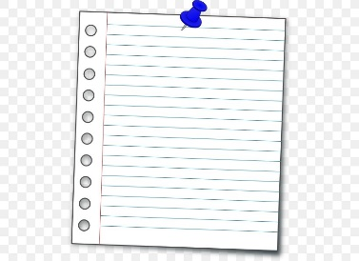

We will try and keep you as informed as possible about what we have been doing in class dates and important information.

Thank you for your continued support and we look forward to you joining our learning journey through the term
Miss Rees and Staff

