PE Activities
It is important to keep fit and active during this time. To help you do this, here is an activity to try at home.
Complete a warm-up by stretching your whole body.
Main Activity: Time yourself doing each of these actions and record how many you have completed:
- 30 seconds of lunges
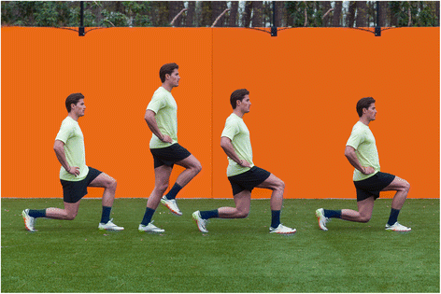

- 30 seconds of burpees
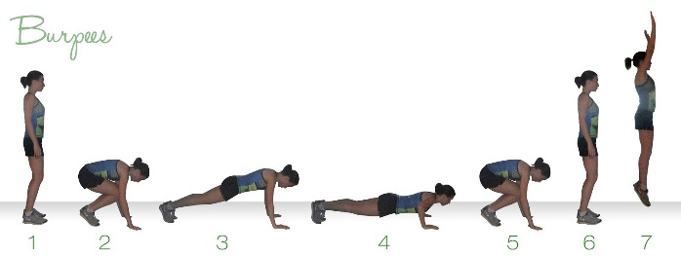

- 30 seconds of sit-ups

This Photo by Unknown Author is licensed under CC BY-SA

- 30 seconds of squats
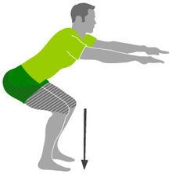
Try this again next week to compare how many exercises you completed.

